**6.6 Use logarithmic graphs**

When you obtain data for two variables *x* and *y*,and the graph is a straight line, the relationship between *x* and *y* is *y = mx + c*, the equation of a straight line.

Often the graph is not a straight line. You can use logarithms to convert the curves of relationships of the forms *y* = *axn* and *y* = *kbx* into straight lines.

You are expected to know that when you have data for *x* and *y* and you plot

* log *y* against log *x* and get astraight line, then the equation connecting *y* and *x* is *y* = *axn*   
  (the line has intercept log *a* and gradient *n*)
* log *y* against  and get a straight line, then the equation connecting *y* and *x* is *y* = *kbx*   
  (the line has intercept log *k* and gradient log *b*)

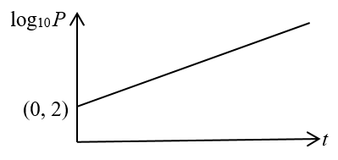Examples

**Example 1** A lake’s fish population, *P*, is modelled by the equation *P = kbt*, where *k* and *b* are constants and *t*is the number of years since the population was first estimated.

The straight line on the diagram shows the linear relationship between *t* and log10*P* over a period of 10 years.

The straight line starts at (0, 2) and its gradient is 0.1.

**(a)** Write down an equation of the straight line in terms of log10*P* and *t*.

**(b)** Find the values of *k* and *b* correct to 3 significant figures.

**(c)** Interpret in terms of the model the value of constant *k*.

**(d)** Find, to 2 significant figures, the population according to the model when *t* = 10.

**(e)** State two reasons why this may not be a realistic model.

|  |  |
| --- | --- |
| **(a)** log10 *P* = *mt* + *c*  log10 *P* = 0.1*t* + 2  **(b)**    As *P=kbt*, *k* = 100 and *b* = 1.26  **(c)** It is the initial population.  **(d)**  **(e)** Two possible reasons are:   * Inaccuracies in measuring the gradient may result in very different estimates. * The model suggests unlimited growth. | In *y = mx + c*:   *y* is log10 *P*   *x* is *t*   the gradient *m* is 0.1   the intercept *c* is 2  Use the rules of logarithms and exponents.  Or: the population when it is first estimated.  Substitute *t* = 10.  Other good reasons are possible; for example, population growth may not be proportional to population size,  or the initial estimate may have been wrong. |

**Example 2** A scientist records the following data for the variables *x* and *y*.

|  |  |  |  |  |  |
| --- | --- | --- | --- | --- | --- |
| ***x*** | 1 | 2 | 3 | 4 | 5 |
| ***y*** | 200 | 1600 | 4200 | 17 000 | 69 000 |
| **log10*y*** |  |  |  |  |  |

She thinks the relationship between *x* and *y* may be modelled by *y = kbx*.

**(a)** Complete the table, giving answers to 2 significant figures.

**(b)** On a grid, plot the values of log10*y* against the values of *x.*

**(c)** By drawing a line of best fit find the values of *k* and *b*, giving your answer to 2 significant figures*.*

|  |  |  |  |  |  |  |  |  |  |  |  |  |  |  |  |  |  |  |  |
| --- | --- | --- | --- | --- | --- | --- | --- | --- | --- | --- | --- | --- | --- | --- | --- | --- | --- | --- | --- |
| **(a)**   |  |  |  |  |  |  | | --- | --- | --- | --- | --- | --- | | ***x*** | 1 | 2 | 3 | 4 | 5 | | ***y*** | 200 | 1600 | 4200 | 17 000 | 69 000 | | **log10*y*** | 2.3 | 3.2 | 3.6 | 4.2 | 4.8 |   **(b)**    **(c)**  *c* = 1.8  *m* =    *k* = 63 and *b* = 4.4 | E.g. log10200 = 2.301…  When they are plotted, the points are very close to a straight line.  *c* is the *y*-intercept  (Any value in the range 1.6 to 1.9 would be acceptable.)  *m* is the gradient  (Any value in the range 0.60 to 0.68 would be acceptable.)  Equation of line is  log10 *y* = *mx* + *c*  (Any value for *k* in the range 40–79 and for *b* in the range 4.0–4.8 would be acceptable.) |

**Example 3** The relationship between *y* and *x* is modelled by *y* = *axn*, where *a* and *n* are constants.

**(a)** Show that the relationship *y* = *axn* can be expressed in the form   
 , giving *m* and *c* in terms of *a* and *n.*

The graph shows the line of best fit for values of log10*y* plotted against values of log10*x*.

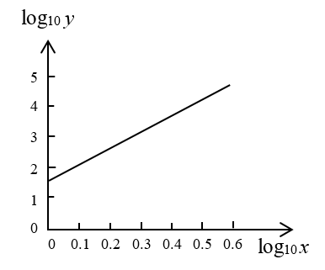

**(b)** Find the values of *a* and *n*.

**(c)** Find the value of *y* when *x* = 1.1

|  |  |
| --- | --- |
| **(a)**  *y* = *axn*    *m = n* and *c* = log10 *a*  **(b)** *n = m =*  *c* = 1.5, so  **(c)** *y* = *axn* = 31.6*x*5  = 31.6 × 1.15  = 50.9 | Take log10 on both sides and use the laws of logarithms.  compare  with  *m* is the gradient  *c* is the *y*-intercept  Substitute values for *a*, *n* and *x.* |

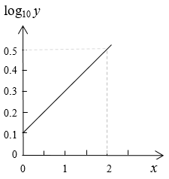Exercise

**1.** The equation connecting *y* and *x* in the diagram is *y* = *kbx*.

Find the values of *k* and *b.*

Give your answers to 3 significant figures.

**2.** A scientist records the following data for the variables *x* and *y*. He thinks the relationship between *x* and *y* may be modelled by *y* = *axn*, where *a* and *n* are constants.

|  |  |  |  |  |  |
| --- | --- | --- | --- | --- | --- |
| ***x*** | 79 | 2500 | 7900 | 80 000 | 630 000 |
| ***y*** | 100 | 800 | 2100 | 9 000 | 35 000 |

**(a)** Copy and complete the following table, giving your answers to 2 significant figures.

|  |  |  |  |  |  |
| --- | --- | --- | --- | --- | --- |
| **log10*x*** |  |  |  |  |  |
| **log10*y*** |  |  |  |  |  |

**(b)** On a grid, plot the values of log10*y* against the values of log10*x.*

**(c)** By drawing a line of best fit, find the values of *a* and *n*, giving your answers to 2 significant figures*.*

**(d)** Find, to 2 significant figures, the value of *y* when *x* = 900 000.

**(e)** Give a reason why the answer to part **(d)** may not be accurate to 2 significant figures.

**3.** The area, *A*km2, of an oil spill is measured each day. *A* is modelled by *A = kbt*, where *t* is the number of days since the first measurement.

**(a)** Show that log10 *A* = log10 *k* + *t* log10 *b.*

**(b)** Use the graph below to find, to 2 significant figures, the values of *k* and *b.*

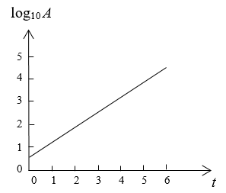

**(c)** Use these values to estimate the number of days before the area is over 2000 km2.

**(d)** Comment on this model.

Answers

**1.** The straight line has *y*-intercept 0.1 and gradient 





**Alternative method**

intercept = log *k* = 0.1

and gradient = log *b* = 0.2 

**2. (a)**

|  |  |  |  |  |  |
| --- | --- | --- | --- | --- | --- |
| log10*x* | 1.9 | 3.4 | 3.9 | 4.9 | 5.8 |
| log10*y* | 2 | 2.9 | 3.3 | 4.0 | 4.5 |

**(b)**

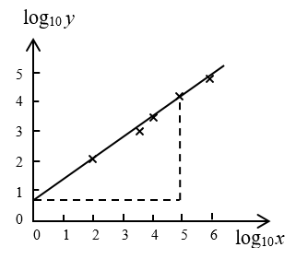

Intercept = 0.7 (this is read from the graph, 0.6 and 0.8 are also acceptable)  
and gradient =  (accept 0.60 to 0.73)

The equation connecting *y* and *x* is *y* = *axn*.

Taking logs: log10 *y* = *n*log10*x* + log10*a*  
So, the line has intercept log *a* and gradient *n*.

So *n* = 0.67 and (accept 4.0 to 6.3)

**(c)**  and substitute *x* = 900 000

= 49 000 to 2 sf. (accept 15 000 to 140 000)

**(d)** One of the following, but there may be other reasons.

* Measuring the gradient and intercept is not accurate (to 2 significant figures).
* Extrapolation is not reliable.

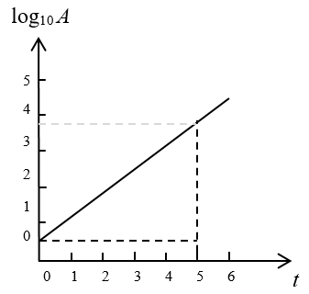**3. (a)** 

**(b)** intercept = 0.6 (accept value from 0.6 to 0.7)

gradient = (accept 0.62 to 0.66)

log10 *A* = 0.6 + 0.64*t*

 (accept 4.0 to 5.0)

 (4.2 to 4.6)

**(c)** Substitute *A* = 2000

 (accept 3.9 to 4.4)

After 4 days the area is about 2000 km2

**(d)** One of the following, but there may be other reasons.

* Measuring the gradient and intercept is not accurate.
* The model suggests unlimited growth.