**6.3 The function ln *x* and its graph**

Youare expected to know

* that ln *x* is the inverse function of 
* how to solve equations of the form 
* how to solve equations of the form 

The logarithm of *x* to the base e is written as ln *x*. This is called the natural logarithm and is the same as . The rules of logarithms apply to ln *x*, so we have the following formulas.







The graphs of the functions  and  are shown on the diagram.

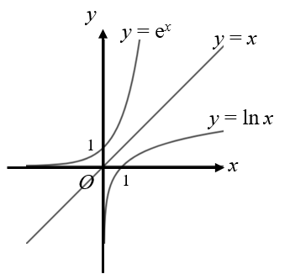

****passes through (1, 0) and has the *y*-axis as an asymptote.

****passes through (0, 1) and has the *x*-axis as an asymptote**.**

Each graph is a reflection of the other graph in the line *x = y*. The functions  and  are each other’s inverses.

When you apply a function to *x* and then apply the inverse function, you get back to *x*. This gives the following two formulas.





These two formulas can be used to solve equations of the form  and .

Examples

**Example 1** Solve.

Give your answer to 3 significant figures.

|  |  |
| --- | --- |
|  | Take natural logarithms on both sides.  Use the formula .  Rearrange and use your calculator. |

**Example 2** Solve.

Give your answer to 3 significant figures.

|  |  |
| --- | --- |
|  | Raise to the power of e on both sides.  Use the formula .  Rearrange and use your calculator. |

**Example 3** Solve.

Give your answer in the form *a*ln 2 + *b*, where *a* and *b* are rational numbers.

|  |  |
| --- | --- |
|  | Take natural logarithms on both sides.  Use the formula and note that 16 = 24.  Use .  Finally rearrange. |

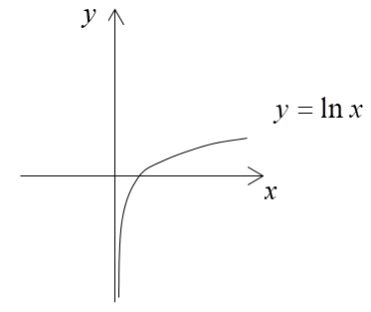Exercise

**1.** The diagram shows a sketch of the graph of ****.   
 Sketch and label the graphs for the following.

**(a)** 

**(b)** 

**2.** Solve the following equations, giving your answers to 3 significant figures.

**(a)** 

**(b)** 

**(c)** 

**3.** Solve the following equations, giving your answer in exact form.

**(a)** 

**(b)** 

**(c)** 

**4.** The mass, *m* grams, of a seed *t* days after it has been harvested is modelled by  where *d* and *k* are positive constants.

When the seed is harvested, its mass is 10 grams and 20 days later its mass is 5 grams.

**(a)** Write down the value of *d*.

**(b)** Show that .

(**c)** Find the mass after 70 days. Give your answer to 2 significant figures.

**(d)** Comment on the suitability of the model.

**(e)** Suggest an improvement to the model.

**5.** Find the exact solution to the equation .

Answers

**1.** For  reflect  in the *x*-axis.

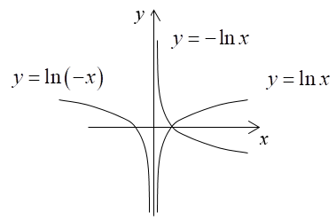 For  reflect  in the *y*-axis.

**2. (a)** 

**(b)** 

**(c)** 

**3. (a)** 

**(b)** 

**(c)** 

**4. (a)** *d* = 10

**(b)** 

**(c)** . The mass is 0.88 grams.

(**d)** According to the model, the value of the mass will become nothing eventually, this is not realistic.

**(e)** At some stage the seed will not get lighter anymore. So, assuming that its final weight is reached after 20 days, the model could be



**5.** 