**2.5 Represent inequalities graphically**

You need to be able to use shading to graphically represent linear and quadratic inequalities such as *y* > *x* + 1

and *y* > *x*2 + 5*x* + 6.

There are three steps to follow:

1. Draw the graph for the equation using either a dotted or solid line.
2. Choose one point and check whether it is in the required region.
3. Shade and label the region.

You need to be familiar with the conventions for using dotted and solid lines.

* + If the line **is** included in the inequality, draw a solid line.
  + If the line **is not** included in the inequality, draw a dotted line.

Some people shade the required region and others shade the region that is not required. Always make sure your answer is clear by labelling the diagram carefully.

Examples

**Example 1 (a)** Sketch the line *x* + *y* = 3.  
**(b)** Indicate the region *x* + *y* ≤ 3.

|  |  |
| --- | --- |
| **(a)**    **(b)** | The sum of the *x*-coordinate and the  *y*-coordinate is 3 for each point on the line with equation *x* + *y* = 3.  The inequality is *x* + *y* ≤ 3, which means the line **is** included, so you should mark it as a **solid** line.  For every point in the shaded region the sum of the *x*-coordinate and the  *y*-coordinate is less than 3. |

**Note:** In Example 1 the required region has been shaded. You could instead shade out the region that is not required, but always make your answer clear.   
The label *x* + *y* ≤ 3 in the diagram shows exactly what you mean.

**Example 2** Sketch the region *y* > 2*x* – 3.

|  |  |
| --- | --- |
| When *y* = 0, *x* = 1.5  When *x* = 0, *y* = –3 | First draw the line *y* = 2*x* – 3.  This is a straight line with *y*-intercept –3 and *x*-intercept 1.5  The inequality is *y* > 2*x* – 3, which means the line is **not** included, so you should draw a **dotted** line.  Check which is the required region by checking one point, e.g. (0, 0).  Substituting in *y* > 2*x* – 3 gives   0 > 2 × 0 – 3   0 > –3 This is correct, so shade and label the region containing (0, 0). This is the required region. |

**Example 3 (a)** Illustrate the region for which *y* ≤ *x* + 4 and *y* ≥ *x*2 + *x*.  
**(b)** Find the smallest value of *y* for the points (*x*, *y*) in this region.  
**(c)** Find the largest value of *x* + *y* for the points (*x*, *y*) in this region.

|  |  |
| --- | --- |
| **(a)**    **(b)** The smallest value for *y* will be at the turning point of the parabola, where *x* = –0.5.  When *x* = –0.5,   *y* = *x*2 + *x* = (–0.5)2+ (–0.5)   = 0.25 – 0.5   = –0.25  The smallest value of *y* is –0.25 | First draw the line *y* = *x* + 4, it passes through (–4, 0) and through (0, 4).  Then draw the parabola for *y* = *x*2 + *x*,  it passes through (–1, 0) and through  (0, 0).  Both the line and the parabola are solid.  The point (0, 1) satisfies both inequalities, so shade the region between the straight line and the parabola, which contains (0, 1).  This is the lowest place within the shaded region.  Substitute *x* = –0.5 into the equation for the parabola and solve to find the value of *y* at this point. |
| **(c)** The greatest value of *x* + *y* = *c* is found at the point of intersection of the line and the curve in the diagram.  The largest value of  *x* + *y*  is here.  For the points of intersection,   *x* + 4 = *x*2 + *x*.  So, *x*2 – 4 = 0  *x* = 2 or *x = –*2  When *x* = 2,   *y* = *x* + 4   = 2 + 4   = 6  The largest value of *x* + *y* is   2 + 6 = 8 | All the lines *x* + *y = c* are parallel to  *x* + *y =* 3 (see Example 1).  When *x* = –2 the value of *y* is less than when *x* = 2. This means *x* + *y* is also smaller, so you don’t need to consider this possibility. |

Exercise

**1. (a)** Sketch the lines .

**(b)** Shade the region where .

**2.** Sketch the region .

**3. (a)** Sketch the region given by.

**(b)** Show that –1 is the smallest value of *x* for points (*x*, *y*) in this region.

**4. (a)** Illustrate the region for which *x* > 1, *y* ≥ –1 and *x* + *y* < 3.

**(b)** If *m* and *n* are integers, find the greatest value of *n* for points (*m*, *n*) on this region.

**5. (a)** Sketch the region given by.

**(b)** Find the smallest value for *y* for the points (*x*, *y*) in this region.

Answers

**1.**

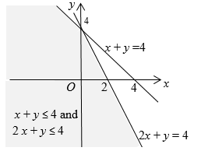

When you sketch a line you must indicate the intercepts on the axes but no scales are required.

The point (0, 0) is in both regions as *x* + *y* = 0 + 0 ≤ 4 and 2 *x* + *y* = 2 × 0 + 0 ≤ 4

**2.** Find the intercepts of the line .

When *y* = 0, 

When *x* = 0, 

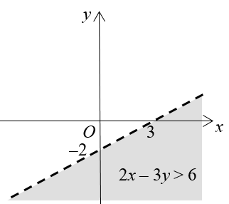

Check the point (–1, 0) for 

 so (–1, 0) is **not** in the region.   
 So shade and label the region below the dotted line. (Note that the line is dotted as it is not included in the region.)

**3. (a)**

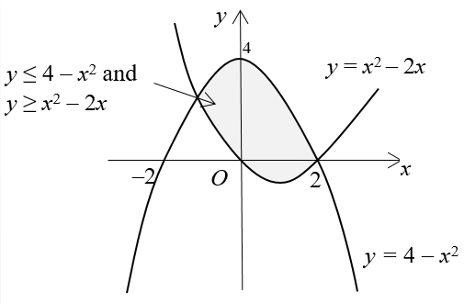

*y = x*2 – 2*x* = *x*(*x* – 2); when *y* = 0, *x* = 0 or *x* = 2

*y =* 4 – *x*2 = (2 + *x*)(2 – *x*); when *y* = 0, *x* = –2 or *x* = 2

when *x* = 0, *y* = 4 – 02 = 4

The point (1, 0) satisfies both equations and is therefore in the region.

**(b)** The diagram shows that the smallest value of *x* can be found where the curves intersect.



So the smallest value of *x* is –1.

**4. (a)**

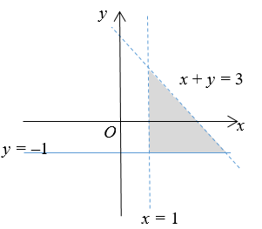

The required region is the shaded triangle, the lines *x* = 1 and *x + y =* 3 are not included*.*

**(b)** The points on the line *x* = 1 are not included, so look at the points with *x* = 2. (2, 1) is on the line *x + y =* 3 which not included*.* (2, 0) is in the region, so *n* = 0.

**5. (a)**

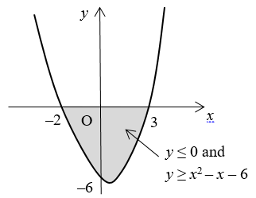

*y* = *x*2 – *x* – 6 = (*x* – 3)(*x* + 2)

When *y* = 0, *x* = 3 or *x* = –2

When *x* = 0, *y* = –6

The line *y* = 0 is the *x-*axis and *y* ≤ 0 is below the *x*-axis.

(0, –1) is in the region as –1 ≥ 02 – 0 – 6

**(b)** The smallest value for *y* is on the minimum point of the curve, where *x* = 0.5 as the curve is symmetric. So the smallest value for *y* is *y* = 0.52– 0.5 – 6 = –6.25