**7.1 Differentiation**

You need to be able to

* sketch the graph of the gradient function for a given curve
* differentiate from first principles

**The gradient function**

When you sketch a gradient function you need to look for

* stationary points
* parts of the curve where the gradient is positive
* parts of the curve where the gradient is negative.

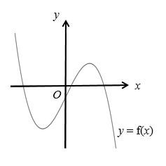

Examples

**Example 1** Thediagram shows the graph of *y* = f(*x*).

Sketch the graph of the gradient function   
 for the graph of *y* = f(*x*).

|  |  |
| --- | --- |
|  | Use the graph of *y* = f(*x*) to construct the graph for the gradient function *y* = f '(*x*). The scales on the *x*-axes are the same; the scales on the *y*-axes may be different.  At the two points marked A, the tangent to *y*= f(*x*), is horizontal and the gradient is 0.  Therefore f ′(*x*) = 0 at these points.  The parts of the curve labelled B and D  have a negative gradient so f ′(*x*) < 0 for these *x*-values.  The part of the curve labelled C has a positive gradient and the gradient function is therefore above the *x*-axis. At the point on the curve labelled C the gradient is the greatest so this is a maximum point on the gradient function. |

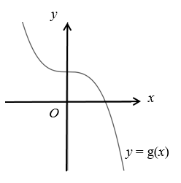**Example 2** Thediagram shows the graph of *y* = g(*x*).  
 Sketch the graph of the gradient function   
 for the graph of *y* = g(*x*).

|  |  |
| --- | --- |
|  | When *x* = 0, the tangent is a horizontal line and the gradient is 0.  So the gradient function, g′(*x*),  is equal to 0.  The gradient function for the  graph of *y* = g(*x*) is always  negative, except where *x* = 0.  So the gradient function is  always below the *x*-axis, except  at the point (0, 0). |

**Differentiating from first principles**

When you differentiate from first principles to find the gradient at a point *A* on a curve, you start by finding the gradient of chord *AB* and then let point *B* get closer and closer to *A*.

*A*

*B*

tangent

When point *B* moves along the curve and gets closer to point *A*, the gradient of the chord *AB* gets closer to the gradient of the tangent.

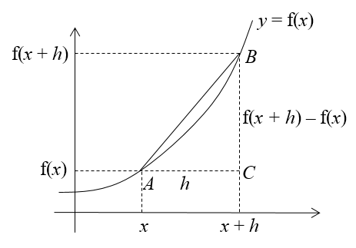First find the gradient of a chord *AB* when *A* and *B* are points on the curve of *y* = f(*x*).

The horizontal distance between *A* and *B* is *h*.   
If the *x*-coordinate of *A* is *x*, the *x*-coordinate of *B* and *C* is *x* + *h*.   
The *y*-coordinates of *A* and *B* are f(*x*) and f(*x + h*).

The gradient of chord *AB* =

As *B* approaches *A* (you write this as *B* → *A*), *h*approaches 0 (*h* → 0) and the gradient of chord *AB* approaches the gradient of the tangent.

This gives the following formula, which is in the formula booklet.



**Note:** You will only be required to differentiate polynomials with small integer powers (up to 3).

where f ′(*x*) is the gradient of the tangent at a point with *x*-coordinate *x*.

Examples

**Example 3** Find from first principles the gradient of the curve *y = x*2 at the point (1, 1).

|  |  |
| --- | --- |
|  | Draw a chord on the graph from  point (1, 1) to a point on the curve with *x*-coordinate 1 + *h*.  This second point has a *y*-coordinate of (1 + *h*)2.  Use a triangle to calculate the gradient of the chord.  The horizontal side has length *h*, and the vertical side has length (1 + *h*)2– 1. (Look at the numbers on the *y*-axis.)  This is the formula for f ′(*x*) with 1 substituted for *x*.  As you cannot divide by 0, you cannot substitute *h* = 0 at this stage.  Expand the bracket and simplify.  Now you can substitute *h* = 0 and find the required gradient. |

**Alternative notation:**



When *h* → 0, 2 + *h*→ 2 and the gradient of the chord → 2.

So the gradient of the curve at (1, 1) = 2

**Example 4** Find from first principles the gradient function of f(*x*) *= x*2

|  |  |
| --- | --- |
|  | A chord has been drawn from the point (*x*, *x*2) to a point with *x*-coordinate *x* + *h*. This second point has a *y*-coordinate of (*x* + *h*)2.  Use the triangle to calculate the gradient of the chord. The horizontal side has length *h*, and the vertical side has length (*x* + *h*)2 – *x*2.  This is the formula from the booklet. As you cannot divide by 0, you cannot yet substitute *h* = 0.  Expand the bracket and simplify.  Now you can substitute *h* = 0 and find the answer. |

**Note:** You do not need to draw the diagram when answering the question.

**Example 5** Prove from first principles, that the derivative of *x*3 is 3*x*2.

|  |  |
| --- | --- |
| So f ′(*x*) = 3*x*2 | First work out the numerator for the formula.  Expand the bracket and simplify.  And factorise.  Use the formula for f ′(*x*).  Cancel *h*.  You can now substitute *h =* 0. |

Exercise

**1.** Sketch the graph of the gradient functions for each curve.

**(a) (b) (c)**

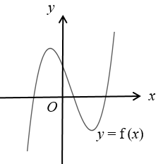 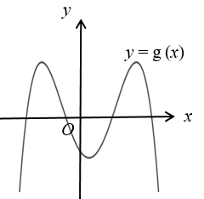 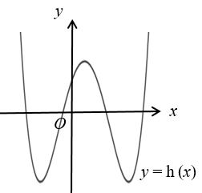

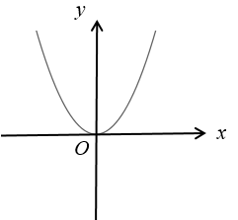**2.** The diagram shows the gradient function of a curve.

**(a)** The original curve passes through the point (0, *c*).   
 Sketch the original curve.

(**b)** On the same diagram sketch a different curve with the   
 same gradient function.

**(c)** How can you transform the first curve to the second curve?

**3.** Find from first principles the gradient of the curve *y =* (*x* + 1)2 at the point (2, 9).

**4.** Find from first principles the gradient function of f(*x*) *=* 3*x*2.

**5.** Prove from first principles, that the derivative of *x*2 + 5*x* is 2*x* + 5.

Answers

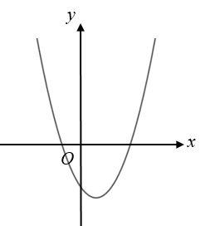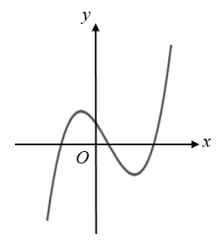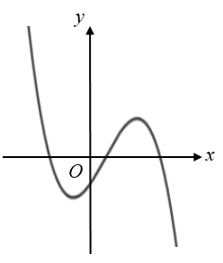**1. (a) (b) (c)**

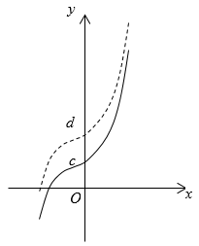**2. (a)** See solid curve on diagram.

**(b)** See dashed curve on diagram.

**(c)** Translation over vector 

**Note.** (0, *d*) can be anywhere on the *y*-axis

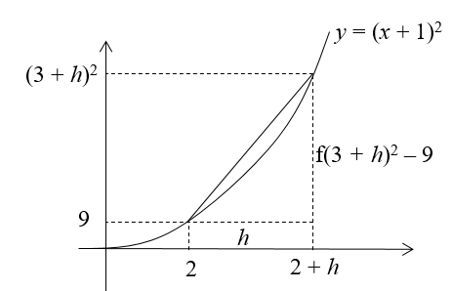**3.** When *x* = 2 + *h*, *y* = ((2 + *h*) + 1)2 = (3 + *h*)2.



When 

So the gradient of the curve at (2, 9) = 6

**4. **

So 

**Alternative method**

Gradient of chord =





So 

**5.** 





So the derivative of *x*2 + 5*x* is 2*x* + 5.

**Alternative method**

Gradient of chord =





So the derivative of *x*2+5*x* is 2*x* + 5.