Welcome in the Name of Christ
Good Shepherd Lutheran Church
439 E. Norvell Bryant Hwy
Hernando, FL 34442
352-746-7161

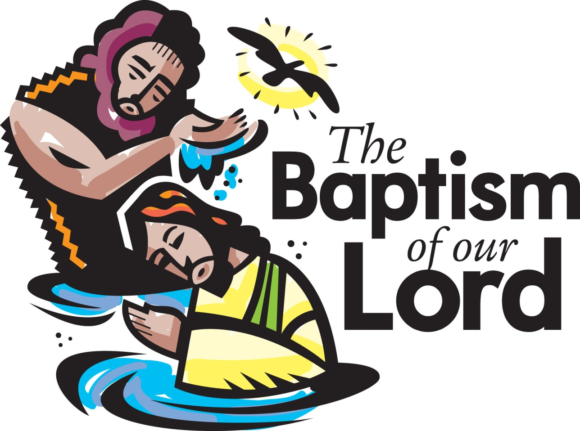

January 12, 2020

The Reverend Dennis W. Koch, Pastor
Reverend William Barrett, Visitation Pastor
Renate Williams Slick, Director of Music, Organist & Pianist
Roger Johnson, Choir Conductor
(Congregation responses are in bold print)

Prelude
Announcements and Welcome

GATHERING
Doxology
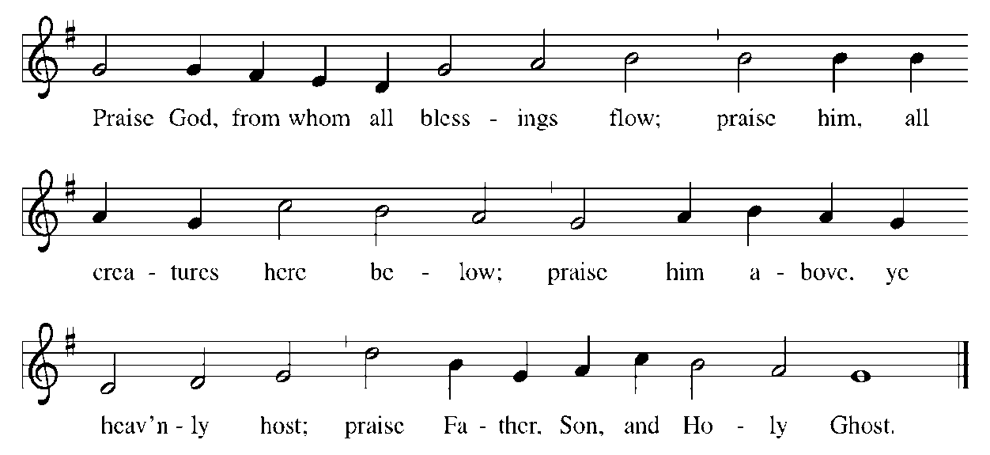
CONFESSION AND FORGIVENESS
All may make the sign, of the cross, the sign, marked at baptism, as the presiding minister begins.

Blessed be the holy Trinity, ☩ one God,
the eternal voice from heaven,
the anointed and beloved one,
the Spirit moving over the waters.
Amen.

As we approach the mystery of God, let us come in confession,
trusting the love of Christ crucified and risen.
Silence is kept for reflection.
God who searches us and knows us,
you have shown us what is good,
but we have looked to other lights to find our way.
We have not been just in our dealings with others.
We have chosen revenge over mercy.
We have promoted ourselves
instead of walking humbly with you.
With what shall we come before you?
Forgive us our sin,
and show us your salvation
in the face of Jesus Christ our Savior.
Amen.

Beloved of God,
you have not received the spirit of the world,
but the Spirit that is from God,
poured out for you in the faithfulness of Jesus Christ.
Receive the promise of baptism:
You are God’s child; ☩ your sins are forgiven.
Rejoice and be glad, for yours is the reign of heaven.
Amen.

Gathering Hymn “Oh, Love, How Deep” ELW 322

Apostolic Greeting
The Grace of our Lord Jesus Christ, the love of God and the communion
of the Holy Spirit be with you all.
And also with you.

Kyrie
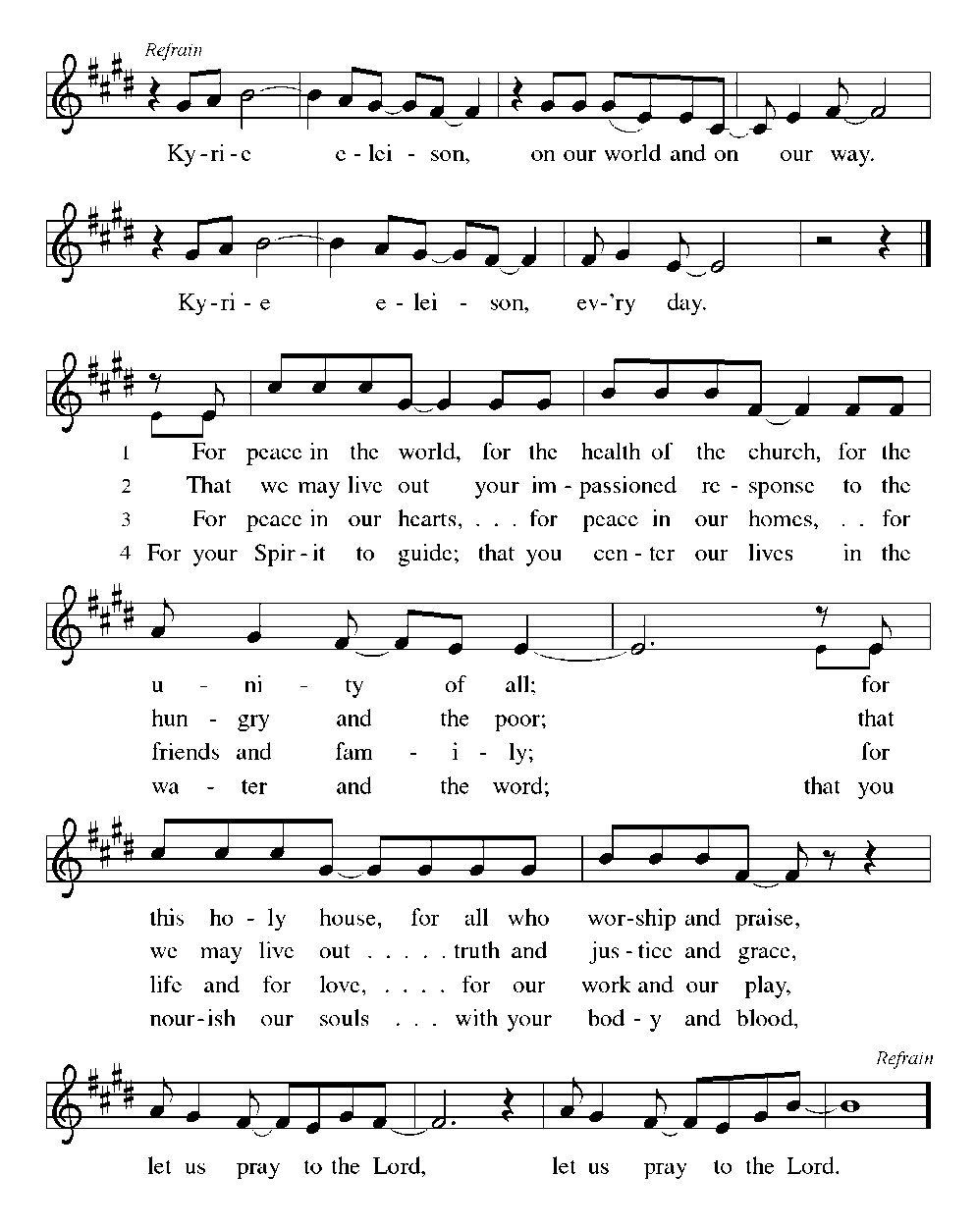
Canticle of Praise “This is the Feast”

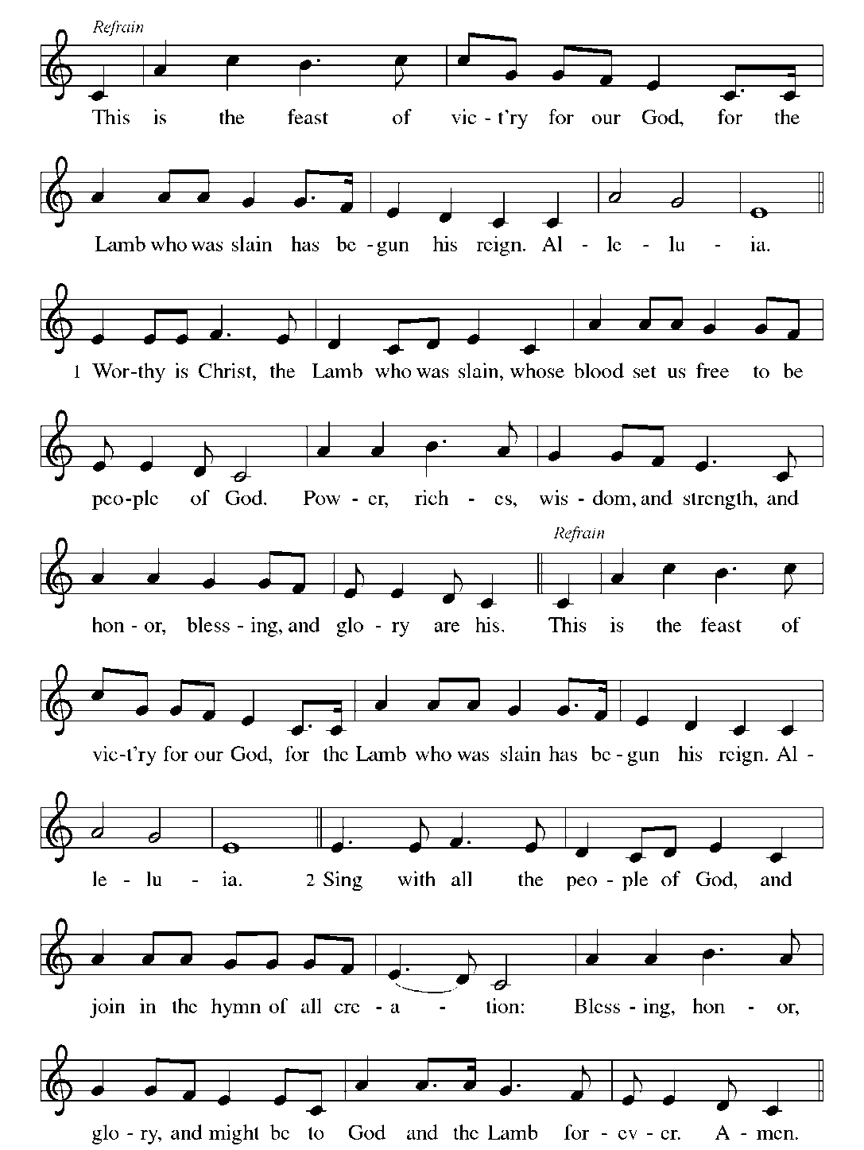
Prayer of the Day
O God our Father, at the baptism of Jesus you proclaimed him your beloved Son and anointed him with the Holy Spirit. Make all who are baptized into Christ faithful to their calling to be your daughters and sons, and empower us all with your Spirit, through Jesus Christ, our Savior and Lord, who lives and reigns with you and the Holy Spirit, one God, now and forever.
Amen.

The assembly is seated

First Reading: Isaiah 42:1-9

¹Here is my servant, whom I uphold, my chosen, in whom my soul delights; I have put my spirit upon him; he will bring forth justice to the nations. ²He will not cry or lift up his voice, or make it heard in the street; ³a bruised reed he will not break, and a dimly burning wick he will not quench; he will faithfully bring forth justice. ⁴He will not grow faint or be crushed until he has established justice in the earth; and the coastlands wait for his teaching. ⁵Thus says God, the Lord, who created the heavens and stretched them out, who spread out the earth and what comes from it, who gives breath to the people upon it and spirit to those who walk in it: ⁶I am the Lord, I have called you in righteousness, I have taken you by the hand and kept you; I have given you as a covenant to the people, a light to the nations, ⁷to open the eyes that are blind, to bring out the prisoners from the dungeon, from the prison those who sit in darkness. ⁸I am the Lord, that is my name; my glory I give to no other, nor my praise to idols. ⁹See, the former things have come to pass, and new things I now declare; before they spring forth, I tell you of them.

The Psalm will be spoken responsively

Psalm: Psalm 29

¹Ascribe to the Lord, you gods, ascribe to the Lord glory and strength.
²Ascribe to the Lord the glory due God’s name; worship the Lord in the beauty of holiness.
³The voice of the Lord is upon the waters; the God of glory thunders;
the Lord is upon the mighty waters.
⁴The voice of the Lord is a powerful voice; the voice of the Lord is
a voice of splendor.
⁵The voice of the Lord breaks the cedar trees; the Lord breaks the cedars of Lebanon;
⁶the Lord makes Lebanon skip like a calf, and Mount Hermon like
a young wild ox.
⁷The voice of the Lord bursts forth in lightning flashes.
⁸The voice of the Lord shakes the wilderness;
the Lord shakes the wilderness of Kadesh.
⁹The voice of the Lord makes the oak trees writhe and strips the forests bare.
And in the temple of the Lord all are crying, “Glory!”
¹⁰The Lord sits enthroned above the flood;
the Lord sits enthroned as king forevermore.
¹¹O Lord, give strength to your people;
give them, O Lord, the blessings of peace.

Second Reading: Acts 10:34-43

³⁴Peter began to speak to [Cornelius and his household]: “I truly understand that God shows no partiality, ³⁵but in every nation anyone who fears him and does what is right is acceptable to him. ³⁶You know the message he sent to the people of Israel, preaching peace by Jesus Christ—he is Lord of all. ³⁷That message spread throughout Judea, beginning in Galilee after the baptism that John announced: ³⁸how God anointed Jesus of Nazareth with the Holy Spirit and with power; how he went about doing good and healing all who were oppressed by the devil, for God was with him. ³⁹We are witnesses to all that he did both in Judea and in Jerusalem. They put him to death by hanging him on a tree; ⁴⁰but God raised him on the third day and allowed him to appear, ⁴¹not to all the people but to us who were chosen by God as witnesses, and who ate and drank with him after he rose from the dead. ⁴²He commanded us to preach to the people and to testify that he is the one ordained by God as judge of the living and the dead. ⁴³All the prophets testify about him that everyone who believes in him receives forgiveness of sins through his name.”

Gospel Acclamation
The assembly stands and sings to welcome the gospel
The Holy Gospel according to Matthew.
Glory to you, O Lord

Gospel: Matthew 3:13-17
¹³Then Jesus came from Galilee to John at the Jordan, to be baptized by him. ¹⁴John would have prevented him, saying, “I need to be baptized by you, and do you come to me?” ¹⁵But Jesus answered him, “Let it be so now; for it is proper for us in this way to fulfill all righteousness.” Then he consented. ¹⁶And when Jesus had been baptized, just as he came up from the water, suddenly the heavens were opened to him and he saw the Spirit of God descending like a dove and alighting on him. ¹⁷And a voice from heaven said, “This is my Son, the Beloved, with whom I am well pleased.”

After the gospel is read,

The gospel of the Lord.
Praise to you, O Christ.

Children’s Sermon / Sermon

Hymn of the Day “Baptized in Water” ELW 456

Apostles’ Creed
I believe in God, the Father almighty,
creator of heaven and earth.
I believe in Jesus Christ, God's only Son, our Lord,
who was conceived by the power of the Holy Spirit,
born of the Virgin Mary,
suffered under Pontius Pilate,
was crucified, died, and was buried;
he descended to the dead.
On the third day he rose again;
he ascended into heaven,
he is seated at the right hand of the Father,
and he will come to judge the living and the dead.
I believe in the Holy Spirit,
the holy catholic Church,
the communion of saints,
the forgiveness of sins,
the resurrection of the body,
and the life everlasting. Amen

Prayers of Intercession
The prayers are led by the assisting minister. Each portion ends with these words:
Lord, in your mercy,
Hear our prayer.
At the conclusion of the prayers,
Amen.

Passing of the Peace
The peace of the Lord be with you always.
And also with you.
The assembly may stand and greet each other and may say, Peace be with you.

MEAL
An offering is gathered and the table is set. Appropriate music may also be offered. As the gifts are brought forward, the assembly stands for the prayer by the assisting minister.

Offering/Offertory Prayer

Dialog
The Lord be with you.
And also with you.
Lift up your hearts.
We lift them to the Lord.
Let us give thanks to the Lord our God.
It is right to give our thanks and praise.

Preface
It is indeed right, our duty and our joy…
…we praise your name and join their unending hymn:

Holy, Holy, Holy
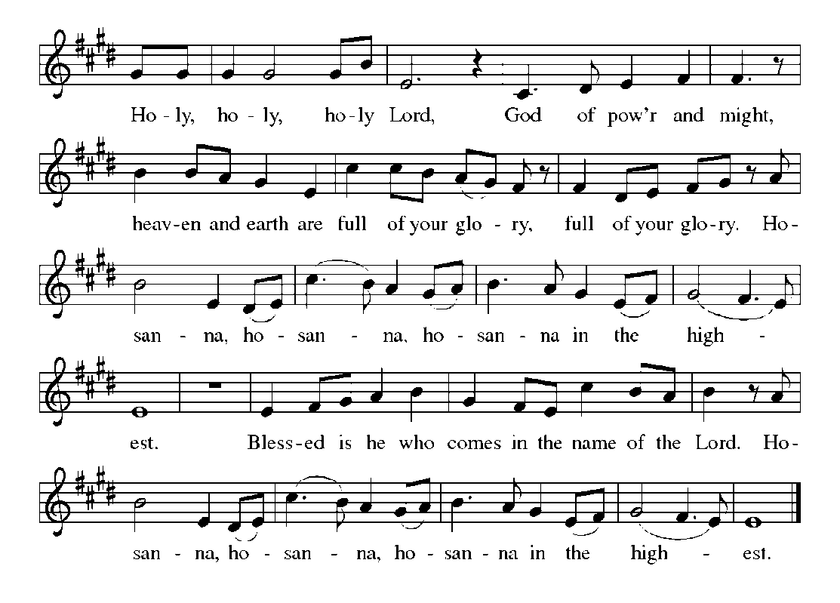
Eucharistic Prayer
Holy One, the beginning and the end, the giver of life …
…Let us proclaim the mystery of faith:
Christ has died.
Christ is risen.
Christ will come again.

…We look with hope for his coming.
Come, Lord Jesus.

… Bring the gift of peace on earth.
Come, Holy Spirit.

… one God, now and forever…
Amen.
And now joining hearts and, if you choose, hands we pray together the prayer that Jesus taught us:

The Lord’s Prayer
Our Father, who art in heaven, hallowed be thy name,
thy kingdom come, thy will be done, on earth as it is in heaven.
Give us this day our daily bread; and forgive us our trespasses,
as we forgive those who trespass against us; and lead us not into temptation, but deliver us from evil. For thine is the kingdom,
and the power, and the glory, forever and ever. Amen.

Invitation to Communion
Here is the Lamb of God who takes away the sin of the world!
Come to the table of mercy and joy.

All baptized Christians, regardless of denomination, are welcome to commune. Children who are not yet communing will receive a blessing.
Lamb of God
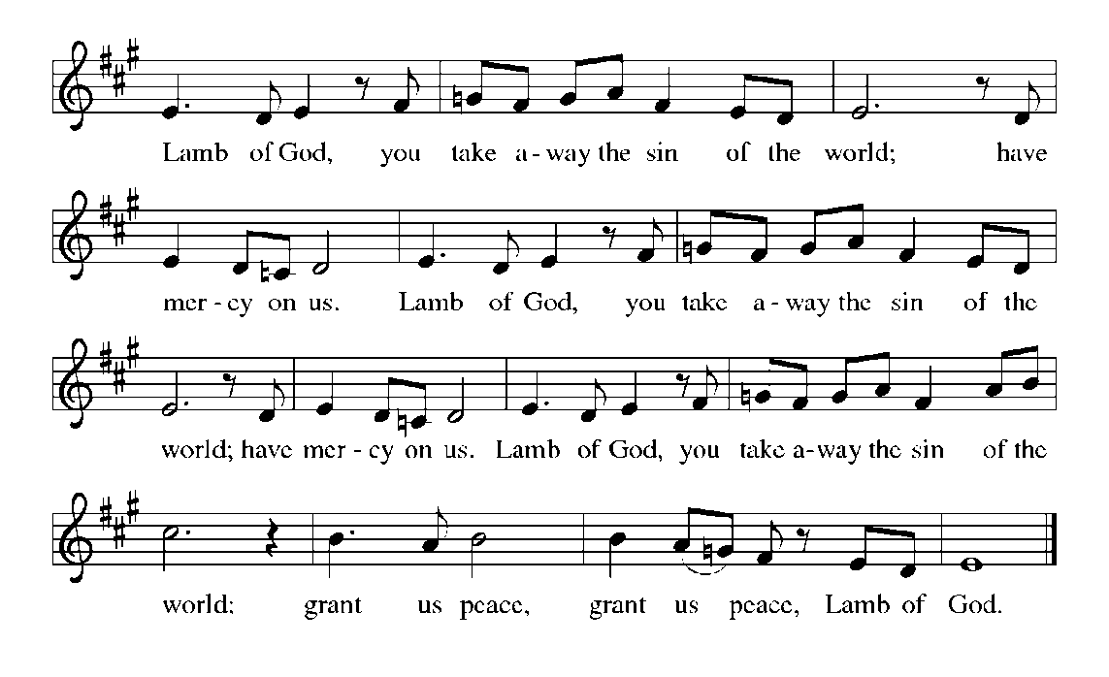
(Please come forward as directed by the ushers. Gluten-free wafers are available. Wine is available by individual cup and a common cup. Grape juice is provided in the center ring of each tray. If you cannot eat the host, or if the grape juice is exhausted, be assured that you fully receive the Risen Lord and his forgiveness even in only one “element.” If you are unable to come forward, please notify an usher and communion will be brought to you.)

Additional Communion Hymns: 814, 800, 608, 677

Post Communion Prayer

Sending of Communion Assistants

Blessing

Recessional Hymn “Wade in the Water” ELW 459

Dismissal
Go in peace. Let your light shine, and have fun doing it!
Thanks be to God.

Music and liturgical excerpts reprinted by permission One License.net #A-722106.
New Revised Standard Version Bible, © 1989, Division of Christian Education of the National Council of the Churches of Christ in the
United States of America. Used by permission. All rights reserved.
WELCOME VISITORS. We extend a warm welcome to all who are visiting and hope you will return to worship with us again.
THIS WEEK AT GSLC
SUNDAY
8:30 & 11:00 a.m. – Worship
9:45 a.m. –Youth & Adult Sunday
School
9:45 a.m. & Noon Equal Exchange
Coffee, Tea & Cocoa Sale

MONDAY
9:30 a.m. – Mary Martha
10:00 a.m. – Bible Study
1:30 p.m. – Fellowship

TUESDAY
8:00 a.m. – Breakfast at Mama’s
Kuntry Kafe
9:00 a.m. – Pastoral Care
11:00 a. m. – Evangelism
11:30 a. m. –AA
6:00 p.m. – Bells
6:30 p.m. – Cub Scouts Pack #975

WEDNESDAY
8:00 a.m. – SOS
10:00 a.m.– Quilters
6:30 p.m. – Choir

THURSDAY
8:30 a.m. – SOS

FRIDAY
8:00 a.m. – Property Workday
1:00 p.m. – Hilltoppers

SATURDAY
9:00 a.m. – 5:00 p.m. -Scouts
Pinewood Derby
WE ARE EQUIPPED WITH A HEARING LOOP Assistive Listening System. Please switch your hearing aid or cochlear implant to “T” during worship. Additional hearing devices are available from the Media Center.

TODAY’S WORSHIP LEADERS, assistants, fellowship teams and volunteers are listed in our monthly newsletter. Our sincere thanks to all!

FLOWERS in the sanctuary today are given to the glory of God.

MUSICAL OFFERINGS TODAY
8:30AM - “Thy Holy Wings” –
The Flock
11:00AM- “Wade in The Living Water” –
Chancel Choir

KEEP THEM IN YOUR PRAYERS
Sheila Mandell, Dawn Clark, Jack Bregger, Ken Swade, Ken Drennen, John D. Colson, Suzanne Mahr, Helen Maidhof, Isabelle Amundsen, Barb Johnson, Dave Boerger, Carol Lee Johnson, Marian McGauran, Arlene, Rowen, Denise, Thomas, and Steve, Victoria, Tylor and Trenton.

Attendance last Sunday
Early 114 Late 86 Total: 200
General Offering $9,031.00

LARGE PRINT BULLETINS available upon request (ask an usher). REMEMBER to silence your cell phone during worship.

ANNOUNCEMENTS

ANNOUNCEMENTS
REMINDER TO ALL – As you enter the sanctuary, please lower your voices so as not to disturb those who are meditating and praying in preparation for worship.

EQUAL EXCHANGE COFFEE, TEA & COCOA is for sale today in the fellowship hall following both services. Please help W/ELCA as they support the farmers sponsored by Lutheran World Relief (LWR).

BIBLE STUDY resumes tomorrow morning at 10:00 a.m. with Pastor Koch and Pastor Barrett. No sign up required.

FELLOWSHIP will meet tomorrow afternoon at 1:30 p.m.

Pastoral Care will meet Tuesday, January 14th at 9:00 a.m. Please contact Dave Sotrines at 860-1765 if you are unable to attend.

EVANGELISM will meet Tuesday, January 14th at 11:00 a.m.

THE QUILTERS will meet Wednesday, January 15th at 10:00 a.m.

HILLTOPPERS will carpool from the church at 12:30 p.m. to dine at Mr. King Chinese Restaurant in Crystal River. Call Louise Olson at 344-4479 with your reservation.

W/ELCA SOAP SUNDAYS are January 19th and 26th. Please help us as we support LWR by bringing in bath size bar soap on these days and leave it in the designated container in fellowship hall.

SOCIAL MINISTRY COMMITTEE would like to know if congregational members need help with simple household tasks, like changing a hard to reach light bulb, lifting, and/or moving household items, repairing a dripping faucet or other routine household tasks. OR are you handy and willing to provide help to members? Whether you need help or can give it, please contact Lynn Bechdolt at labech@comcast.net or leave a message at 276-252-2960.

