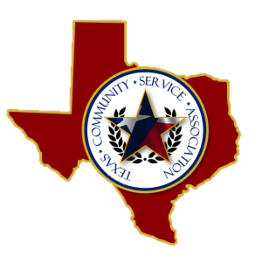

Board of Directors
2015-2018

OFFICERS
President
David L Peters
Smith County Juvenile Probation
Vice President
Israel Tena
El Paso Juvenile Probation

Treasurer
Lonnie Rogers
33rd & 424th Judicial District CSCD

Secretary
Senae Williams
Victoria County Juvenile Probation
Historian
Guadalupe Garza
Bexar County CSCD

BOARD MEMBERS

Santos Aguilar
Gillespie County CSCD

Chris Shirley
Gregg County Juvenile Probation

Joby McDaniel
Cass County CSCD

Rita Garcia
Bexar County CSCD

ADVISORY COMMITTEE

Karla Bautista

M’Leesa Seals

Jared Grimes

Agenda

TCSA SPECIAL BOARD MEETING
Hilton Waco
113 S. University Parks Dr.
Waco, TX | 76701
Contact: Stu Arledge
PH: 254.759.5526 FX: 254.752.7761
Monday, January 27, 2020
8:00 am to 2:00 pm

I. Call meeting to order (over breakfast)
II. Approve minutes provided from Annual Board Meeting 10-16-2019
III. Ratification of previously approved minutes
IV. Status of IRS Reporting- Lonnie Rogers
V. Tour Hilton Waco (9:00 - 10:00 a.m.)
VI. Tour of Holiday Inn Express Waco South (10:00 - 11:00 a.m.)
VII. Tour of Hotel Indigo (11:00 a.m. - 12:00)
VIII. Return to Holiday Inn Board room (12:00 - 2:00p.m.)
1. Financial Report- Lonnie Rogers
2. Sunday Reception
3. Luncheon
4. Door Prizes/Auction items
5. Food Pantry
6. T-Shirts/TCSA shirts
7. Plaques
8. Inventory
9. Conference Agenda topics
10. TCSA Board Pictures
11. Bank Signatures
IX. Discussion/Additional New Business
X. Next Meeting
XI. Adjourn Meeting

