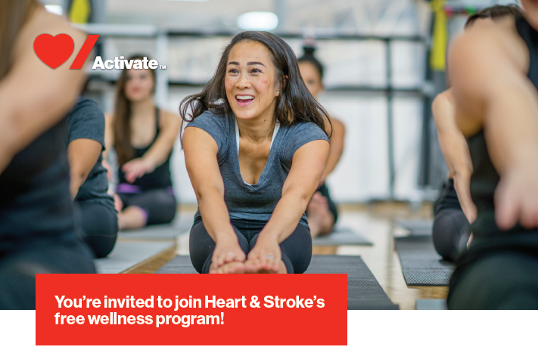
Exciting news, Royal Canadian Legion! Heart & Stroke has brought their free wellness program to the South Western Ontario Region soon!

Heart & Stroke Activate is a free 6-month wellness program that helps you manage your blood pressure for a healthier life. Get everything you need to eat better, move more and manage stress.
Benefits include:
- Online health platform with curated content and trackers
- Support from a personal health coaches and Loblaws in-store Dietitian
- 2-month free membership to YMCA-YWCA locations in the Ottawa Region (for non-YMCA members)
- PC Optimum points to reward healthy behaviour

Activate your journey today!
1. Book your free in-person appointment.
2. Meet a Heart & Stroke trained volunteer in your community and enroll in the program.
3. Start your personal journey to healthier living with Activate tools and resources.

Get everything Activate has to offer if you’re over 40, do not have diabetes, not on blood pressure medication, and have blood pressure between 121-139 systolic (Activate trained volunteers will measure this for you).

Where will Activate be recruiting?
The team will be at the following locations:
- Sun, June 16 (9AM-1PM and 3PM-7PM): YMCA Chatham-Kent (101 Courthouse Ln)
- Mon, June 17 (9:30AM-7:30PM): YMCA Sarnia-Lambton (1015 Finch Dr)
- Tues, June 18 (9:30AM-7:30PM): YMCA Windsor (500 Victoria Ave)
- Wed, June 19 (9:30PM-7:30PM): YMCA Windsor (500 Victoria Ave)

You can drop in, but it’s best to book an appointment by clicking here to ensure a great experience!

Need more information? Visit heartandstroke.ca/activate

Book your free in-person appointment today!

™The heart and / Icon on its own and the heart and / Icon followed by another icon or words are trademarks of the Heart and Stroke Foundation of Canada.

