Agency System Users Guide

Version 3 – May 28, 2006

Executive Summary
This document describes use of the Agency System. This system was built to assist non-profit/501(c)(3) organizations who provide basic human needs assistance to people in their community. These organizations typically provide food, personal care items, diapers, clothes and limited financial assistance. The financial assistance is typically items such as rent assistance to prevent an eviction, utility payment to avoid a shutoff, gasoline money and payment for prescriptions.

The system tracks the clients and services provided to the clients. Various reports are produced. The system also provides for recording information on Volunteers and the hours they provide, donors and the donations they make.

Other Documentation Available
There are two additional types of documentation available:

Agency System Technical Documentation

Step by Step Implementation

Development Timetable

The system was initially installed in November 2004. As of May 28, 2006 there are a total of 12 installations. Several have now been operating for approximately one year.

The system has been continuously updated as problems are encountered and as new capabilities are required to meet United Way Reporting or requested by two or more users of the software.

Applicability

- Basic human needs agency – see above description

- Food Pantry – take away groceries

- Free clothing for needy

- Emergency financial assistance – funding for Rx, avoid utility shutoff, avoid eviction

Limitations

- Oriented to free services. No provision for recording any payments for services.

- Does not register, enroll or record pre-approval of people for programs or services.

- Does not record client visits or contact (except through recording services they may receive and/or the optional entry of notes which can be entered by date.)

.

Information Captured and Reported
The system was designed to allow reporting of demographic statistics for services provided. The following data is maintained for each individual in the household: date of birth, sex, race and whether or not the individual is disabled. The system also records the zip code of the household.

Information about clients includes information on the applicant, other members of the household, education & employment status for the applicant and spouse and total household income and expenses. Each time assistance is provided, the system records the service provided, the amount and for whom the service was provided (entire household or a specific individual). The statistics recorded may represent the entire household, in the case of food or rent assistance, or a specific individual in the household in the case of clothing or a prescription. This allows detailed, accurate statistical and demographic reporting of services provided

Referrals to other agencies can also be recorded. In the event that assistance could not be provided, the reason why the agency was “unable to serve” can be recorded, using standardized descriptions (for statistical reporting) or the provision to select “Other” and then record a specialized comment unique to the circumstances.

Generalized, Table-Driven Logic
Wherever possible, the system was built to be generalized. Much of this is done by control tables. There are tables which define: programs and services, race, age groups, relationship definitions, Zip codes in the service area, marital status, highest education level attained, what kind of ID verification is provided and referral options for other agencies. Interactive forms are provided for easy review and editing of these tables. This allows the system to be customized for each agency while maintaining a common set of Access programs and logic. It also allows for more consistent date entry by allowing these types of data to be selected from drop down list boxes. In the screen examples which follow, fields which have a “downward arrow at the right, as in this example

allow the user to select the proper entry from a predefined list of alternatives.

Potential for conversion from an existing system
If an automated conversion from an older system has been done, the system may provide a link from the new system to the old data, for reference and as an aid in the transition. Note that while a handful of automated conversions have been done, each is unique and such is not provided as part of the free software. I can provide copies of the code used for prior conversions – for use by a knowledgeable Access programmer. Alternatively, I can develop a custom conversion routine for a fee.

Donors and Volunteers
The system also maintains information on donors and volunteers. Each donation may be recorded separately by date and type of donation. Similarly, hours worked by volunteers may be recorded weekly. Reporting of volunteer hours and donations is provided both for the agency and for each individual volunteer and donor.

Context Sensitive HELP
Within the system, there is context sensitive HELP, via F1, for all key forms and selected fields.

Stand Alone or Network Implementation
The system may be used on a single PC, which has Microsoft Access 2000 or later installed. It can also be accessed concurrently from multiple PCs on a local area network or LAN, provided that each PC has the correct permissions and a copy of the Microsoft Access software.

If at all possible, all PCs using the system should be using the same version of Access. This is not a Microsoft requirement, but seems to cut down on “weird problems”.

Also, in a Network Implementation, it is recommended NOT to use Windows 2000 as this seems to make settings for access by other PCs more complex (perhaps based on the author’s limited expertise with Windows 2000).

Recording Phone Calls Received

The system also provides for entry of data on phone calls received by type of inquiry
Main Menu and Summary of Main Menu Options and Overall System Capabilities

This is the Main Menu of the system. It is started automatically when the Access database is opened. It must remain open while the system is being used.

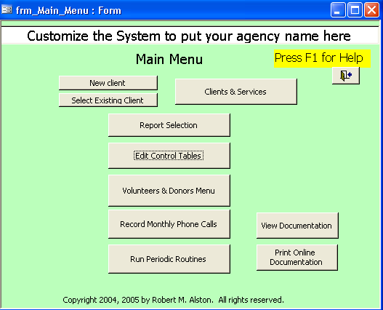

Note in the latest demo, the top right button, “Clients & Services” is not shown. It remains in the full, unrestricted version, primarily for compatibility with older versions of the software. The top left most two buttons provide for equivalent functionality.
There are 10 buttons (9 in the demo program) for key sections of the program.

The top two buttons at the upper left are alternatives to the button at the upper right. They were created to improve the performance of the system in a multi-PC, multi-user version of the system. The two buttons at the upper left can be used as appropriate or you can use the single button at the upper right. User choice.

NEW CLIENT – This is an alternative to the button “Clients & Services” button. It is used only to enter information for a new client. While viewing the new client, you may not go to any other client. To do that you must close the form and return to the main menu.

SELECT EXISTING CLIENT – This is an alternative to the button “Clients & Services” button. It is used to bring up a selection screen to locate an existing client. Once identified, you can go to that client’s information. However, while viewing the existing client information, you may not go to any other client. To do that you must close the form and return to the main menu.

CLIENTS & SERVICES - This is original main entry into the program. From the form that is displayed you can view any previously entered client and/or enter a new client.

For each of the above three buttons you can enter/view information on all clients including the applicant, others in the household, education levels of applicant & spouse, household income & expenses and all services provided. There is also a tab for recording follow-up actions which may be required. When entered, a "See Actions" prompt shows up on the main page. If the system contains converted data, a link to the old system data is included for reference.

REPORT SELECTION - This is where you specify the selection criteria and specific reports to be produced. All reports are presented in preview mode initially and can easily be printed from there. The selection criteria which are applicable to all reports include:
. Date range
. A selected program or "All programs"
. A selected service or "All services"
. A selected client or "All clients"

EDIT CONTROL TABLES - Many of the information which must be standardized are presented via drop-down lists, where the appropriate data is selected. The sources of these lists are tables in the database. They can be added to, modified and deleted via these edit forms. The system has tables for:
. Programs and services offered
. Referrals that can be made
. Race codes
. ID verification
. Highest education level attained
. City/State/Zip
. Marital status
. Relationship types
. Donation types
. Phone call types (for calls received by the agency)
. Phone types (home, work, cellular, etc)
. Standard Actions for Family Action Plans
. Standard reasons why the agency was unable to service the request
. System control parameters - be careful if modifying these!

VOLUNTEERS & DONORS MENU - The system has capabilities to tracks Volunteers and hours provided as well as donors and donations received.

RECORD MONTHLY PHONE CALLS - This selection brings up a form to enter data on monthly phone calls received at the agency using standard types of calls.

RUN PERIODIC ROUTINES - This menu item currently has two functions. One is to run a query that identifies duplicate Social Security codes used anywhere in the system. The other is to provide instructions on how you can export information from the system (ex. To Excel) using built-in Access export capabilities.

VIEW DOCUMENTATION – This button allows you to view and navigate through information on all forms in the system. This is the same information that will pop up when you are viewing a form and press F1.

PRINT ONLINE DOCUMENTATION - This button allows you to print all pages of the online information on all forms in the system. This is the same information that will pop up when you are viewing a form and press F1.

Installation Overview

The full application is provided as a single .mdb file.

The evaluation version is a single .mde file. The evaluation version is limited to 10 clients. If you exceed that at some point the system will erase all client data. So don’t do it!! The evaluation version is locked so you cannot access the logic of the forms, VBA behind forms, reports and modules. But it still runs and shows all the features and capabilities of the system.

The system was built for Access 2003. It can be run on Access 2000 or 2002 provided the database is converted to that format. Sometimes minor changes must be made to the libraries used by Access. It probably will run on Access 97 although it has not been tested in that environment. Contact the author for details.

Simply copy the .mdb or .mde file into the location where you want to keep the database.

I suggest you create a shortcut to the database and place the shortcut on your desktop. You can do this by locating the database using MS Windows Explorer (right click on Start and select Explore). Make sure the window does not fill the screen. Minimize any other open windows so the desktop is seen around the explorer window. Locate the file with Explorer. Right click on the file and while holding down the right mouse button, drag the file to any open place on the desktop. Release the mouse button. Select the “create a shortcut” option. You can now move the shortcut to wherever you want it on the desktop.

Note that there is also a separate, very detailed, step by step installation document. This document covers the very important initial step of customizing all the user definable control tables.

Customization

In many ways the database was built to be table driven, that is, wherever prudent, key specifications of how the system is used is stored as data in tables. This allows different agencies to use the same software but customize it to meet their needs.

To prepare for customization you need the following:

- List of all services offered and the programs under which each service is offered.
  - Identify if the service is financial, meaning that dollars are given (ex. Rent, Rx, utilities) or non-financial (food, clothing, etc).
  - Identify the maximum quantity (number or dollar amount for each service) that will be provided. This is recorded so that you don’t inadvertently enter an erroneous large amount.
  - For non-financial services, decide what unit of measure you want to record the services provided. For example, for Food, do you want to record number of items, number of shopping bags, number of days food provided, or approximate dollar value of the food.
  - Identify if the service applies to the entire family (ex. Food, rent, utilities) or a specific individual in the family (ex. Clothing, Rx)
  - Optionally identify the standard amount of time used to screen clients receiving this service. Such standard figures much be developed by recording the actual amount of time required, for a number of times each service was provided. A statistical average can be calculated. If this is entered into the system, reports of services provided can also tabulate the administrative time required for eligibility screen, based on standard times.
  - Decide the sequence in which you want the services to be shown in drop down list boxes when you are recording services provided. The initial data provides sample services with sequence numbers of 10, 20, 30…etc. Such numbering is highly recommended as it will allow easy insertion of new services later on without need for renumbering.

- List of City, State and Zip codes serviced by the agency. This is key for demographic statistics.

- Referrals that can be made – What other agencies do you make referrals to? The system allows for entry of one referral each time a service is provided.

- Race codes – what race definitions do you use? You can designate up to 7 race codes, single character each, with a text description. When selecting race in a drop down list box both the single character and text description are shown. When stored on the form and in the database, only the single character is recorded. Race code 8 is always “O” for Other. The system is limited to 7 race codes plus other due to the “buckets” for recording the number of people by race in each household.

- ID verification – What options do you allow for verification of ID and Address?
The system has a table for standard types of ID verification which are allowed at an agency.

- Highest education level attained – what education level terms do you use?
The system has a table which allows you to store standard education levels from which you can select for the applicant and spouse.

- Marital status codes – any specific status terms you like to use?
The system has a table which stores standard definitions of marital status for the applicant/client

- Relationship – Do you have standard terms used for the relationships of people in a household?

- If you are going to record statistics on phone calls received, what standard categories for phone calls received do you want to use?
The system provides a capability of entering counts of phone calls received by type of call.

- For the applicant, what standard definitions of Marital Status do you want to allow?

- What age groups do you need to report services data? The system allows for up to 8, mutually independent age groups. This allows you to record data using one set of groupings as well as an alternate set of age groups, providing the total number of groups do not exceed 8.

- Donations - If you use the part of the system that tracks donations, this table allows you to define standard types of donations.

- Phone types - For volunteers and donors, there are two fields for phone numbers. For each field, you can designate the type of phone number that has been recorded (ex. Home, work, cellular, etc.). This table lists the standard types of phone numbers that you can pick from when entering a phone number

- Standard Actions - The system provides for follow-up items for each client. These can be unique to the situation or can be standard, likely as part of a family action plan or similar. This table allows you to store standard actions to make them easily available , to avoid typing and ensure consistency for reporting.
Actions can also be used for miscellaneous follow-up items, for the Agency to be sure to do, the next time the client requests services.

- Reasons Unable to Serve
The system limits entry to selections from a predefined list.

.

With this information gathered, start the system by double clicking on the .mdb or .mde file. When the main menu is shown click once on the “Edit Control Tables” button. This brings up the following menu:

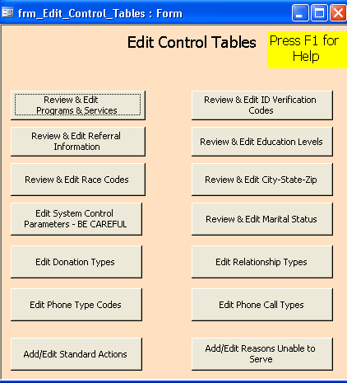

Click on each button, leaving the “Edit System Control Parameters – BE CAREFUL” button for last. Review the initial data in each table and modify as needed to meet your needs.

If you need assistance on basic Access database conventions, please see Appendix I or on the main menu, click on the “Documentation” button at the lower right of the main menu.

Review & Edit Programs and Services

This is a key table in the system! It defines the Programs at the agency and also lists Services associated with each program. Data on services provided to clients is tracked by client, service and quantity. These can be aggregated to the Program level.

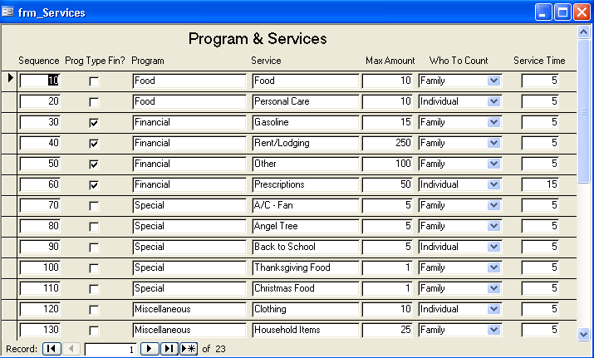

SEQUENCE - This is the sequence in which the services are listed in the drop-down list box when recording services provided.

PROG TYPE FIN? This indicates whether the Program/Service is financial, dollar amounts provided, or non-financial which comprises all goods provided. This indicates which drop-down list, under which tab, the service is listed.

PROGRAM – This is the name of the program. You will also enter the related service that is part of this program. One program may hve one or more services. Service names must be unique. Services are recorded as provided and can be totaled by Program.

SERVICE – This is the specific service, for the designated Program. This must be a unique name used only once (cannot reuse the same service name under different programs). This is the basic building block for recording the services you provide. You record the service, who was served (family or individual in a family) and the quantity of the service which was provided.

MAX AMT - Allows you to specify a maximum amount that can be recorded for any service. If you do not intend to use this, please set to 9999. Each time a service entry is made for a client, the amount provided entered is validated and must be less than or equal to this amount.

WHOTOCOUNT - Specifies whether the service applies to the entire Family or to an Individual. If an Individual, this is the key to the logic to ensure an individual is selected when the user makes the entry for this service being provided for a client. It also specifies what statistics are to be collected in the service record - RACE, SEX, Disabled and Age. The system will record statistics for the Family or the selected individual, as appropriate.

Note that if you ever have to modify this table, while in process of entering a service for a client, you will have to either 1) stop the processing of entering the service for the client and close the Clients & Services form. Reopen it once the changes are completed. Alternatively, 2) you can a) Click on “Records” and then “refresh”; and b) change the service to something else, then again, select the desired service (that you just modified). This enables the system to pick up the other parameters for the service that you may have just entered or changed.

SERVICE TIME – If you have determined standard time durations for screening clients, by type of service requested, you can enter the standards here. Reports of services provided include totals of screening time, totaled by type of service.

Edit System Control Parameters

The system control table edit form looks like this:

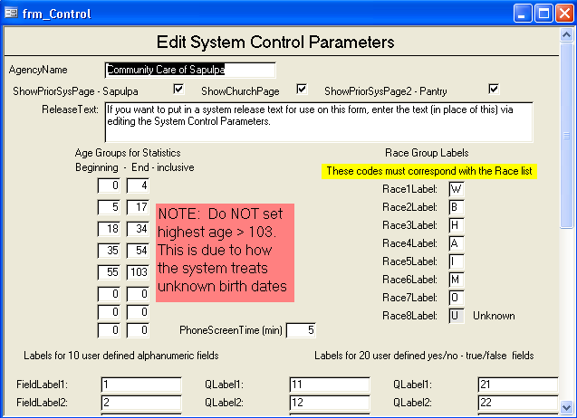

In it you specify:

AgencyName – as it will appear on the Main Menu and other forms.

ShowPriorSysPage - Sapulpa– check this box only if you the Sapulpa agency and converted data from another system and want the data available in this system on a read only basis.

ShowChurchPage – check this box only if you are a church and converted data from another system and want the data available in this system on a read only basis.

ShowPriorSysPage2 - Pantry – check this box only if you converted data from another system and want the data available in this system on a read only basis.

ReleaseText – If you want to use the Client Information form (which can be printed from the main client information form) as a release form, enter the text of your release in this box. It will be shown at the end of the client information report.

Age Groups for Statistics – The system counts the number of individuals in each household by various age groups. Services provided also report the number of individuals served by age groups – these age groups.

Note that these age groups can overlap. That way you can actually have more than one set of age groups which differ slightly. In the above example of the form page, you could add the following groups, if slightly different age groups were required for a funding source:
55 – 65
66 – 103 (same as “66 & over”)

It is important that these get established correctly up front. They can of course be changed. However, there is no method provided for recasting the historical data.

Race Group Labels – In addition to a control table containing a drop down list box of race codes and descriptions, to be selected when entering information about the applicant and each other member of the household, the system calculates counts of the total number of persons in the household by race code. Here you must enter the race group label for up to 7 race codes. NOTE THAT THESE MUST AGREE WITH THE CONTROL TABLE OF RACE CODES.

Phone Screen Time (min) – If you have established standard times for handling phone inquiries, you can enter the standard time here. The report on phone calls will include calculations of time spent screening callers at standard.

Labels for 10 user defined fields – The system provides 10 fields (alphanumeric 255 characters max) that can be user defined. Here you enter the labels that you want for the fields.

Labels for 20 user defined yes/no – true/false fields - The system provides 20 yes/no fields that can be user defined. Here you enter the labels that you want for the fields.

Delete Test Data

If the system has any test data in it, now is the time to delete it. You need to delete test clients and test volunteers/donors.

Open the database.

1)Delete client test data:

On the main menu click on the “Clients & Services” button.

Notice the number at the bottom “of xxx”. The xxx shows the number of records in the database.

On the record shown, left click on the vertical border of the form. The border should turn black.

Press the delete key on your keyboard.

If asked to confirm the delete, click “OK” or “YES”.

Repeat this until there are no more records.

2)Delete Donor & volunteer data:

Click on the Volunteers & Donors button on the Main Menu

Click on the Volunteers & Donors button on the Volunteers & Donors Menu

The number in “of xxx” shows how many records need to be deleted.

On the record shown, left click on the vertical border of the form. The border should turn black.

Press the delete key on your keyboard.

If asked to confirm the delete, click “OK” or “YES”.

Repeat this until there are no more records.

Set Access Database Settings

Click on “Tools” then “Options” then select the “Edit/Find” tab.

Make sure the radio button in front of “General Search” is selected.
This option allows searches to search all fields stored for a client (except information on others in the household and prior services provided).

Click on “OK to close the form.

Initial Backup

This would be an excellent time to run your backup procedure!

Be sure to verify that the correct version of the database was backed up. You can check some of the parameter tables to confirm that. You can also confirm that there are no client records in the database.

Entering Information for a New Client

This is one of the most used forms of the system. To enter information for a new client, select the “Clients & Services” button on the Main Menu.

Now click on either the “New client” button or select the >* button on the bottom row. Either will take you to a blank form, for entering a new client.

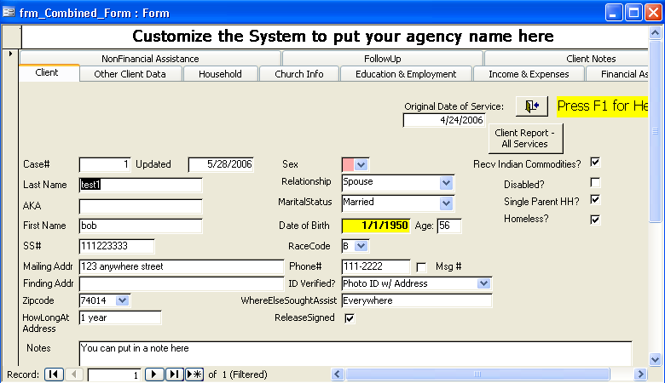

Note that the upper left Find, New Find, Select Client, Select Dependent and Select Case# will only be displayed if the upper right main menu button “Clients and Services’ is selected. Otherwise, different selection capabilities are provided.

The form consists of up to 11 tabs for information about this client.

Often when entering a new client, you want to setup the new client with just the required data to allow recording the services you are providing. The rest of the information can be entered later.

Key Data for a New Client

The key data for entering a new client includes basic name information as well as various data used for statistics. Specifically

Client’s last name
Client’s first name
Client’s Address
Client’s sex
Client’s date of birth (to calculate age)
Client’s race
Client’s disability status
Client’s zip code

In addition you need to enter key information for each other person in the household. These are entered on the tab labeled “Household”.

Other person’s last name
Other person’s first name
Other person’s sex
Other person’s date of birth (to calculate age)
Other person’s race
Other person’s disability status

It is important that you add this information before you enter any record of services. The reason for this is that the statistics on the services provided are captured when the service is entered. If the service is for an individual, the sex, date of birth and race of the individual are needed for the statistics, along with the family zip code. If the service is for the family, then the sex, date of birth and race for all members of the household are needed, again along with the zip code of their address.

Entering Remaining Information for a New Client

In addition to the key data for entering a new client, you also need to enter ALL of the information for the new client. This involves entering information on the following tabs of the frm_Combined_form form:

- Client
- Other Client Data
- Household
- Church Info
- Education & Employment
- Income & Expenses
- Financial Services
- Non-financial Services
- OldPantrySystem
- Client Notes
- FollowUp

Each is discussed below

Client Tab
The key client data listed above is key and must be entered before any recording of services is done. However, there is a lot of other information that should be entered on this form.

Note that where appropriate, choices are provided using drop-down list boxes. These are used for:

Zip code
Sex
Relationship
Marital Status
Race

These lists are established unique to the particular agency. They can be customized as required. To do so, follow the instructions for “Edit Control Tables”.

Note also that the forms are setup to allow you to use the TAB key between fields. It follows the left most column first, then the next column. When you press tab and reach a field with a drop down list box, the box automatically opens up allowing you to select the desired entry. You can alternatively click within the box (not the “down arrow”) and the list will also open up.

Some fields are mandatory. The system will not let you enter a new client without a value for these fields. If you forget to enter a mandatory field, an error message is displayed and you are returned to the form to enter the missing information.

When you have completed entering all of the information for the new client, you can print a report of all information entered, including all services entered to date, by pressing the “Client Report – All Services” button.

After completing entry of the information on this tab, proceed to the Household Tab to enter information on others in the household.

Other Client Data Tab
This tab is for a page of user defined data. The system provides for 10 alphanumeric fields of up to 255 characters. The user may define the label for each field via the System Control edit form. Once done, the fields will have labels which are unique to your requirements.

The system also provides for 20 yes/no (or true/false) data fields. Again the user may define the label for each field via the System Control edit form. Once done, the fields will have labels which are unique to your requirements.

One use for the yes/no fields being proposed on a handful of agencies is to use them to record “risk factors” for the clients being served. These can then be reported as part of the service statistics. In fact, the Service Statistics #2 report was developed specifically to provide such.

Household Tab
This tab allows you to record information on all others living in the household. In most cases the entries are pretty straightforward and similar to entries made for the client.

The inactive flag is used for established clients for whom a household member is no longer in the household. This allows the information to be retained, but no longer shown in statistics.

This form allows for others in the household to have a different last name than that of the client.

If the system contains information converted from a prior system, there may be information immediately following the table listing others in the household. This is the case for Sapulpa. For Sapulpa, key fields from the prior system are shown:

Prior System – spouse – spouse first name and optionally age and optionally the ssno

Prior System – Ages of others in the household and optionally the age of the client listed first in parens

Prior Systems – Names of others in the household

This is provided to assist in straightening out errors that may occur when converting prior system information. IF the option to “ShowPriorSysPage – Sapulpa” is unchecked in the system control table, the above three fields are not displayed.

The final section of this tab is a section of statistics on the persons in this household. Counts of people by race, sex, agegroup and disability status are recorded.. It is updated automatically by the system whenever information on the client tab is changed and/or information on others in the household is changed.

??????<<It is also recalculated immediately before recording services provided (as age groupings may have changed).>> ???????

You can also request the statistics to be recalculated by pressing the “Calculate Statistics” button.

Church Info
This tab shows church affiliation. You can set a parameter via the System Control page, to not display this tab unless it applies to your installation.

Education & Employment Tab
In this tab you can enter education and employment information for both the client or applicant and spouse, if applicable.

The options in the drop down list box for “Highest Level Education” can be established as desired for the agency using the “Edit Control Tables” function.

The other fields allow free form text entry.

Income & Expenses Tab
This tab allows you to enter details of income – by source – and expenses – by type – for the household. The unit of measure is up to you but most likely monthly works well. If desired, you can enter the household monthly income as a single value in the first income field.

There is provision for one “Other” income amount and description and two such entries for expenses.

The system calculates the totals automatically.

Note that this information is for all persons in the household, combined. There is no provision for entering the information separately for each member of the household.

Financial Services Tab
See below in section “Entering Services for Clients”.

Non-Financial Services Tab
See below in section “Entering Services for Clients”.

Prior System Tab
If the system contains converted data, this tab may provide access to the converted data. The data is read-only and frozen as of the date of conversion. It is provided for reference only. You can set a parameter to not display this tab unless it applies to your installation. Whether or not this tab is shown is controlled by the “ShowPriorSysPage – Sapulpa” parameter setting in the System Control file.

OldPantrySystem Tab
This tab shows data from the original system of a Food Pantry which was converted to this system. You can set a parameter to not display this tab unless it applies to your installation. Whether or not this tab is shown is controlled by the “ShowChurchPage” parameter setting in the System Control file

Follow Up Tab - (useful for recording formal action plans)
This tab allows you to enter reminder notes of actions to be taken with this client in the future. The date can be entered manually or the system will automatically enter the current date if left empty. The text can be whatever you want. If these are short term, reminder messages, they can be deleted when completed or resolved.

When a client has one or more entries here, a “See Actions” field, highlighted in red, will appear on the first tab for the client information. Clicking on that field will take you directly to this tab.

This tab can also be used to record a formal ‘family action plan” and provide a permanent record of the plan and status. The items can be marked as completed and the date of completion recorded. While the system does not presently produce reports of the actions recorded here, such can be added without much difficulty.

Client Notes tab –
This tab allows you to enter an unlimited number of dated notes, each of which can be up to 65000 characters in each entry. Optionally the name or initials of the author can be entered.

Entering Services for Clients

Note that before entering data on services for new clients, it is critical that key information for the client and others in the household be entered first. This is necessary to provide the demographic and statistical reporting required. See the section “Entering Information for a New Client”.

Entry of services provided is divided into two groups of services – Financial, where dollar amounts are provided – and Non-Financial – food, clothing and everything else that is not dollars. Each category of service is entered in a different tab. But the tabs are quite similar.

Financial Assistance

You can leave the date field blank and the system will automatically enter today’s date. If catching up data entry, you can enter the date of service.

Each entry is made up of two lines. Most fields on the top line. The bottom line consists of two fields, colored Red for entry of the reason why the client was unable to be served and Green for entry of free form comments.

The Service Requested drop down list box shows only Financial services. It is important that this be selected before completing other information on the form.

Quantity requested and quantity provided should be self explanatory. If the agency is unable to serve the client as requested, it is important that the quantity requested is recorded. Of course, in such a case, the quantity provided must be zero.

Check # and “1st time” (the service was provided) are optional entries, based on the needs of the agency.

The “Who Served” field is a key field for statistical reporting. Each service is defined as being either for the FAMILY as a whole or an INDIVIDUAL. This is done in the Programs & Services control table. When the service is for the FAMILY, statistics for the entire family - # persons, age groups, sex, race, disability status and zip code are recorded as part of the service record. If the service is for an INDIVIDUAL, you need to select the specific INDIVIDUAL, either the client or APPLICANT (always denoted by the generic term “Applicant”) or the first name of someone else in the household. Except for the client/Applicant, the drop down list is customized to show the first name of each member of this household. The system then records the statistics for that specific individual as part of the service record.

The system has checks to ensure that you have selected the correct type of “Who Served” for the service provided.

Agency Referral allows recording information about a referral you may have made to another agency. Only one agency referral can be recorded for a given service record..

Unable to Serve – This field at the left of line 2, having a red background, can be filled with a text description of why. The description must be selected from a drop down list box of predefined reasons. If none apply, select “Other” and enter a specific explanation in the adjacent comments field. Also, when this field is used, the “Amt Provided” must be zero.

Comments field, on line two with a green background, allows for entry of any other comments you may want. For example, in the case of clothing, you may want to record exactly what clothing was provided.

When the Financial Assistance tab is displayed, the system tries to ensure that at least the last two services are listed and there is a place to enter a new service. Note that you can scroll through all prior Financial services which have been recorded.

Non-Financial Assistance

Works generally the same way as the Financial Assistance tab.

Note that it is important that each agency determine the unit of measure for each non financial type assistance provided. How do you count food provided? Clothes? The unit of measure is not explicitly stated but for the reports to be meaningful, entries must be consistent.

Editing Client Information

Editing client information is essentially the same as for entering it the first time. So be sure to read that section for information.

A key difference is in locating the client you want to edit. There are multiple ways to do this.

The primary method of selecting a prior client, is to select the second button at the upper left of the main menu, “Select Existing Client”. This brings up the following selection menu where you can select all matches by a combination of last name, and/or first name and/or social security number. You can do this for client information or for information on others in the household.

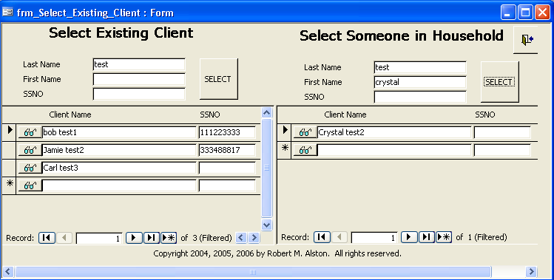
Enter the selection criteria in the correct half of the form and then press “Select”. Scroll through the matches shown above. When you find the desired existing client, click on the “eyeglasses” icon to bring up the full detailed form for that client.

An alternative method is to select the button “Clients and Services” at the upper right of the Main Menu. Using the resultant form, you can select existing clients using the following three drop down list boxes:

- Select Client drop down list box

- Select Dependent drop down list box

- Select Case number from the drop down list box

You can also use either of the following two buttons which causes pop up selection screens to be displayed:

- FIND Button

- NewFIND Button

Select Client via drop down list box –

Simply click into the blank box and the drop down list will appear. You can optionally enter one or more letters of the last name and the list will change to show entries beginning with those letters. Once you have found the desired individual click on the name in the list.

Select Dependent via drop down list box –

Simply click into the blank box and the drop down list will appear. You can optionally enter one or more letters of the last name and the list will change to show entries beginning with those letters. Once you have found the desired individual click on the name in the list.

Select Case# via drop down list box –

Simply click into the blank box and the drop down list will appear. You can optionally enter one or more digits of the case# and the list will change to show entries beginning with those numbers. Once you have found the desired case# click on the case# in the list.

FIND button

Clicking this button brings up a search box where you can enter any number or text. When you click “Find Next” the system will search the information in the Client, Education & Employment and Income Expenses tabs – for all clients – for the entered text or number. Note it does not search the Household members’ information nor the history of prior services.

It is possible that there will be more than one match for the text or number you entered. So if what is initially displayed is not correct, click “Find Next “ again. A quirk of the way the Find works is that you will find the same client repeatedly – first on the Client tab, then on each of the other tabs. So just keep pressing “Find Next” until you go to the next individual.

NewFIND Button

Clicking this button brings up a search box where you can 1) search by name or social security number or 2) select a person by name.

- Search by Name or Social Security Number - This search covers all names and social security numbers of clients and others in households. Click the large FIND button. Next enter the name or social security number(no dashes) and click “Find Next”. The result is shown at the bottom of the form “frm_Search_and_Select”. Repeat clicking “Find Next” as required.

- Click in the blank drop down list box and start typing the last name of the desired individual. The list will scroll automatically to people who name starts with those characters. Once you have found the desired individual, select with a left mouse click or press enter. If the name is of a client, you will be redirected to the client’s main tab. If the name is of a person in the household of a client, you will be redirected to the listing of that person in the “Household” tab of the client with whom this individual is associated.

Once a prior client has been selected, the same general form having multiple tabs for information on the client is displayed:

Editing a Previously Entered Service for a Client
You can edit/correct information for a previously entered service. However this is not advised as the statistics for the individual or family that exist at the time of the change will be captured and replace the data captured at the time of the original entry. However, if the service entered is wrong or some other service error, this risk may be worth the correction.

Just go to the client and scroll thru the historical services. Change whatever needs changing.

Note that this is the only way to correct for family statistics or individual statistics which are recorded at the time the service is entered. To force the system to recapture the statistics, from the statistics in the system at the present time, find the previously entered statistic. Change the service type to something else. Then change it back. The system captures the statistics on race, age and sex at the time the service type is selected.

Enter Information on Volunteers and Donors

As noted earlier the system allows you to maintain information about Volunteers and Donors. In addition to the information about these individuals, the system also allows for recording information on donations made and volunteer hours worked.

To enter information on a new Volunteer or Donor or to update information, from the Main Menu, select Volunteers & Donors Menu. Then on the next menu, again select Volunteers & Donors.

If a new individual, click on the “>*” button to start a new entry. Otherwise, Click on the “>” button to find the desired one.

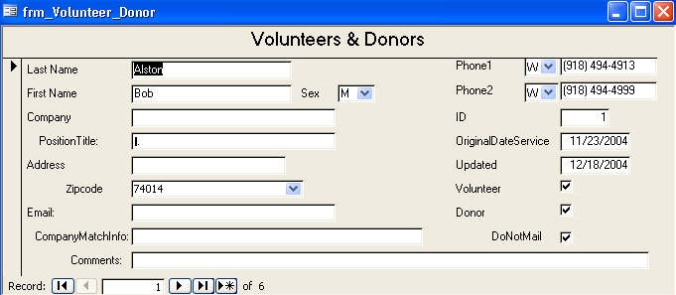

Be sure to note whether the individual is a Volunteer, a Donor or both.

For phones, you can enter two phone numbers. The system allows you to select the type of phone number from several options.

Enter Donations
To enter donations, from the Main Menu, select Volunteers & Donors Menu. Then on the next menu, select “Donors & Donations”.

Click on the “>” button to move to the Donor’s record.

The system will show at least the last two donations and space to enter a new donation.

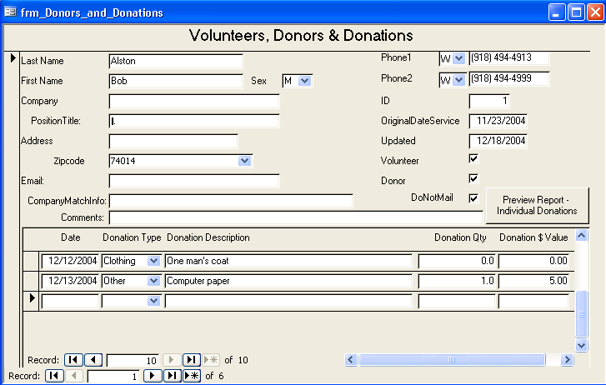

You can enter the date or leave it blank to let the system use today’s date.

Select the “Donation Type” and enter a text description.

Enter the quantity and estimated value.

For a report of donations from this individual, click on the “Preview Report – Individual Donations”.

Enter Volunteer Hours Worked

To enter the hours worked for a single individual, on the Main Menu, select Volunteers & Donors Menu. Then on the next menu, select “Volunteers & Hours”.

Click on the “>” button to move to the volunteer’s record.

The system will show at least the last two entries for hours worked and space to enter a new donation.

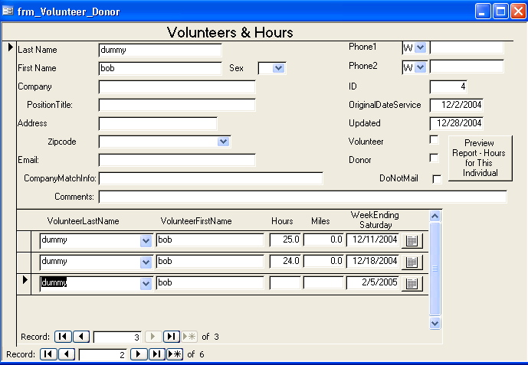

Note that the new entry line is pre-filled with the last and first name of the volunteer. Also the system has assumed that the date for the new entry is the upcoming Saturday. You can enter another date, provided it is a Saturday, in the field or select it from the popup calendar.

All entries of time are for a week ending on Saturday.

The system prevents duplicate entries. It also prevents entries for weeks beyond the current one and more than one week ago.

Enter Volunteer Hours – More Than One Volunteer

Some agencies will likely keep a volunteer time sheet manually and then total the hours for entry at the end of the week.

If you are entering volunteer time worked for more than one volunteer, , on the Main Menu, select Volunteers & Donors Menu. Then on the next menu, select “Enter Hours for All Volunteers”.

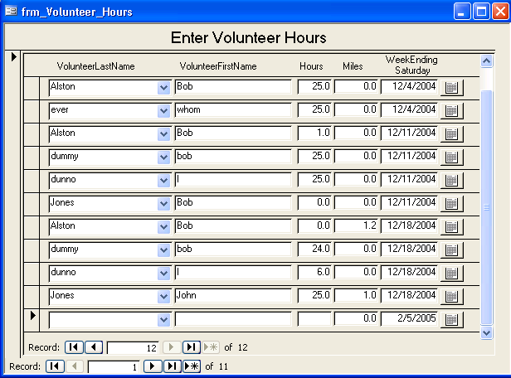

The system will show prior volunteer hours in ascending date sequence with a blank line for entry of a new entry.

Select the last name of the volunteer from the drop down list box. The selected person’s last name and first name fields are filled.

Enter the hours worked for the week and optionally enter any miles driven.

The system guesses that the entry is for the week ending this Saturday. You can change that by entering another Saturday date or selecting another Saturday date from the popup calendar.

The system also verifies to avoid duplicate entries.

Running an Individual Information and Services Report for a Client

You can easily print an individual client report, containing the information on the client and others in the household and the services provided.

To do so, follow the procedures in the section “Editing Client Information” to select the desired client. Then on the “Client” tab, click on the button “Client Report All Services”.

Running Reports

From the system main menu, click on the “Report Selection” button.

The following screen is displayed:

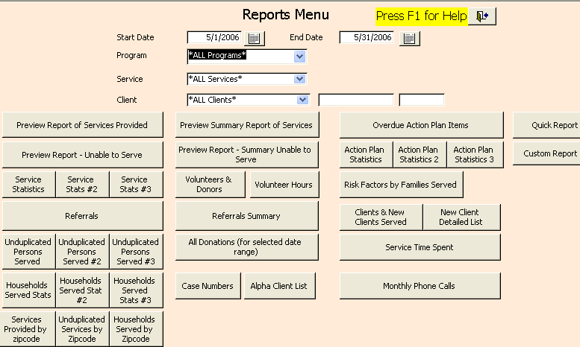

NOTE: The information which follows can be obtained when this screen is displayed by pressing the F1 key.

Report Selection - This is where you specify the selection criteria and specific reports to be produced. All reports are presented in preview mode initially and can easily be printed from there. Selection criteria applicable to all reports includes:

. Date range

. A selected program or "All programs"

. A selected service or "All services"

. A selected client or "All clients"

DATE RANGE - This is automatically set by the system to facilitate monthly reporting. If the current day is in the first half of a month, the date range initially set is for last month. Conversely if the current date is in the last half of the month, the date range is set for the current month.

Dates can be changed by entering a valid date. They can also be changed by using the pop-up calendars and then selecting the button to store the current date on the calendar.

If either date field is not a valid date, the date criteria are not used and data covering all dates is selected.

PROGRAMS - A specific program can be selected. When done, all services for that program are reported (unless of course, a specific service is also selected below).

SERVICE - A specific service can be selected. Normally either a program or a service would be selected but not both.

CLIENT - A specific client can be selected. Once selected, the client's first and last names are shown as well as the client's case number.

Once all selections have been properly set, any report selected will have its data limited by these selections.

Each report includes the application selection criteria in the heading of the report.

- Report of Services Provided

- Unable to Serve

- Service Statistics

- Service Statistics#2

- Unduplicated client service statistics

- Run Query - Services Provided by Zip Code

- Clients & New Clients Served

- Kids Kloset Customers

- Summary Report of Services

- Summary Unable to Serve

- Volunteers & Donors

- Volunteer Hours

- All Donations (for selected date range)

- Case Numbers

- Monthly Phone Calls

- Service Time Spent

Record Monthly Phone Calls

The system provides a very basic way of entering the volume of incoming calls. The user can specify categories to be used for segregating phone calls. The system was intended to enter calls by month, but it would seem any other interval would also work, provided there are not duplicates for a single date.

Since it may be advisable to report the time spent in answering phone inquiries, the system allows entry of a standard number of minutes for an incoming phone call. The report will use this value to compute the number of minutes for the specified number of phone calls.

Run Periodic Routines

Presently, there are only two periodic routines available:

- Report of Duplicate Social Security Numbers
This reports lists duplicates in groups. For each individual listed, it indicates if the person is an applicant or a member of another household, and if so, the name and case number of the applicant for that household. Since there may be legitimate reasons for someone to show up twice in the system, duplicate ssno errors are just warnings when a new ssno is entered. This report provides a way to see all duplicates in the database.

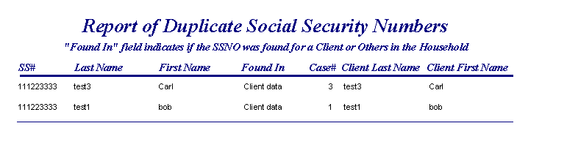

- Export Data
The export form which pops up has information on how to do exports. At this time, three queries have been developed for the purpose of exporting data. They are all named “qry_Export…”.

View Documentation

This button provides a form that you can use to page thru all of the documentation which is available online via F1. Each page indicates the form and, where applicable, the specific field or “control” for which the documentation applies.

The initial page shows contains general information about the Microsoft Access conventions which apply to the entire system.

Print Online Documentation

This button allows you to print all the documentation which you can view via the above button, and which is available in the system via F1.

Appendix A – Microsoft Access Database Conventions

This information can also be obtained by clicking on the “View Documentation” button on the Main Menu.

MENU DRIVEN - This system has a hierarchical menu based design. A main menu and sub-menus to help navigate through the system.

NEVER close the Main Menu unless you are shutting down the system. There are hidden fields on the Main Menu needed for proper operation of the system.

The Access Database system has some standard, built in conventions that apply to all systems built with access. The following sections describe some of these.

RECORD TO RECORD MOVEMENT.

At the bottom of any Form having more than one record of information, there are a series of "movement" icons that help you move between records. These include:

|< Moves to the very first record
< Moves to the prior record
## Shows the number of the current record. You can also enter a specific number to move to that record.
> Moves to the next record
>| Moves to the last record
>* Moves to a blank record when you can enter a new record.

Note that there is no predefined sequence to the records. When you enter a new record, it is at the end of the records. When you return later, it very likely is not the last record in the list. This is due to the Access database. Simply select the client or search for the client.

CHANGING THE SIZE OF A SCREEN -
Some screens may be less than the full size of the PC screen when opened. For many forms this is fine. If not, you can often move the cursor to the top/bottom or side until it changes to a "two-headed arrow" like " <--> Then right click and hold down the mouse click and drag the form to resize.
Alternatively, you can click the "square box" next to the "red x" at the upper right of the form. This will enlarge the current screen object to full screen size.

CLOSE THE CURRENT SCREEN DISPLAY
To close the current window on the screen, click on the "red X" at the upper right of the form or report or other screen being displayed.

UPDATES in Access are generally automatic. When data has been entered or changed, at the upper left of the form, you can see the image of a pencil. That means new data has been entered and not yet written to the database or that changes have been entered and not yet written. When you move to a new record, these updates are written automatically. If you want to "undo" any of these "pending updates" click on the "counterclockwise arrow" on the top bar of the screen.

DELETE RECORDS
In access records are deleted by clicking on the vertical border at the left of the screen. When it turns black hit the delete key. Usually you must confirm a deletion.

NETWORK ACCESS to the database. This system can be accessed by any authorized PC on a local area network (LAN) which is properly authorized and has a copy of Microsoft Access installed.

CANNOT SEE THE ENTIRE REPORT?

To enlarge the report, click anywhere in the report. This should expand the report, if the cursor looks like a "magnifying glass". If the report text is larger but you cannot see the entire report, click on the "box" in the upper right of the report, to enlarge the report to full screen.

PRINT A REPORT
To print a report that is currently displayed, first check to make sure that the report is fitting on the page correctly and not spilling over to another page. Click on the ">" key at the bottom of the report and go to page 2. If page 2 is like page 1 then there is no spillover. Click on the printer icon at the top of the screen or select FILE and then PRINT.

ERROR YOU CANNOT RESOLVE
Sometimes a unique sequence of events will leave you in a situation where you cannot complete entry of the current record. In that case, click the red "X" at the upper right of the form you are viewing. You should get the same error message one more time. Click "OK". Then you will get the message "YOU CANNOT SAVE THE RECORD AT THIS TIME". Click "YES" and the form will close. The last record, you were working on is not saved. Prior additions or changes to other records were completed and saved.

FIND Options - The FIND button by default provides a most general search, searching all fields of client data (excluding info on services provided historically and info on others in the household). The target text or number can be any part of any field. If this gives you too many matches, you can change the FIND options to specify only find matches that match at the START OF FIELD or only matching the WHOLE FIELD.
Note that the same name may be displayed multiple times, once found, as the FIND option finds the last name on each page of the multi-page form. Just keep pressing the FIND NEXT button.

CHANGES TO CONTROL TABLES - Changes to control tables are not effective immediately if you have another form already open. Before adding new entries to CONTROL TABLES, close any other open forms. If necessary enter a temporary value, close the form, make the CONTROL TABLE change, then reopen the form and make the final change with the new control table entry in the drop down list box.

Appendix B – Technical Documentation

Note that there is a separate technical documentation document which includes information about Visual Basic routines used in processing events associated with Forms, Modules, Macros and specific techniques and approaches used.

This is provided with the full, unrestricted version of the software.

Appendix C – Report Examples

<provided in the full users guide>
About the Developer

Bob Alston is a long time volunteer for the United Way and a 30-year veteran of the computer profession. He spent 10 years as a systems consultant with a “Big 8” consulting firm. Most of his past 20 years as been as the Chief Information Officer (CIO), the top “IT” person in corporations ranging from $1 to $7 billion in annual revenues and has managed IT organizations of up to 400 persons. He has worked primarily in the manufacturing, wholesale distribution and specialty retail sectors.

Bob has always had a “technical” orientation and one method of focusing this interest has been his use of the Microsoft Access database and development environment. Bob has used Access to build budget development & tracking systems, project tracking and reporting systems, a job search contacts & opportunities tracking system and various utilities.
Bob can be reached at bobalston9@yahoo.com

