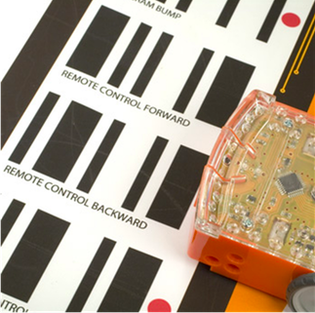
To start: Get the Ed Workbook:
https://meetedison.com/content/EdBooks/EdBook1-Barcodes-and-Edison.pdf

- Place Edison above the arrow on the right side, facing the barcode
- Press the record (round) button 3 times
- Wait while Edison drives forward and scans the barcode

What happens? Describe how it works?

Try a different one:

What happens? Describe how it works?

Go to the Ed Workbook and try more codes.

