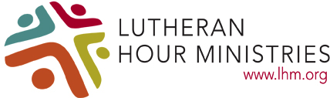

Guidelines for Selecting an LHM New Family Rep 2019

The New Family Rep. should:

Have a loving relationship with the Lord. The ministry of bringing Christ to the nations, and the people to Christ, will mean more to someone who has a love for the Lord, as well as a love for souls.

Be a member of, and actively participates in, an LCMS congregation in the North Wisconsin District.

Have knowledge of Lutheran Hour Ministries and the LLL OR be willing to learn how LHM may benefit them, their family, and their church, such as:
- Project Connect: Booklet display ministry resource
- The Lutheran Hour: Radio program bringing Jesus’ story of salvation to homes and the
world.
- Para el Camino (For the Journey): The Lutheran Hour adapted into Spanish
- Video-Based Bible Studies & Resources – 30+
- Daily Devotions: Sent to your email address (also, seasonal devotions for Advent & Lent)
- Men’s Network: Empowering men of today
- On-line Mission Trips – Geared toward parochial schools
- International Ministry and Global Impact: Centers located around the world

And hopefully share their experience from the Convention and the knowledge of these resources with their home congregation and others who may request them.

Be open to prayerfully becoming more involved in LLL/LHM.

Have a desire to make a difference. Be enthusiastic about missions. Be willing to share their experience with others.

No age limit. Just willingness to grow in faith and love of God’s Ministry!

