Iota Phi Theta® Fraternity, Inc.
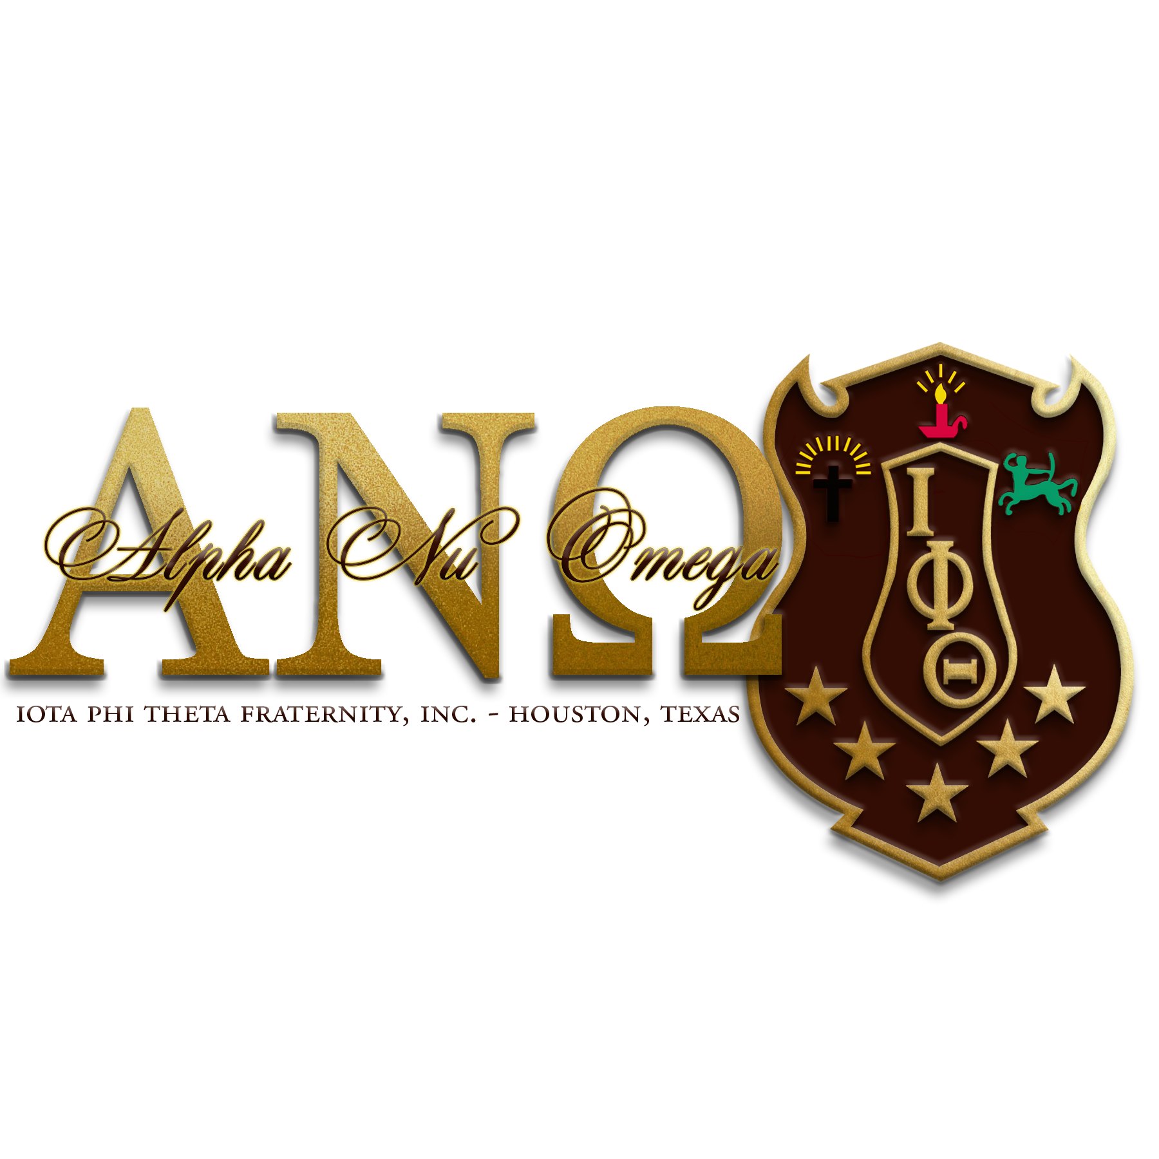
Executive Board
2016-2018

Ryan Johnson Sr.
Polaris

Freddie Green Jr.
Vice Polaris

Justin S. Manuel
Secretary

John Allen
Treasurer

Alpha Nu Omega Alumni Chapter
P.O. Box 542123
Houston, Texas 77254

November Meeting Minutes
November 10, 2018

Call to Order
The meeting was called to order by Polaris Ryan Johnson, Sr. at 10:21 am.

Prayer
Vice Polaris Freddie Green, Jr. led the brothers in prayer.

Recitation of Stars
Brother Baron Gates led Recitation of Stars.

Adoption of Agenda
Vice Polaris Green Jr. moved that we adopt the agenda with flexibility, that motion was properly seconded by Bro. John Allen (Motion Carried)

Approval of Minutes
Secretary Justin Manuel moved that the minutes be approved with the necessary corrections, that motion was properly seconded by Vice Polaris Green Jr. (Motion Carried)

Treasury Report
The treasury report for this reporting period includes 2 expenditures for a total of $1600.00. The payments were made to NPHC-Houston for 2019 Dues in the amount of $350.00, and a deposit for the Black Owt 5.0 in the amount of $1250.00. There are 2 deposits of $858.36 and $426.02 for a deposit total of $1284.38.

Community Service
The next chapter community service events will be Breakfast with Santa on December 1 and Evening with Santa on December 14, 2018.

Social
The next social event is the Black Owt 5.0 on December 8, 2018.

Membership
No reports.

IYA
No Reports

NPHC-Houston
The NPHC-Houston will host 2 community service events. Breakfast with Santa on December 1, 2018 at Blue Triangle Multi-Cultural Center, and December 14, 2018 at the 5th Ward Multi Service Center from 6:00pm-8:00pm. Also on December 8, 2018 there will be a Big Awesome Book Sort at the Region 4 Education Service Center. There are 55 volunteers needed.

The Christmas Meeting and Dinner will be on December 10, 2018. The chapter is responsible for bringing corn for dinner.

Undergraduate Chapter Report
Epsilon Alpha
The chapter is preparing for the end of the semester and NPHC Week.

Scholarship
The BlackOWt 5.0 will be held December 8, 2018 at 7pm. We will be handing out 2 scholarships. Brothers please note this is not a gala, after 5 attire is appropriate. Tickets are $55.00 and are available for purchase from chapter brothers or via the chapter website www.houstoniotas.com.

New Business
The brothers who have declared for a position on the chapter E-Board for the 2019-2021 Administration include:

Polaris- Torrie Richardson
Vice Polaris- Justin Manuel
Secretary- Baron Barnes-Gates
Treasurer- Freddie Green Jr.
Membership/Reclaimation- Ryan Johnson Sr.
Community Service- Jarell Miller

Nominations will remain open until the next chapter meeting. If any brothers are interested they can email Polaris Johnson Sr. to declare candidacy. Votes will take place at the December 15, 2018 meeting.

Adjournment
Polaris Johnson, Sr. adjourned the meeting at 11:01 am.

