Iota Phi Theta® Fraternity, Inc.
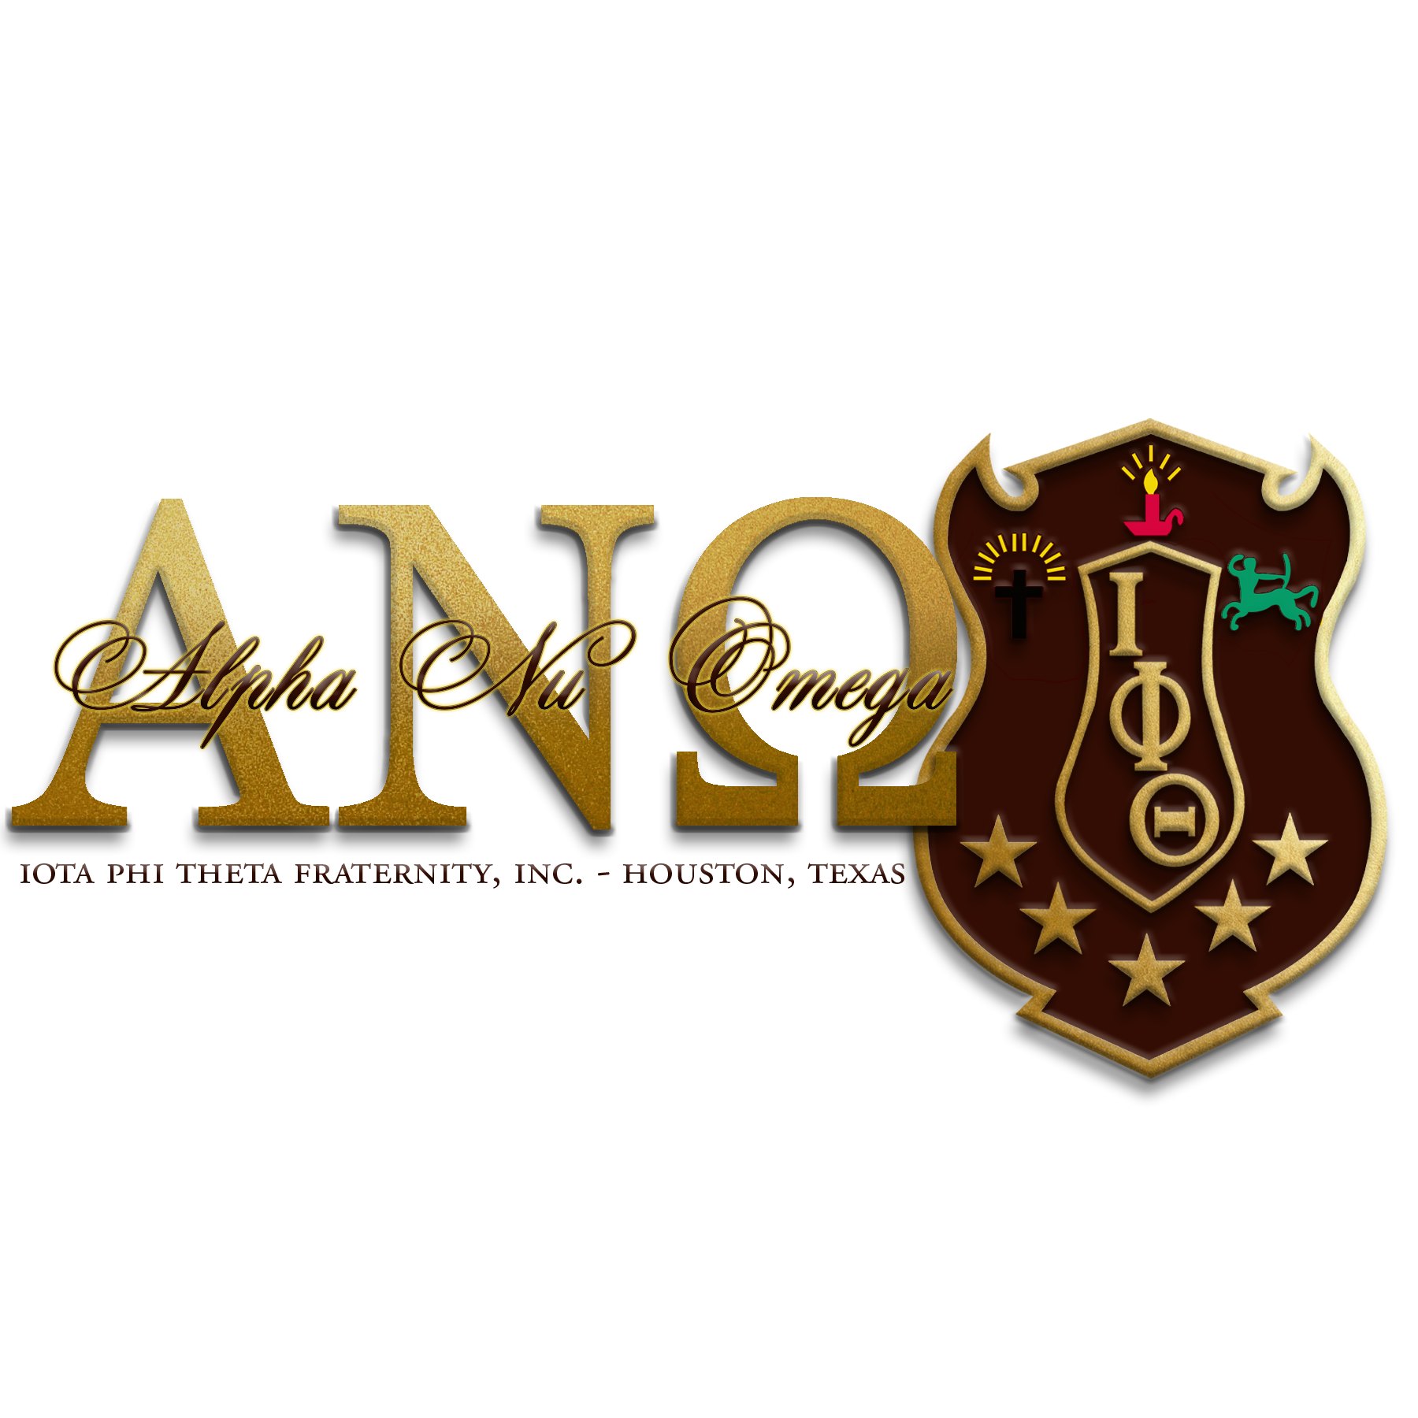
Executive Board
2016-2018

Ryan Johnson Sr.
Polaris

Freddie Green Jr.
Vice Polaris

Justin S. Manuel
Secretary

John Allen
Treasurer

Alpha Nu Omega Alumni Chapter
P.O. Box 542123
Houston, Texas 77254

August Meeting Minutes
December 15, 2018

Call to Order
The meeting was called to order by Polaris Ryan Johnson, Sr. at 10:31 am.

Prayer
Bro. Jarell Miller led the brothers in prayer.

Recitation of Stars
Secretary Bro. Justin Manuel led Recitation of Stars

Adoption of Agenda
Bro. Torrie Richardson moved that we adopt the agenda with flexibility, that motion was properly seconded by Bro. Baron Barnes-Gates (Motion Carried)

Approval of Minutes
Secretary Bro. Manuel moved that the minutes be approved with the necessary corrections, that motion was properly seconded by Vice Polaris Green Jr. (Motion Carried)

Treasury Report
The treasury report for this reporting period has no deposits or expenditures. We currently have $4774.49 in the Chase account. This is money associated with the 2018 REACH for the Stars Scholarship event. We owe Vice Polaris Green Jr. $3369.12 for the event. Also we are responsible for 2 Scholarships of $500.00 each.

Community Service
The chapter did community service with the Houston NPHC for the month of December. We participated in Breakfast With Santa at the Blue Triangle Multi-Service Center. The next community service event will be discussed at the January Meeting.

Social
The chapter social committee will be putting together a few events for brothers to participate in the coming months. A few ideas that have come up are Bowling nights, steak nights, and brotherhood brunch.

Membership
The chapter is currently in good standing for membership intake. Brothers have been charged to participate in the “Bring a Brother Back” campaign for the new year. Each brother said they would work on bringing a brother back to the fold.

NPHC-Houston
The NPHC-Houston is had its End of Year Meeting/Christmas Dinner on December 10, 2018. Bros. Ty Hinton, Freddie Green Jr., and Justin Manuel attended on behalf of Alpha Nu Omega.

A discussion about rotating office position with the Gamma Upsilon Omega Chapter was discussed. The Fort Bend Chapter will be on the board for the next administration.

Bro. Freddie will serve as the Divine Nine Charitable and Education Foundation Representative for Iota Phi Theta Fraternity, Inc.

Undergraduate Chapter Report
Epsilon Alpha
The chapter is financial and in good standing both with the fraternity and school. Currently the chapter no members. We hope to have intake this coming semester.

National/Regional Conferences
The information for Conclave will be coming out shortly. Please check the email account that National HQ has for you.

The Southern Regional Conference will take place March 21-24, 2019 in Austin, Texas. Please check out the Southern Region website for more information.

Scholarship
The BlackOWt 5.0 was held December 8, 2018 at 7pm. The event was successful despite the low attendance from our fraternity brothers. Bros. Green and Manuel did an excellent job with the event but we have to have more brothers buy tickets and attend the event.

New Business
Chapter dues will remain at $125.00. Dues will be payable January 1, 2019-March 1, 2019. After March 1, 2019 a late fee will be applied to chapter dues.

Chapter meetings will be moved to the 3rd Saturday of the month until further notice.

Chapter Elections- the presented slate was elected unanimously. The Alpha Nu Omega 2019-2021 E-Board will be as follows:

Torrie Richardson-Polaris
Justin Manuel-Vice Polaris
Baron Barnes-Gates-Secretary
Freddie Green Jr.-Treasurer
Jarell Miller-Community Service Rep
Scott Dalencour Historian-
Ryan Johnson Sr.-Membership/Reclamation

Adjournment
Polaris Johnson Sr. adjourned the meeting at 11:55am.

