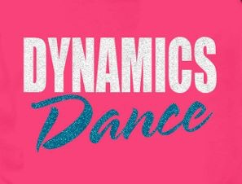  Dynamics Dance works hard to employ qualified, fun, well-rounded instructors who are always furthering their learning as both educators and dancers. Our instructors have been teaching in studios and schools (both public and private) and they are all currently dancing in local dance companies. We regularly attend dance educator conventions and training workshops so that we can bring your dancer a safe, current, structured dance education. Do not hesitate to contact us with any questions!  - Miss Kristen (Dance Director)  Miss Landyn  Miss Kaytlynn  Miss Katie |  |  | Who We Are  About Us  Dynamics Dance is committed to providing an engaging, age-appropriate, structured dance education for various levels in order to grow self-confidant, healthy, responsible dancers and young adults.  Contact Us  Phone: (417) 890-0946  Email: dynamicsdancers@yahoo.com  Web: dynamics-gymnastics.com  DYnamics Dance  3624 West Republic Road  ​Springfield, MO 65807 |  |  | DYnamics Dance  - Try your first class FREE!  - Come dance with us!  - Come dance with us!

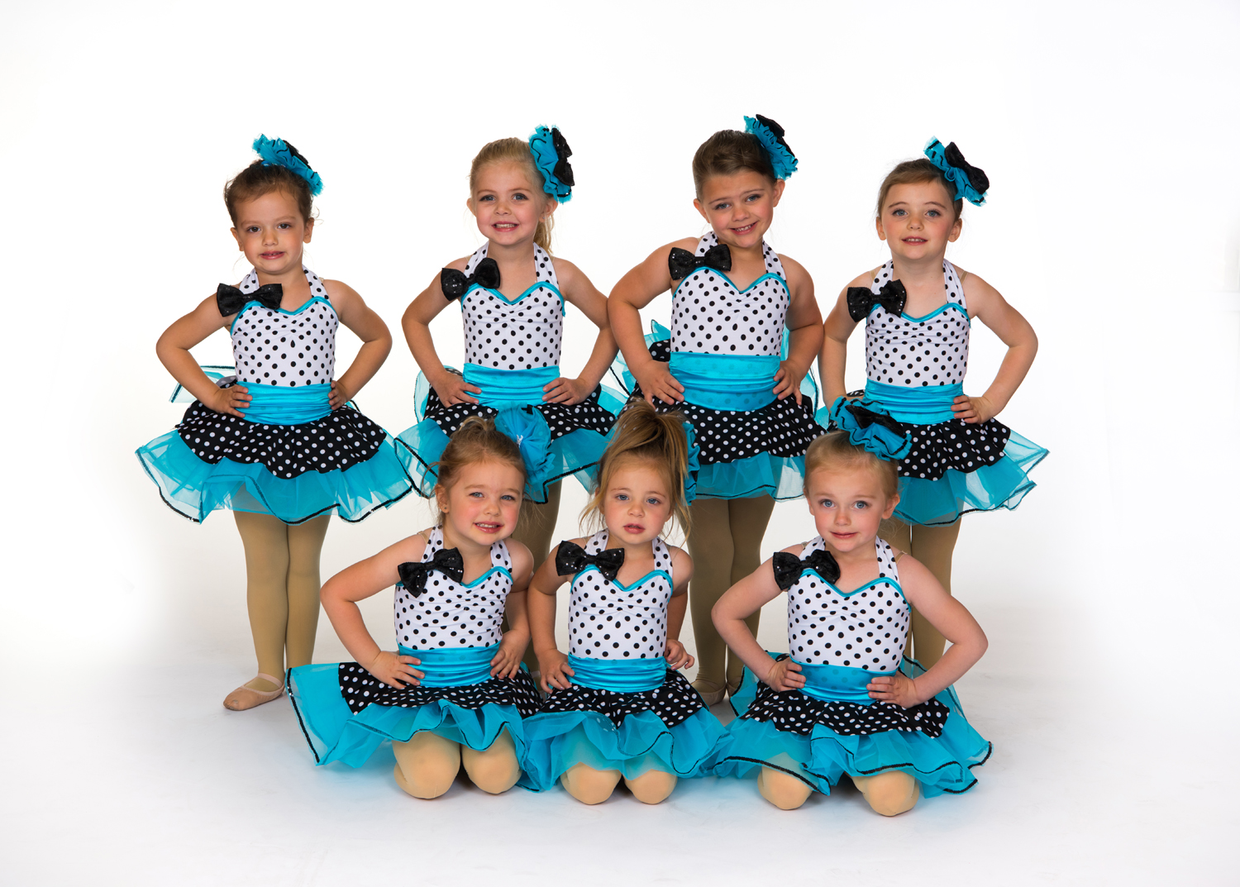  Cost  Annual Registration Fee: $30  1 class: $54/month (Weekday morning classes $39)  Dynamics offers discounts for additional classes and siblings.  Sessions  Dynamics Dance accepts new students at any time. We work around 3 main dance sessions, but tuition is paid monthly. Dancers may drop at any time, however spring costume and recital fees are not refundable.  FALL SESSION  This session ends with an informal Winter Showcase. (Mid August-December)  Spring SESSION  This session ends with a formal Spring Recital. (January-May)  summer SESSION  This session ends with a performance at a Cardinals Baseball game. (June-Mid August) |  |  | Classes Offered  Twirl and Tumble (Ages: 3-4)  Can’t decide what to take at Dynamics? Try out this popular split between ballet and tumbling for your little mover.  Combo I (Ages: 5-8)  Beginner Ballet and Tap combo class  Combo II (Ages: 5-8)  Advanced Ballet/tap/jazz combo class  Ballet i/II (Ages: 9+)  A ballet class designed to teach ballet technique, emphasizing grace, posture, flexibility, and strength.  Tap i/ii (Ages: 9+)  A tap class designed to teach tap technique, emphasizing balance, rhythm, and fine motor skills.  Jazz/Lyrical i/ii (Ages 9+)  - A class designed to teach both jazz and lyrical technique, emphasizing musicality, flexibility, emotion, strength, and stage presence.  Hip Hop (Ages 9+)  - A class designed to teach hip hop technique, emphasizing musicality, athleticism, isolations, and being cool!  Musical Theater (Ages 9+)  - A class designed to teach basic dancing, singing, and acting.  Dance Improvisation (Ages 9+)  - A class designed to encourage creativity, self-expression, and confidence. Dancers will explore the art of choreography and the creation of movement though the elements of dance,  Dynamics Dance team  This team is for dancers who are interested in more classes and performance opportunities. We focus on ballet, lyrical, and jazz. Performances include community performances and local dance competitions.  PRIVATE LESSONS  Interested in learning a custom solo or duet? Dynamics Dance offers private lessons for dancers wanting to perform or compete a solo or duet. Cost is $50/hour. |  |  | 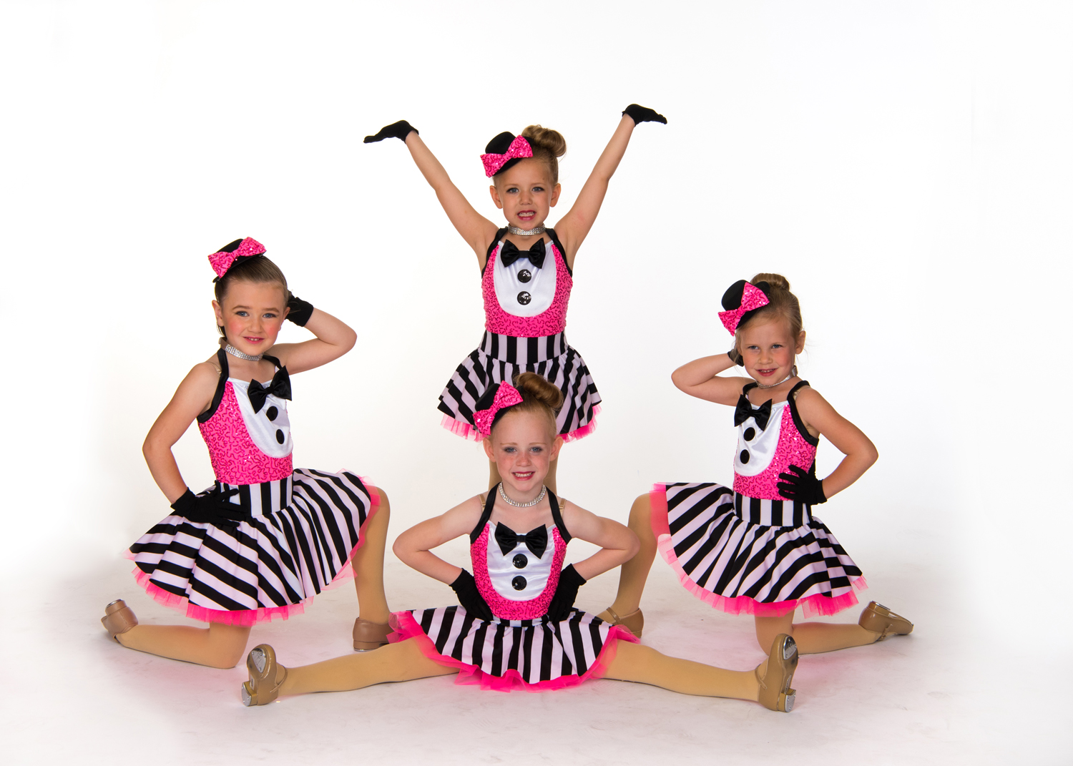  Dress Code  - Twirl/Tumble, Pre-Dance, Dance I Girls: Pink or black leotard (no skirt) with pink or black tights, shorts, or leggings and pink ballet shoes (tan tap shoes also needed for Pre-Dance and Dance I)  - All Boys: black shorts or pants with a white tee or tank and black ballet shoes (and black tap shoes if needed)  - All Level I/II classes: Fitted, style-appropriate dancewear (solid colors preferred) with the appropriate shoes (pink ballet shoes for ballet, tennis shoes for hip hop, tan jazz shoes for jazz/lyrical and musical theater, tan tap shoes for tap)  - Dance Team: Darling team: Light pink and black with tan jazz shoes Diva Team: Hot pink and black with tan jazz shoes and tan lyrical shoes Diamond Team: Bright blue and black with tan jazz shoes and tan lyrical shoes  We sell all the dancewear you need at affordable prices at the Dynamics South Pro Shop!

