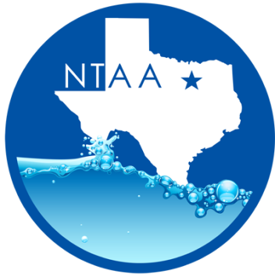
North Texas Aquatics Association Meeting
Friday, January 19, 2018 @ 10:00am
City of Hurst Library
901 Precinct Line Rd
Hurst TX 76053

Minutes

- Welcome – Monica Martin- President
- Introductions

- Approval of Minutes
  - Maria Campbell –City of Arlington
  - Jenna Stevenson – City of Denton

- Program Presentation – Under the Microscope by Monica Martin

- NTAA status update – Monica Martin
  - Spring Seminar: March 28, Lewisville –Monica Martin
    - We are still looking for presenters.
  - 2018 NTAA meeting’s:
      - March , 2018: Spring Seminar: City of Lewisville
      - April 20,2018: City of Plano
      - September 21, 2018 : TBD (Open Election)
      - October, 2018: City of Farmers Branch

- Industry Updates
- ARC update: Jeremy Post
- Learn to Swim registration will is now open!
- Lifeguard Management is all online!
- The ARC store has new manikins and CPR donut mask for sale.

- E&A: - Madison Bass
  - Lifeguard Instructor classes will be held in North Richland Hills Feb 23-25, 2018 and March 16-18, 2018

- NTGG: - Jennifer Kashner

    - Committee members please don’t forget to turn in your activate sheets to Anne ASAP.
    - Next meeting information soon to come.

- TAAF –Jennifer Kashner

  - TAAF Summer Games for 2018 & 2019 will be held in College Station.

- AOAP – Monica Martin
  - Feb 6-9, 2018 Florida
  - 2019 and 2020 will be held in City of Frisco

- TPPC –Monica Martin/Jennifer Post
  - TPPC will be held in Montgomery TX on January 29- February 2,2018
  - Region 1 Rep will be up for election in February.
  - There will be a State Guard Games meeting during this year’s conferences.

- TRAPS – Monica Martin
- TRAPS State will be held in College Station.

Check us out online at www.northtexasquatics.com

