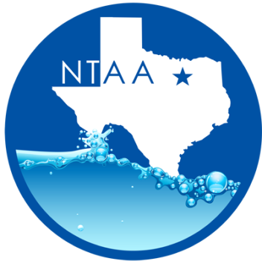
North Texas Aquatics Association Meeting
Friday, April 20, 2018 @ 10:00am
City of Plano
Oak Point Center
6000 Jupiter RD
Plano, TX 75074

Minutes

- Welcome – Monica Martin- President
- Introductions

- Approval of Minutes
  - Ashley MacKay–City of Plano
  - Erin Anderson – City of Arlington

- Hershey’s Ice Cream- Meeting Sponsor

- Program Presentation –AED Reading -by Ashley Mackay

- NTAA By Laws Update and Approval -Monica Martin
  - By Laws where reviewed and approved by the NTAA body.
  - Ashley MacKay- City of Plano
  - Christina Rial- City of Lewisville.

- NTAA Financial Review- Ashley Mackay
  - Ashley changed bank accounts for NTAA. With this change, NTAA is no longer receiving a monthly account charge.
  - Current account balances is $3,729.79

- Industry Updates
- ARC update: Jeremy Post
  - ARC web cast will be taking places next Wednesday April 25, 2018.
  - LTS banners are available! Order today.
  - LGIT Reviews are still needed. If you are interested in holding one, please contact Jeremy.
  - SABA is going away. A new system is in the works.
  - WSI course will be updated in 2019.

- E&A: - Jennifer Kashner
  - Lifeguard Instructor classes will be held in North Richland Hills. One more class left for before the season starts.

- NTGG: - Christina Rial and Kelly Nicole
  - Final review of all events.
  - PD is finalizing the packet.
  - We are still in need of sponsors.
  - Run thought of the events will be taking place on May 10 at 9 AM starting at Oak Point.

- TAAF –Christina Rial
  - Region 4 scholarship is now open.
  - Region 4 swim meet schedule finalized.

- AOAP – Monica Martin
  - 2019 and 2020 will be held in City of Frisco

- WWA- Monica Martin
  - 2019 will be held in Las Vegas

- TPPC –Monica Martin
  - Still working on finalizing next year’s location.

- TRAPS – Christina Rial
- TRAPS State will be held in El Paso
- Looking for great speakers for Aquatics sessions.

Check us out online at www.northtexasquatics.com

