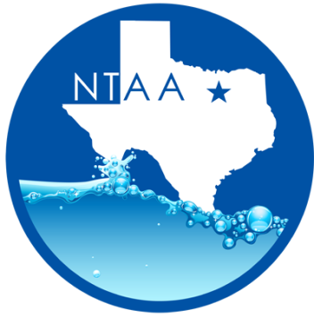
North Texas Aquatics Association Meeting
Friday, April 20, 2018 @ 10:00am
City of Arlington
717 W Main
Arlington TX 76013
Minutes

- Welcome –Ashley Mackay- City of Plano
- Introductions

- Approval of Minutes
  - Rachael Arroyo- City of Farmers Branch
  - Erin Anderson – City of Arlington

- Commercial Filtration Supply- Meeting Sponsor

- Program Presentation –“Understanding Our Past” Paul Marcias City of Farmers Branch

- NTAA Election for positions.- Ashley Mackay
  - NTAA underwent elections through a survey monkey for President and Secretary. These positions are both 2-year terms.
  - The winners
    - Jennifer Kashner-Fry for President
    - Paul Marcias for Secretary

- NTAA 2019 Meetings
  - November 16,2018 City of Frisco
  - February 15, 2019 City of Grapevine
  - April 19,2019 City of McKinney
  - September 20,2019 City of Southlake
  - Winter Social : Friday December 7th In Grapevine area
    - More Information to come on location
    - Time: 5-7 PM
  - Spring Seminar: Looking at the week of March 9. City of Plano is looking to host.
  - We are looking at the following Tracks
    - Programing
    - Maintenances
    - Training
    - Water Safety
  - If you are interested in specking please let us know!

- Industry Updates
- ARC update: Paul David Morgan
  - We are needing to host LGI and LGIT reviews in the area. If you are interested in hosting please contact Jeremy Post

- E&A: - Maddison Bass
  - The first Lifeguard Instructor classes was posted for our area in November at the NRC Center.

- NTGG: - Ashley Mackay
  - The City of Frisco is interested in hosting the 2019 games. Ashley and Monica will be meeting them to go over what is needed to host the games. In addition, any questions they may have for hosting. We are very excited about this opportunity

- TAAF –Jennifer Kashner
  - The Annual Meeting was held this week in Lack Jackson.
  - The winner for the 22/23 Summer Games is Brownsville.

- AOAP – Jennifer Kashner
  - 2019 and 2020 will be held in City of Frisco
  - Register today! Early bird registration ends Oct 1

- WWA- Matt Ball
  - 2019 will be held in Las Vegas

- TPPC –Paul David Morgan
  - This year’s Conferences will be held in San Antonio on the river walk.
  - You can now register online!
  - Dates for this year’s Conferences is January 28 – February 1,2019

- TRAPS – Rachael Arroyo
- TRAPS Region 4 Conferences will be held in Round Rock on October 19,2018
- TRAPS State will be held in El Paso February 18-22 ,2019

Check us out online at www.northtexasquatics.com

