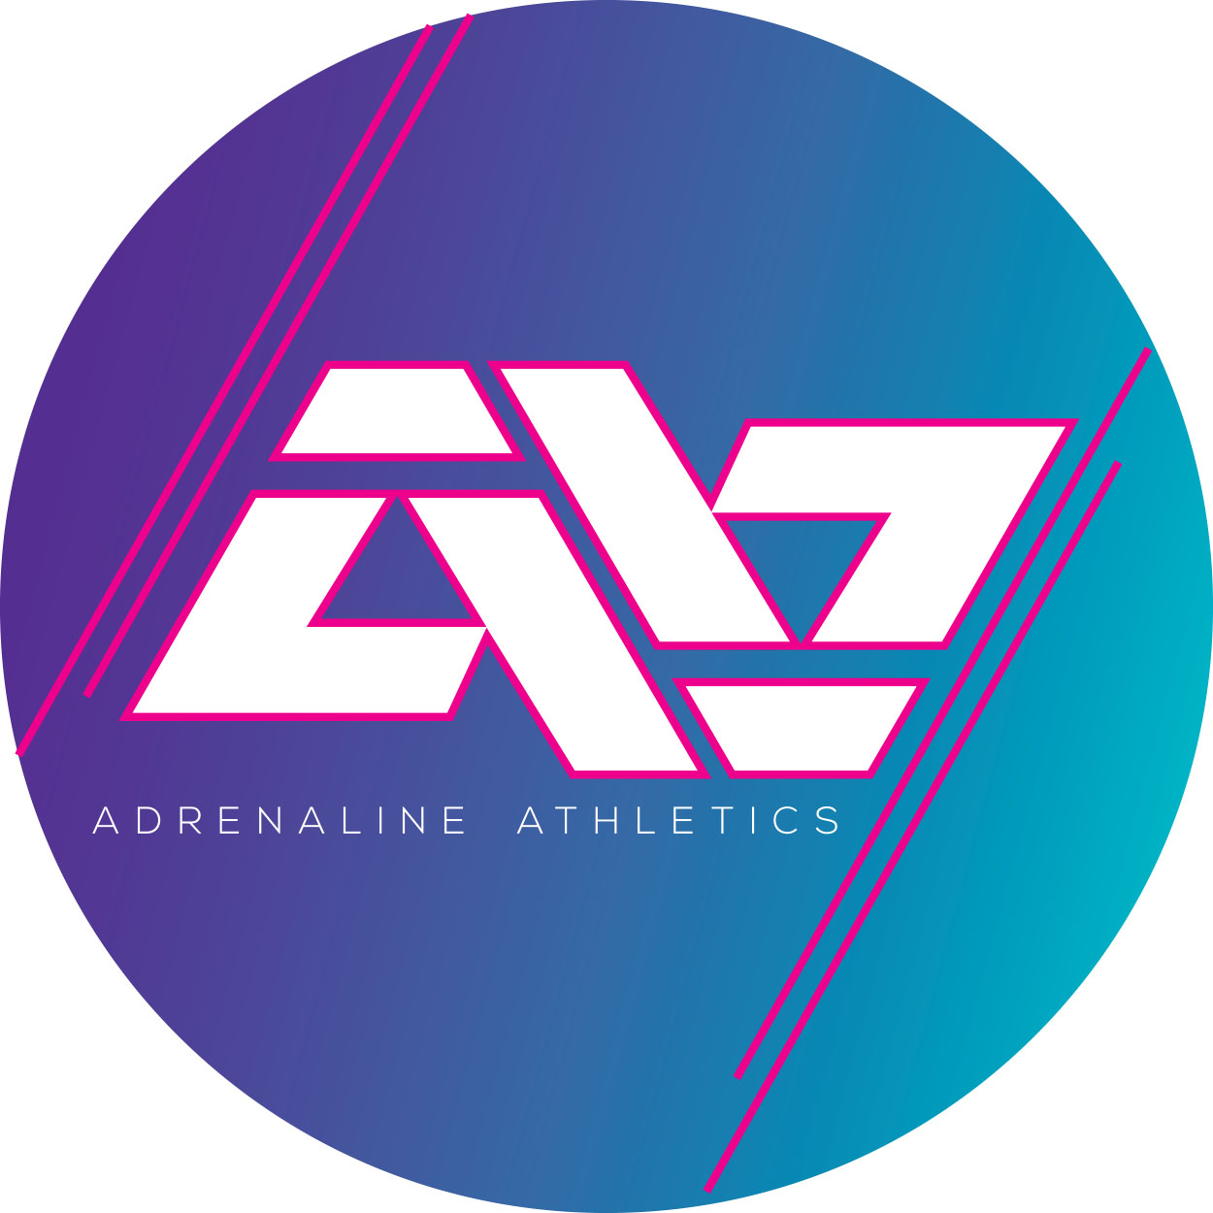

Waiver, Medical Treatment Authorization, Media Consent and Liability Release
Athlete Name________________________________________________________________________________ Parent / Guardian Name(s):_____________________________________________________________________________________Birthdate: _____________________________Home Phone:_______________________________________
I, the undersigned parent or guardian, do hereby grant permission for my son / daughter, whose name is _______________________________________________, and hereinafter shall be referred to as “participant,” to participate in the activities run by ADRENALINE ATHLETICS and associated events.
Disclaimer Clause
Adrenaline Athletics All-Star Cheerleading Club, Agents, contractors, coaches/instructors, volunteers, members and representatives (all hereafter referred to as "Adrenaline Athletics"), are not responsible for any injury, loss or damage of any kind sustained by any per- son while registered as a Adrenaline Athletics member and participating in any and all Adrenaline Athletics sanctioned events, activities, practices, social activities, promotional events, travel to and from any event, whether held at the premises of Adrenaline Athletics or elsewhere (all hereafter referred to as "Adrenaline Athletics Activities",) including, but not limited to, injury, death, loss or damage.
Description of Risks
In consideration of my / my child's membership and / or participation in Adrenaline Athletics Activities, I acknowledge that I am aware of the possible risks, dangers and hazards associated with being a member, including the possible risk of severe or fatal injury to me / my child or others. These risks include, but are not limited to:
All manner of injuries resulting in muscular injuries and soft tissue injuries including bruises, scrapes, cuts, etc., from executing strenuous and demanding physical techniques, collisions with walls, floor, ceilings, contact with other participants, and failure in proper execution of techniques either by my me / my child or other participants;
All manner of injuries resulting in sprains, dislocations, concussion, broken bones, hematomas, whiplash, contusions, pulled or strained muscles, torn ligaments, muscles and tendons, joint strain and sprain, and bruising to the tail bone, wrists, legs, arms, back, neck, and injuries of the gluteus maximus, pulled groin muscle, and heart attack / stroke, head, facial, eye and / or dental injuries;
All manner of spine or spinal chord injuries;
All manner of injuries, severe or fatal, resulting in cuts, tears, bruises or punctures caused by shoes, finger nails, jewelry, hair accessories or props either from me / my child or from another participant;
Transmission of diseases or skin diseases in various ways and types from contact with other participants resulting in death, disease or other illnesses;
All manner of medical problems resulting from heat exhaustion, asthma, communicable diseases, skin rashes, and cramps; All manner of internal injuries of body parts and organs, and trauma to larynx or pharynx;
That my / my child's risk of injury increases as I / my child becomes fatigued, experiences pain, frustration, and / or performance anxiety;
All manner of injuries and / or death that may result from transportation (all modes or types) used to and from Adrenaline Athletics Activities.
Initials: __________________
In consideration of Adrenaline Athletics allowing me / my child membership and participation in Adrenaline Athletics Activities, I agree as follows:
1. TO WAIVE ANY AND ALL CLAIMS that I / my child have or may have in the future against Adrenaline Athletics, contractors, coaches/instructors, volunteers, members and representatives as a result of my / my child's membership and / or participation in Adrenaline Athletics Activities.
2. TO RELEASE ADRENALINE ATHLETICS LTD. from any and all liability above and beyond the provided coverage, from any loss, damage, injury or expense that I / my child may suffer, or that my next of kin may suffer as a result of my / my child's membership and / or participation in Adrenaline Athletics Activities due to any cause whatsoever.
3. TO HOLD HARMLESS AND INDEMNIFY ADRENALINE ATHLETICS from any and all liability for any damage to the property of, or personal injury to, any third party, resulting from my / my child's membership and / or participation in Adrenaline Athletics Activities.
4. TO HOLD HARMLESS AND INDEMNIFY ADRENALINE ATHLETICS in connection with the services and / or accidents of any train, vessel, carriage, aircraft, bus, privately owned or rented motor vehicle or other conveyance, which may be used during my / my child's membership and / or participation in Adrenaline Athletics Activities.
5. TO HOLD HARMLESS AND INDEMNIFY ADRENALINE ATHLETICS for any cancellation, injury, loss accident or delay occasioned by the proprietor, employee or service of any accommodation which may be used during my / my child's membership and / or participation in Adrenaline Athletics Activities.
6. TO FOLLOW all instructions and rules given by those responsible for or in charge of Adrenaline Athletics Activities while I / my child am / is a member and / or participating in Adrenaline Athletics Activities. I am aware that the rules are in place to provide a safe environment for the entire membership.
7. TO ACKNOWLEDGE AND UNDERSTAND that cheerleading and tumbling require the Coach to perform manual spotting which involves direct physical contact and is designed to assist the participant in the safe performance of the program skills.
8. TO UNDERSTAND that in case of emergency I will be contacted as soon as possible. My insurance carrier or I will assume all expenses in case of emergency. Initials: ______________________
Protection of Personal Privacy: By signing below, I consent to having the information in this document collected by Adrenaline Athletics. Initials: _____________________
Media / Appearance Clause: Permission is granted to use my / my child's picture or image in any or all future advertisements, new stories, broadcasting, website and marketing literature or promotional materials for Adrenaline Athletics and / or events sponsored or conducted by them. I hereby waive any right to compensation or any claim of ownership hereto. Initials: _____________________
I have read and agree to the above Waiver, Medical Treatment Authorization, Media Consent and Liability Release.
_______________________________________________________________ ______________________________________________ Signature of Parent / Guardian (or Participant if 18 years of age or older) Date
This agreement must be completed in full (signed, dated and initialled where indicated) before any participant may begin Adrenaline Athletics Activities.

