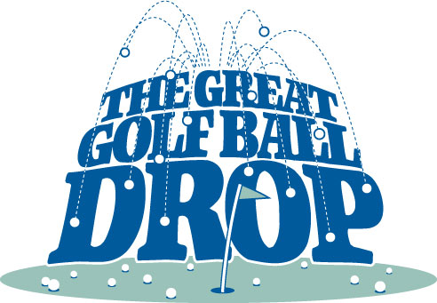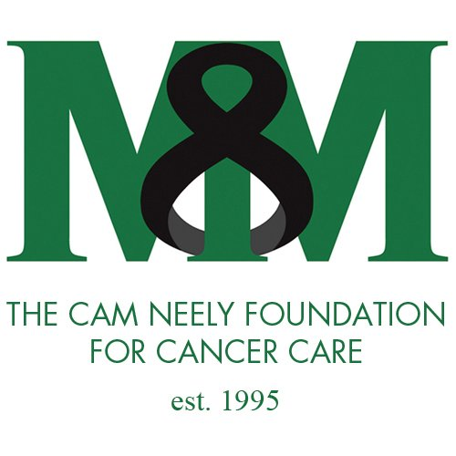

BUY YOUR GOLF BALL TODAY FOR THE FAIRMOUNT POST 85
FIRST ANNUAL 2018 GOLF BALL DROP!!!!!
(BALLS WILL BE DROPPED FROM HEIGHT OF 50 FEET
IN THE FIELD TO THE RIGHT SIDE OF THE PAVILION)
SALES LIMITED TO 200 GOLF BALLS AT $10.00 PER BALL
$1000.00 IN PRIZE MONEY WILL BE DISTRIBUTRED AS FOLLOWS
1ST PRIZE: YOUR BALL IN THE HOLE OR CLOSEST TO THE HOLE
$500.00
2ND PRIZE: YOUR BALL SECOND CLOSEST TO THE HOLE
$300.00
3RD PRIZE: YOUR BALL THIRD CLOSEST TO THE HOLE
$200.00

ADDITIONAL PRIZE!!!!
EACH BALL PURCHASED WILL RECEIVE A TICKET TO WIN ONE OF FIVE (5) HOCKEY PUCKS AUTOGRAPHED BY BOSTON BRUINS HALL OF FAMER, CAM NEELY!!!!

THE OTHER $1,000.00 WILL BE SPLIT BETWEEN FAIRMOUNT POST 85 AND THE CAM NEELY FOUNDATION FOR CANCER CARE
BALL DROP DATE WILL BE ANNOUNCED ONCE 150 GOLF BALLS ARE SOLD

NAME:________________________________________________ NUMBER OF BALLS:_________

CONTACT INFO:_____________________________________ FUNDS DONATED:___________

