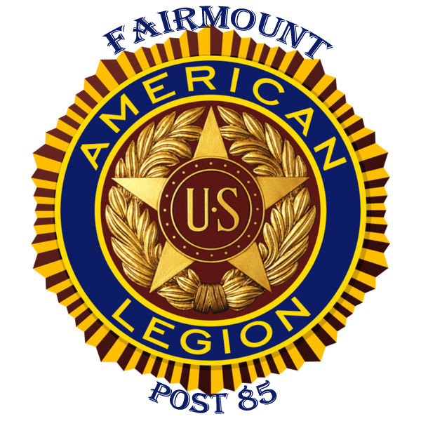
(page 1 of 3)

American Legion Fairmount Post #85
870 River St., Woonsocket, R.I. 02895

Monthly Meeting, Sunday, April 23, 2017
1000 Hours

THIRTEEN (13) MEMBERS IN ATTENDANCE
Meeting Called to Order by Commander Malone at approximately 1000 hours.

Roll Call of Officers:
COMMANDER DAVID MALONE PRESENT
SR. VICE COMMANDER DICK CHRISTIANSEN PRESENT
JR. VICE COMMANDER KIM KASZYK PRESENT
ADJUTANT RICH ALLAIN PRESENT
FINANCE OFFICER BOB VERRIER PRESENT
CHAPLIN MIKE KAROLYSHYN PRESENT
SERVICE OFFICER VACANT
HISTORIAN AL BEAUPARLANT PRESENT
SGT-AT-ARMS VINNY SCIROCCO PRESENT
JUDGE ADVOCATE VACANT

OPENING PRAYER BY CHAPLIN MIKE KAROLYSHYN
PLEDGE OF ALLEGIANCE BY SR. VICE COMMANDER CHRISTIANSEN
READING OF PREAMBLE

REPORTS:
COMMANDER MALONE

Remodeling of pavilion nearing completion. Outside bar and garage doors in pavilion need a coat of paint, volunteers needed. Comrade Dufresne will coordinate with Commander to put in a new LED sign out front. The outside walk-in cooler needs repair, Comrade Dufresne will do repairs and submit bill.

National Commander visited Post 85 on 03 April. Very impressed with the renovations and post overall.
Scholarship applications are now Posted on line and on our Facebook page.
Limited 7 day a week bar menu now available. Microwaveable “Stuffies” and “Loaded potato skins” for now. Saturday’s from Noon to 4pm has a more extensive $5.00 sandwich and fries menu.

Upcoming events are as follows: Community Yard sale in pavilion on May 13th, Wrestling on May 20th and Cigar Night in conjunction with the Masons on July 10th. Tickets are available for the Wrestling and Cigar Night. Tickets are also available for the Fire Pits that will be drawn in August.

(1) (Commander’s report continues on page 2)

New Safe is now in office.
Comrades are reminded to encourage new faces to join Post 85.
Looking for someone with a tall ladder or lift to repair flag pole cable & cable pulley that is broken at the top of the pole. Comrade Beauparlant will look into a company in E. Providence and advise.

Memorial Day flag placement on Veteran gravesites will take place on May 21st following our regularly scheduled meeting.

SR. VICE COMMANDER DICK CHRISTIANSEN

Nothing to Report

CHAPLIN MICHAEL KAROLYSHYN

Memorial Flags at St. Michael’s Cemetary have been placed. Chaplin has a hospital bed that is in great condition available for donation. Contact Chaplin if you are interested.

JR. VICE COMMANDER KIM KASZYK
Nothing to report

FINANCE OFFICER ROBERT VERRIER

Reports income from Keno and operating balance. All bills are currently paid and repairs continued to be made as
needed. Any member in good standing who wishes to review the finance report in detail may do so by contacting the Finance Officer and making an appointment.

SGT. AT ARMS VINNY SCIROCCO

Request made that a sign be put out in front of the Post recognizing that Post 85 is now the “home” of his VFW post. Motion by Commander Malone, seconded by Treasurer Verrier. After discussion MOTION PASSES.

HISTORIAN AL BEAUPARLANT
Will make a donation of $100.00 to the Memorial Day BBQ held at Post #85 for Homeless Veterans’

ADJUTANT RICH ALLAIN

Post #85 outside clean-up sponsored by Friends of Fairmount will take place on Sunday, April 30th. ALL are encouraged to come and lend a hand.

Saturday, May 20th (Armed Forces Day) a request has been made by the activities director at the Oakland Groves Health Care Center to have Members from Post 85 do a meet and greet with their Veteran residents. Scheduled time is 10am with coffee and pastries being served. Post Officers are asked to attend.

Monday, May 29th (Memorial Day) Post #85 will be hosting a Burger and Hot Dog BBQ for indigent and homeless Veterans in Woonsocket, RI. Adjutant will coordinate with Woonsocket Community Care Alliance Veterans’ Advisor Karim Monica Castillo for getting the word out and soliciting of donations for this event. ALL officers are encouraged to attend this event.
(2) (Adjutant’s report continues on page 3)

Reminder that our Flag Day 5K Run is scheduled for Saturday June 10th. Comrades at the March meeting were asked to try to solicit ONE $25.00 sponsorship. Adjutant will put out a flyer with sponsorship information and get it out to the membership.

CHARITY/DONATION REQUEST

Motion made by Commander Malone to donate $40.00 to do a Tee Sponsorship for a Golf Tournament for the American Legion Youth Organization. Motion seconded by Sgt-At-Arms Scirocco. After discussion MOTION PASSES.

Motion made by Commander Malone to purchase an advertisement in the program for the 2017 American Legion RI Annual Convention. Cost is $70.00. Motion seconded by Jr. Vice Commander Kaszyk. After discussion MOTION PASSES.

ELECTION NOMINATIONS AS FOLLOWS:

FOR COMMANDER: Richard Allain nominated by Comrade Dave Malone, Seconded by Comrade Bob Verrier

FOR: SR. VICE COMMANDER: Robert Lefort nominated by Comrade Rich Allain, Seconded by Comrade Dave
Malone.
FOR JR. VICE COMMANDER: Joseph Dufresne nominated by Comrade Rich Allain, Seconded by Comrade Glen
Theroux.
FOR POST ADJUTANT: David Malone nominated by Comrade Rich Allain, Seconded by Comrade Glen Theroux.

FOR FINANCE OFFICER: Robert Verrier nominated by Comrade Dave Malone, Seconded by Comrade Rich Allain

FOR SGT-AT-ARMS: Vinny Scirocco nominated by Comrade Dave Malone, Seconded by Comrade Bob Verrier

FOR CHAPLIN: Mike Karolyshyn nominated by Comrade Dave Malone, Seconded by Comrade Dick Christiansen

FOR HISTORIAN: Al Beauparlant nominated by Comrade Dave Malone, Seconded by Comrade Bob Verrier

FOR SERVICE OFFICER: Vinny Scirocco nominated by Comrade Rich Allain, Seconded by Comrade Bob Verrier

FOR JUDGE ADVOCATED: NONE, POSITION VACANT.

Election of Post Officers will be held at the next meeting on May 21, 2017.
Motion to adjourn by Commander Malone, Seconded by Adjutant Allain
Meeting adjourned at approximately 1055 hours.

Respectfully Submitted,

_____________________________________________
Richard E. Allain, Fairmount Post #85
Adjutant
(3)

