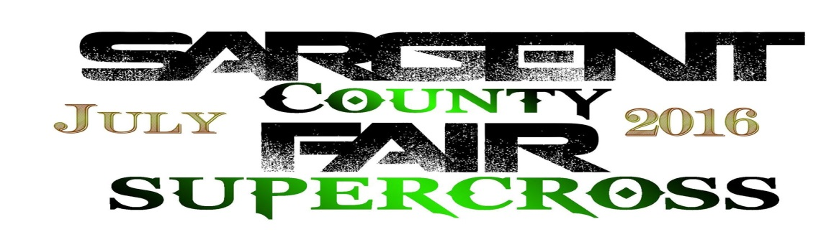
FOR OFFICE USE ONLY

CLASSES: __________
TOTAL: __________
PAID: __________
CASH / CHECK / CARD
STAFF INITIALS: ________
JULY 2018

NAME________________________________ AGE_____ DOB ____/____/____
ADDRESS_________________________________________________________
CITY____________________________ STATE___________ ZIP_____________
PHONE____________________ EMAIL_________________________________
EMERGENCY CONTACT_______________________PHONE_________________
Trophy Classes Registration – TROPHIES TO TOP 5 – 30$ PER CLASS
CLASS | NUMBER | BRAND/MODEL | CLASS | NUMBER | BRAND/MODEL
50 JR (4-6) |  |  | BEGINNER OUTLAW (>124cc)
50 SR (7-8) |  |  | 250 C (NOVICE)
50 OPEN |  |  | 450 C (NOVICE)
65 JR (7-9) |  |  | 250 B (INTERMEDIATE)
65 SR (10-11) |  |  | 450 B (INTERMEDIATE)
65 OPEN |  |  | OPEN OUTLAW (B&C)
85 JR (7-11) |  |  | WOMANS OUTLAW (>85CC)
85 SR (12-16) |  |  | PITBIKE (<130cc)
85 OPEN |  |  | VET 30+
PAYOUT CLASSES - $5,000 (1-5) (<8 RIDERS IS 150%) - $50 PER CLASS
CLASS | NUMBER | BRAND/MODEL | CLASS | NUMBER | BRAND/MODEL
250 PRO |  |  | 450 PRO

SPONSORS_________________________________________________________________________________________
THIS IS A RELEASE AND INDEMINTY AGREEMENT – READ BEFORE SIGNING
RELEASE OF LIABILITY AND ASSUMPTION OF RISK AGREEMENT
IN CONSIDERATION of being permitted to participate in any way in the sport and activities of Motocross/Supercross under the auspices of SARGENT COUNT FAIR SUPERCROSS, I acknowledge, appreciate, and agree that: 1. The risk of injury from the activity and equipment involved in motorized off road activities is significant including the potential for permanent disability and death, and while particular protective equipment and personal discipline will minimize this risk, the risk of serious injury does exist; 2. I KNOWINGLY AND FREELY ASSUME ALL SUCH RISKS, both known and unknown EVEN IF ARISING FROM THE NEGLIGENCE of those persons released from liability below, AND ASSUME ALL RESPONSIBILITY FOR MY PARTICIPATION; and, 3. I understand that the activities of motorized off road activities are physically and mentally intense. I understand the rules of play and will comply with all rules and regulations. If I observe any unusual or unnecessary hazards during my participation, I will bring such to the attention of the nearest official as soon as practical AND LEAVE THE AREA; 4. I, for myself and on behalf of my heirs, assigners, personal representatives and next of kin, FOREVER RELEASE AND HOLD HARMLESS SARGENT COUNT FAIR SUPERCROSS, SARGENT COUNTY FAIR, and SARGENT COUNTY. THE OWNERS AND LESSORS OF THE PREMISES USED TO CONDUCT THE MOTORIZED OFF ROAD ACTIVITIES, THEIR OFFICERS, OFFICIALS, AGENTS, PROMOTERS, SPONSORS AND/OR EMPLOYEES ("Releasees"), WITH RESPECT TO ANY AND ALL INJURY, DISABILITY, DEATH, or loss or damage to person or property, WHETHER CAUSED BY THE NEGLIGENCE OF THE RELEASEES OR OTHERWISE. 5. I understand and agree that the release of Liability AGREEMENT covers each and every motorized off road activity and/or event in which I participate or attend hereafter. 6. I UNDERSTAND THAT THE PROMOTERS OF SARGENT COUNTY FAIR SUPERCROSS DO NOT PROVIDE HEALTH INSURANCE. THE UNDERSIGNED FURTHER AGREES TO ASSUME ALL RESPONSIBILITY FOR DOCTOR, AMBULANCE, HOSPITAL AND MEDICAL EXPENSES AND ANY LOSS OR INJURY TO ME/THE MINOR AND/OR PERSONAL PROPERTY DUE TO PARTICIPATION IN ANY SARGENT COUNTY FAIR SUPERCROSS EVENTS. THE UNDERSIGNED HAS READ AND VOLUNTARILY SIGNS THE RELEASE AND WAIVER OF LIABILITY AND INDEMNITY AGREEMENT, and further agrees that no oral representations, statements or inducements apart from the forgoing written agreement have been made.
IF PARTICIPANT IS UNDER 18 YEARS OLD, HIS/HER PARENT OR LEGAL GUARDIAN MUST SIGN THIS FORM
I FULLY UNDERSTAND THAT THERE IS NO RIDER MEDICAL INSURACE PROVIDED.
I UNDERSTAND THAT MOTORCYCLE RIDING/RACING IS DANGEROUS.
YES, I HAVE READ AND UNDERSTAND THIS ARTICLE;
NOTARY FOR MINOR RELEASE

___________________________________
SIGNATURE OF NOTARY STAMP

____________________________________________ __________
SIGNATURE OF PARTICIPANT DATE

____________________________________________ __________
SIGNATURE OF PARENT/GAURDIAN DATE

