Mail Apps to:
North Gate Vida Nueva
C/O Melissa Walker
13047-162nd Avenue
Foreston, MN 56330

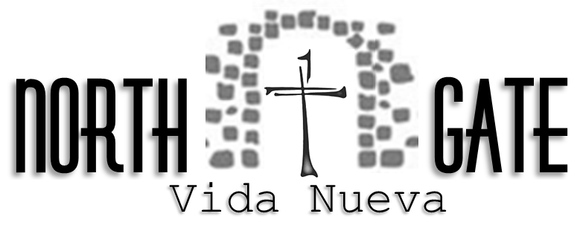

Team Commitment and Application

I, _______________________________________, affirm that I am a (Lay / Clergy) person who is consistent in my walk with Christ, faithful in my local church, supportive of my pastor and an active participant, endeavoring to be an Authentic Christian Leader in my personal Prayer, Study and Action and will strive to present the highest moral standard before the team and candidates; have attended a Vida Nueva or other approved similar weekend; have been selected by the Director, agree to serve on North Gate Vida Nueva Young Women’s☐/Men’s☐ Weekend # ______ Year______.
- I recognize that the Directors, head cha and assistant head chas are responsible for all aspects of the weekend under the direction of the Vida Nueva Council and will submit to their guidelines.
- I will be faithful to my responsibilities. I will attend all required team meetings. I will read & follow my job description. On the weekend I will work within my section in a spirit of cooperation, unity, and love.
- I agree that I am responsible for paying my team fee of $160.00 prior to the weekend.
- If a security clearance is needed, I will agree to have that form completed and cleared 3 days prior to start of weekend.
- I acknowledge that photos or videos may be taken at this event.

Has your information changed since you last served NGVN? Yes ☐ No☐

Signature Date

Full Name __________________ Age ___________
Address _____ City / State ______________Zip_________
Cell Phone ______________ Adult T-Shirt Size: __________________
Church ______ Email _________________
Weekend Attended & # (MTD #9, KCTD #1, ETVN #5 etc.):_________ ___State:_______
Emergency Contact Name: _____ Phone: _________

Special Gifts / Skills / Abilities

Audio / Video Computer Sewing/Crafts Photography
Nurse /Medical Clergy (Ordained) Clergy (Non – Ordained)
Music Abilities Sing Piano Other Instrument(s)

Serving Experience (Weekends/positions served e.g. Cursillo, Emmaus, TEC, Chrysalis, Tres Dias, Vida Nueva etc.)

Position / Talk on Weekend Community / Weekend # Location Date

