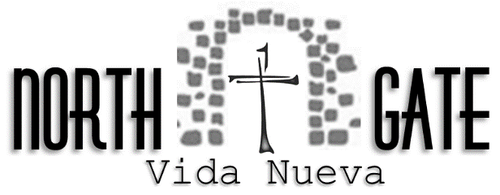
Total cost to attend is $160.00. Please mail this application with a $15.00 registration fee. The remaining balance of $145.00 is due before the weekend.

Candidate Application
Please complete and mail to:
North Gate Vida Nueva C/O Melissa Walker
13047- 162nd Avenue, Foreston, MN 56330

Name: ______________________________________________________ Nickname: __________________

Address: __________________________________________________ City: _________________________

State: ________ Zip:_______________ Phone: ________________________________________

E-Mail:_______________________________________ Sex: M or F

Date of Birth: ____________________ Adult T-Shirt Size: __________________________

Name of School/College & Grade/Year: _______________________________________________________

Name of Church:____________________________________ Location: ______________________________

List Allergies and Special Instructions: _________________________________________________________

Describe any special medical needs: ___________________________________________________________

________________________________________________________________________________________

Dietary (i.e. gluten free, vegetarian, no pork, etc): _________________________________________________________________________________________

I acknowledge that photos and videos may be taken on the NGVN weekends and events. Yes or No
All photos and videos will be made available.

Candidate Signature: _____________________________________________________________________

Parent/Guardian Signature:________________________________________________________________

Phone Number: _________________________________ Email: __________________________________

Sponsor Name:___________________________________ Email: __________________________________

Address:_________________________________________________________________________________

Phone:__________________________________ Relationship to Candidate: __________________________

Sponsor Signature:_______________________________________________________________________

For questions please contact Melissa at 763-313-4039 or go to our website: www.northgatevn.com.

