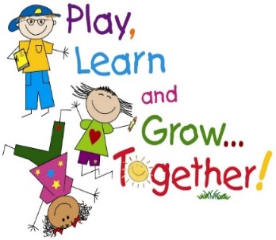

Week of April 9, 2018
Theme: Rainbows
Letter of the Week: Rr
Color of the Month: Blue
Math: Diamond Shape, Number Recognition
Reading: Concepts of Print, Characters
Religion: Prayers
Saint of the Month: Saint Katharine Drexel

Snack/Student of the Day
Monday: Tyler
Wednesday: Karissa
Friday: Aidan

Show and Tell
Monday: Dominic, Jackson, Joseph, Julianne
Wednesday: Karissa, Lilly, Maddie, Marty
Friday: Mason, Owen, Paige

All About Me Student: Mason

Things You Need to Know
This week, the children enjoyed learning about the letter K. They painted, listened to stories, and did various activities focusing on the letter K. They learned about kites and enjoyed the story, Kite Day. They especially liked the short video clip from Mary Poppins with the song, Let’s Go Fly a Kite. The children are practicing writing their names. We encourage you to practice their names at home, focusing on their first name.
Centers:
Writing Kk
Putting bows on a kite string using dice (numbers game) with Mrs. Hoffmann
Upper/Lower Case K coloring sheet
Making/cutting kites with Mrs. Covey
Legos

Looking Ahead to Next Week

We have used up most of our juice supply and we have a good supply of paper towels now, so please send in juice with snack instead of paper towels. Thank you for always helping when needed!

Next Week: Theme: Quilts Letter: Q Color: Blue Shape: Diamond St. Katharine Drexel

