4’s Newsletter

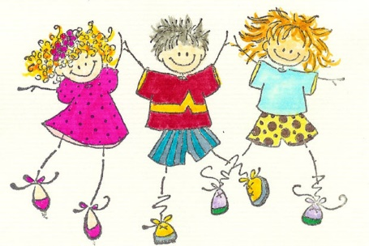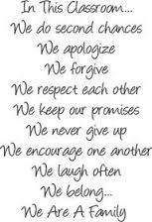

Week of February 20, 2017
Saint of the Month: Saint Patrick
Religion: The Trinity (Father, Son, And Holy Spirit)
Letter of the Week: Mm
Color of the Month: Green
Math: Shamrock, Number 8
Reading: Non-Fiction
Theme: Transportation

What We Learned
During circle time the children did activities reinforcing their knowledge of the letters we have learned so far, the heart shape, the color red and the number 7. The children enjoyed coming to the tables during circle time and took turns circling letters in words written on the chart tablet to review the letters they have learned. The children enjoyed learning about Community Helpers and we read stories about them. They made firetrucks reinforcing the color red and the knowledge of their shapes. They glued circles for the tires, a rectangle for the ladder, and a square for the window. It was a great review of shapes for them. On Friday we took advantage of the beautiful weather and went to the “Field of Dreams” for Gym. This is a big field behind the parking lot where the children got to run around, catch and kick a ball and play tag. The children loved it! The students are practicing writing their names. Please have them practice their names at home for reinforcement. They write an uppercase letter for the first letter of their name and the rest of the letters are lowercase. We had a great week!
Things you need to know

A small, light blue hat was left in the classroom if you are missing it.

Pancake and Pajama Day is scheduled for Wednesday, March 16, which is P week. This is a very fun day where the children come to school in their pajamas and they help make pancakes for snack! If you are able to come help that day it would be great! An email will be going out soon to sign up to volunteer and/or bring in an ingredient.

