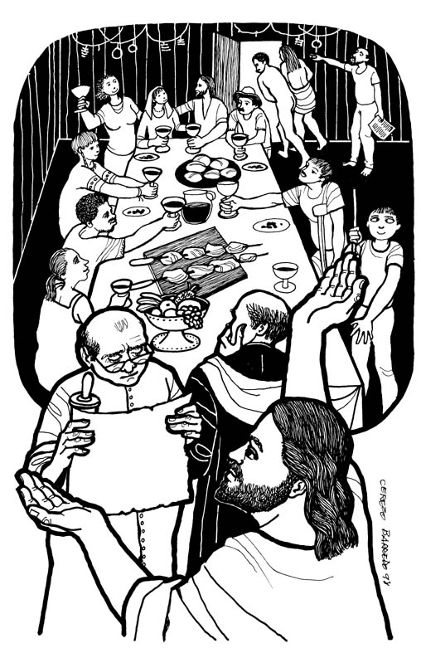

The Holy Eucharist, Rite II at 8 & 10 am
Sunday October 15, 2017

WELCOME TO ST. STEPHEN’S. Expect to be met and refreshed by the Holy Spirit in worship today. If you are visiting, we hope that you find here a warm and friendly place, where you can be “recharged” in mind, body and spirit for the week ahead. Christian Formation is offered for children at 10:00, teens at 11:00, and adults at various times as announced. Everyone is invited for fellowship after the service in the Parish Hall.

Visiting us today? Please introduce yourself to our Greeters and clergy, and sign our Guest Book so we can continue the conversations begun today. Holy Communion is offered at every service to all Christians and Christ-seekers, regardless of age or affiliation. Jesus welcomes you to his table, and sends us all forth in his mission of healing the world.

St. Stephen’s Episcopal Church
5500 North Adams Road, Troy, Michigan 48098
248-641-8080 (phone) 248-641-8067 (fax)
Website: www.ststephenstroy.org Email: office@ststephenstroy.org
The Right Reverend Wendell N. Gibbs, Bishop
The Reverend Susan Anslow Williams, Rector
Caleb Sinclair, Director of Music

The 19th Sunday after Pentecost: October 15, 2017
Quiet Eucharist at 8:00 a.m.
The Word of God
Opening Acclamation Book of Common Prayer (BCP) beginning on page 355
Collect for Purity, said by the priest
Glory to God, said together BCP page 356
Collect of the Day, Lesson insert Lesson insert
First Lesson: Isiah 25:1-9
Gradual Psalm 23
Second Lesson: Philippians 4:1-9
Holy Gospel: Matthew 22:1-14 please stand as able
Response before the reading: Glory to you, Lord Christ.
Response after the reading: Praise to you, Lord Christ.
The Sermon by the Rector
Nicene Creed, said together, standing as able Bulletin page 4
Prayers of the People and Confession of Sin Bulletin page 5
The Peace
Welcome and Announcements
The Holy Communion
An Offering is collected for the work of St Stephen’s Church, as the altar is prepared
The Great Thanksgiving: Eucharistic Prayer B BCP page 367
The Lord’s Prayer BCP page 364
The Breaking of Bread: silence follows
Alleluia. Christ our Passover is sacrificed for us. Therefore, let us keep the feast. Alleluia.
The Communion: All who seek Christ are welcome to his table. Gluten-free wafers are available, and Communion can be brought to you in the pew if mobility is difficult.
Post Communion Prayer, said together BCP page 365
The Blessing
Dismissal Response: Thanks be to God!
The Holy Eucharist with Music, at 10:00 a.m.
Welcome to this Family-friendly service. Nursery Care is available and Christian Education for children and youth is offered to all, whether this is your first Sunday here or your 101st! Ask an Usher for directions to the Education wing of the building.
A note about page references: “BCP” refers to the red Book of Common Prayer found in the book rack. Most hymns come from the blue “Hymnal 1982,” and those marked “WLP” are found in the green paperback, “Wonder, Love and Praise.”
Instructions such as “stand” or “kneel” are always optional for those who would find it difficult.

Prelude, “I Will Sing of the Mercies” Greer
Introit, Siyahamba South African Trad.

Opening Hymn: 408, “Sing praise to God who reigns above” stand

The Word of God

Opening Acclamation

All standing, the Celebrant says
Blessed be God: Father, Son and Holy Spirit.
People And blessed be God’s kingdom, now and for ever. Amen.

The Celebrant says the Collect for Purity
Glory to God, sung by all setting by R. Powell, Hymn S-280

Glory to God in the highest, and peace to his people on earth.
Lord God, heavenly King, almighty God and Father,
we worship you, we give you thanks, we praise you for your glory.
Lord Jesus Christ, only Son of the Father,
Lord God, Lamb of God,
you take away the sin of the world; have mercy on us;
you are seated at the right hand of the Father; receive our prayer.
For you alone are the Holy One, you alone are the Lord,
you alone are the Most High, Jesus Christ, with the Holy Spirit,
in the glory of God the Father. Amen.

Collect of the Day lesson insert
The Lord be with you. And also with you. Let us pray.
First Reading: Isiah 25:1-9 lesson insert
…The Word of the Lord. Thanks be to God.

Gradual Psalm 23 lesson insert

Second Reading: Philippians 4:1-9 lesson insert

Sequence Hymn: 664, “My Shepherd will supply my need” stand

Holy Gospel: Matthew 22:1-14 lesson insert
Response before the reading: Glory to you, Lord Christ.
Response after the reading: Praise to you, Lord Christ.

The Sermon The Rector

Nicene Creed stand

We believe in one God,
the Father, the Almighty, maker of heaven and earth,
of all that is, seen and unseen.
We believe in one Lord, Jesus Christ, the only Son of God,
eternally begotten of the Father,
God from God, Light from Light, true God from true God,
begotten, not made, of one Being with the Father.
Through him all things were made.
For us and for our salvation he came down from heaven:
by the power of the Holy Spirit
he became incarnate from the Virgin Mary, and was made man.
For our sake he was crucified under Pontius Pilate;
he suffered death and was buried.
On the third day he rose again in accordance with the Scriptures;
he ascended into heaven and is seated at the right hand of the Father.
He will come again in glory to judge the living and the dead,
and his kingdom will have no end.
We believe in the Holy Spirit, the Lord, the giver of life,
who proceeds from the Father and the Son.
With the Father and the Son he is worshiped and glorified.
He has spoken through the Prophets.
We believe in one holy catholic and apostolic Church.
We acknowledge one baptism for the forgiveness of sins.
We look for the resurrection of the dead,
and the life of the world to come. Amen.
Prayers of the People The congregation may stand or kneel.

Let us offer our prayers to God saying, “God of all mercy, Hear our prayer.”

Generous God, thank you for all the blessings you have given to each of us in this Household of Faith, St. Stephen’s Church. You have led us, hungry for the bread of life, to your altar of abundance. Help us to flourish in our faith and respond to others with generosity. Bless especially those on our Parish Cycle of Prayer this week: ____
God of all mercy, Hear our prayer.
Ever-watchful God, you notice the needs of all your children and long for us to respond as your eyes and hands and hearts in the world. Guide the leaders of your Churches into unity of purpose, through your Holy Spirit; especially Michael our Presiding Bishop and Wendell our Bishop; and in our Diocesan Cycle of Prayer: ____
God of all mercy, Hear our prayer.
Peace-loving God, we lift our prayers for the places in our world where freedom has been overcome by oppression, and abundance has been overwhelmed by greed or famine. Inspire our elected leaders {___}, and the leaders of all nations, to seek the common good. Protect and strengthen all who work to bring peace in conflict or material assistance under desperate conditions; especially those we love who are serving in the military: ____
God of all mercy, Hear our prayer.
Healing God, pour out your Spirit upon all who suffer, that they may know the power and the mystery of your presence. We especially pray for those with immediate concerns: ____; for those on our long-term prayer list; and others we would like to name aloud: names invited
God of all mercy, Hear our prayer.
Eternal God, we commend to your care our departed loved-ones {especially ___}, and those who have died through violence or disaster {___}. Grant a vision of your paradise to those who mourn, and inspire us with the example of your courageous saints in every generation.
God of all mercy, Hear our prayer.

The celebrant adds a concluding collect; all respond: Amen.

Confession of Sin kneeling as able

Let us humbly confess our sins unto Almighty God. Silence follows

Have mercy upon us, most merciful Father;
in your compassion forgive us our sins,
known and unknown, things done and left undone;
and so uphold us by your Spirit,
that we may live and serve you in newness of life,
to the honor and glory of your Name; through Jesus Christ our Lord. Amen.

Absolution is pronounced by the priest; we respond Amen.
The Peace The Peace of the Lord be always with you. And also with you.
Let us exchange the Peace of Christ with one another.

Announcements
Announcements for our parish life may be made at this point. Please come forward to the Lectern if you have news to share.

The Holy Communion

Offertory Anthem: “My Shepherd Will Supply My Need” Watts, arr. Thomson

Representatives of the congregation bring the people’s offerings of bread and wine, and money or other gifts, to the altar. The people stand while the offerings are presented as we sing:

Doxology
Praise God from whom all blessings flow; praise him, all creatures here below. Praise him above, ye heavenly host. Praise Father, Son and Holy Ghost.

The Great Thanksgiving: Eucharistic Prayer B BCP p. 367
The people remain standing

Celebrant | The Lord be with you.
People | And also with you.
Celebrant | Lift up your hearts.
People | We lift them to the Lord.
Celebrant | Let us give thanks to the Lord our God.
People | It is right to give God thanks and praise.

The Celebrant continues the preface and prayer B

…Therefore we praise you, joining our voices with Angels and Archangels and with all the company of heaven, who forever sing this hymn to proclaim the glory of your Name:

Sanctus sung by all setting by R. Powell, Hymn S-129

Holy, holy, holy Lord, God of power and might,
heaven and earth are full of your glory. Hosanna in the highest.
Blessed is he who comes in the name of the Lord. Hosanna in the highest.

The people may stand or kneel, as the Celebrant continues the prayer.
Acclamation, said together
We remember his death; We proclaim his resurrection; We await his coming in glory.
The Celebrant concludes the prayer; we respond Amen.
The Lord’s Prayer BCP p. 364
And now, as our Savior Christ has taught us, we are bold to say,
Our Father, who art in heaven, hallowed be thy Name,
thy kingdom come, thy will be done, on earth as it is in heaven.
Give us this day our daily bread.
And forgive us our trespasses, as we forgive those who trespass against us.
And lead us not into temptation, but deliver us from evil.
For thine is the kingdom, and the power, and the glory, for ever and ever. Amen.

Breaking of the Bread A period of silence is kept.
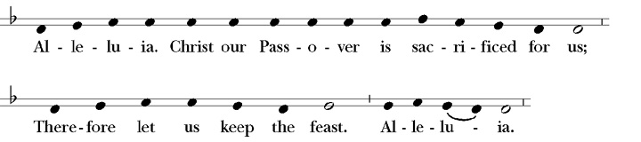
Response

Holy Communion is offered to all Christians and Christ-seekers, regardless of age. Please follow the guidance of the ushers. Please allow the students and teachers of our Youth classes to receive first and leave for their classrooms.

Gluten-free wafers are available upon request. You may choose to receive a blessing from the priest instead, which is signaled by crossing your arms in front of you. If mobility is an issue, please let an usher know as we are happy to bring Communion to you in your pew.

Communion Hymn: 325, “Let us break bread together”

Communion Anthem: “The Lord is My Shepherd” from Requiem (Rutter)

Post-Communion Prayer The congregation may kneel or stand, as able

Eternal God, heavenly Father,
you have graciously accepted us as living members
of your Son, our Savior Jesus Christ,
and you have fed us with spiritual food
in the Sacrament of his Body and Blood.
Send us now into the world in peace,
and grant us strength and courage to love and serve you
with gladness and singleness of heart; through Christ our Lord. Amen.

The Blessing

Closing Hymn: 481, “Rejoice, the Lord is King” stand

Dismissal Response: Thanks be to God.

Postlude, “Crown Him with many Crowns” Greer

Visiting today? We’re glad to meet you! Come for coffee / tea / lemonade
in the fellowship hall.

To get to know our church better, and to get the latest news
on our programs and events, visit our website: www.ststephenstroy.org

St. Stephen’s Vestry, 2017

Alice Moss (2018), Senior Warden Rob Redmer (2019), Junior Warden
Jackie Ingersoll (2018) Norma Ross (2018)
Paula Somerville (2018) Katy Allen (2019)
Richard Kenefic (2019) Roy Waters (2019)
Scott Armstrong (2020) Alan Giles (2020)
Karol Sprague (2020) Justin Wojas (2020)

Email Messages for the entire Vestry can be sent to: Vestry@ststephenstroy.org

St. Stephen’s Staff and Emails

Susan Anslow Williams, Rector rector@ststephenstroy.org
Ken Fuhr, Director of formation formation@ststephenstroy.org
Caleb Sinclair, Director of music music@ststephenstroy.org
Jacki Mudrich, Parish secretary office@ststephenstroy.org
Pam Bonkowski, Book keeper bookkeeper@ststephenstroy.org

