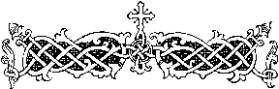

The Olive Shoots

St. Symeon Orthodox Church  
August 14, 2016

Date of feast (August 15, 2016)   
**+**Dormition of the Most-Holy Theotokos**+**

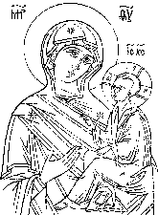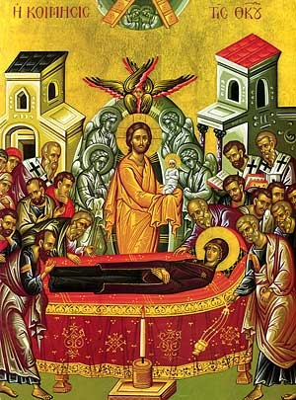

“Most Holy Theotokos save us!”

[*www.theoliveshoots.webstarts.com*](http://www.theoliveshoots.webstarts.com)

**Upcoming Events**

Monday - 10:00 AM: Divine Liturgy

Wednesday – 6:30 PM: Akathist of the Dormition  
Saturday – 6:00 PM: Great Vespers



**Troparion Tone 1**

In giving birth, Thou didst preserve Thy virginity!  
In falling asleep Thou didst not forsake the world, O Theotokos!   
Thou was translated to life, O Mother of Life,  
And by thy prayers thou deliverest our souls from death!

**Kontakion Tone 2**

Neither the tomb, nor death, could hold the Theotokos,  
Who is constant in prayer and our firm hope in her intercessions.   
For being the Mother of Life,  
She was translated to life by the One who dwelt in her virginal womb!

**Today’s Bible Verse-**

“My soul doth magnify the Lord, and my spirit hath rejoiced in God my Savior.”– Luke 1:47

**The Dormition of the Most-Holy Theotokos**

Three days before the death of the Theotokos, Christ told her through an Angel that she would be taken up from earth. “It is the moment,” he said, “to take my Mother to myself. Do not then be any way troubled by this, but accept my word with joy, for you are coming to immortal life.” Because of this, she went up to the Mount of Olives to pray, and the plants on the mountain bowed themselves down to the Theotokos.

After her prayer she returned home and at once the whole house was shaken. She prepared many lights and having given thanks to God she invited her relatives and neighbors. She swept the house and prepared the couch and everything needed for the burial. She told her friends about what the angel said, and as showed them a branch she the angel gave her from Paradise. But the women who were there were sad when they heard this, and the begged her not to leave them orphans. She assured them that when she had passed over she would watch over and protect not only them but the whole world.

Then, there suddenly came the sound of mighty thunder and the Disciples of Christ were brought to her on clouds, and they were also saddened by her news. But she answered them: Friends and Disciples of my Son and God, do not turn my joy to sorrow, but bury my body just as I have arranged it on the bed.

She lay down on the bed and arranged her all-pure body as she wished. She prayed for the conservation of the world and for peaceful life. She filled them too with blessing through her, and so committed her spirit into the hands of her own Son and God.

As Peter began the funeral hymns, the rest of the Apostles took up the bier and took it to her grave. Some of the Jews wanted to push over the bier, but they became blind. One of them, who had touched the bier, had his hands cut off by an angel, until he repented and was healed.

Thomas, however, did not come until three days later. When they opened the tomb for him, the body of the Theotokos was not there! Christ had lead his mother up to be in heaven with him. Most Holy Theotokos save us!

