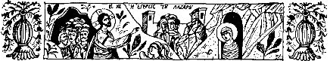
The Olive Shoots
St. Symeon Orthodox Church
April 24, 2016
$Entrance into Jerusalem (Palm Sunday)$
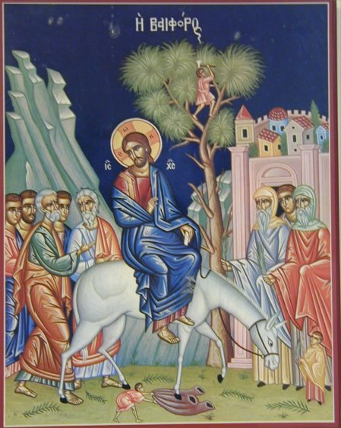
“Hosanna in the highest! Blessed is he that comes in the name of the Lord” ~ The Jews in Jerusalem

www.theoliveshoots.webstarts.com

Upcoming Events
Son.- Bridegroom Matins 5:00 pm
Mon., Tues.- Bridegroom Matins 6:30 pm
Wed.-Holy Unction 6:30 pm
Thurs.-Divine Liturgy 10:00 am, The Passion Gospels 6:30 pm
Fri.-Royal Hours 10;00 am, Vespers of Holy Friday 4:00 pm, Matins of Holy Saturday 7:00 pm
Sat.-Divine Liturgy 10:00 am
Pascha! 11:30 pm


Troparion Tone 1
By raising Lazarus from the dead before Thy passion,
Thou didst confirm the universal resurrection, O Christ God.
Like the children with the palms of victory,
We cry out to Thee, O Vanquisher of death,
Hosanna in the highest!
Blessed is He that comes in the Name of the Lord.

Kontakion Tone 6
Sitting on Thy throne in heaven,
Carried on a foal on earth, O Christ God!
Accept the praise of angels and the songs of children who sing:
Blessed is He that comes to recall Adam!

Today’s Bible Verse:

The next day a great multitude that had come to the feast, when they heard that Jesus was coming to Jerusalem, took branches of palm trees and went out to meet Him, and cried out: Hosanna! ‘Blessed is He who comes in the name of the LORD!’ The King of Israel!”
~ John 12: 12-13

Palm Sunday

Lent has ended and the holy journey to the Lord’s death and Resurrection begins! When people heard that Jesus had raised Lazarus from the dead, they flocked to see him as he was traveling to Jerusalem. Jesus told two of his apostles to go into the city and find a foal (baby) of a donkey. The disciples found it, just as Jesus had said, and Jesus rode the donkey through the crowds to Jerusalem. Those who had come to see him took palm branches off the trees and waved them as he passed, shouting, “Hosanna in the Highest! Blessed is He who comes in the name of the Lord, the King of Israel!” People also laid down their shirts and clothes in Christ’s path as a carpet on which the donkey walked. Soon, however, the same people now shouting, “Hosanna!” will be shouting, “Crucify Him!” for Christ is on His way to His holy Passion and joyous Resurrection! Palm Sunday is one of the Twelve Great Feasts of the church, celebrated eight days before Pascha, the beginning of Holy Week. Hosanna in the Highest! Blessed is He that comes in the name of the Lord!
Palm Sunday
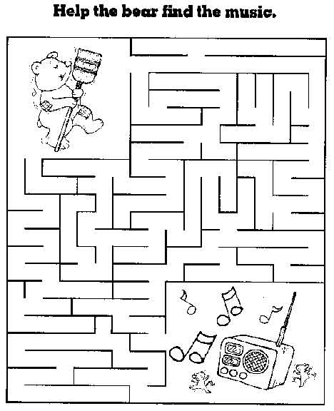
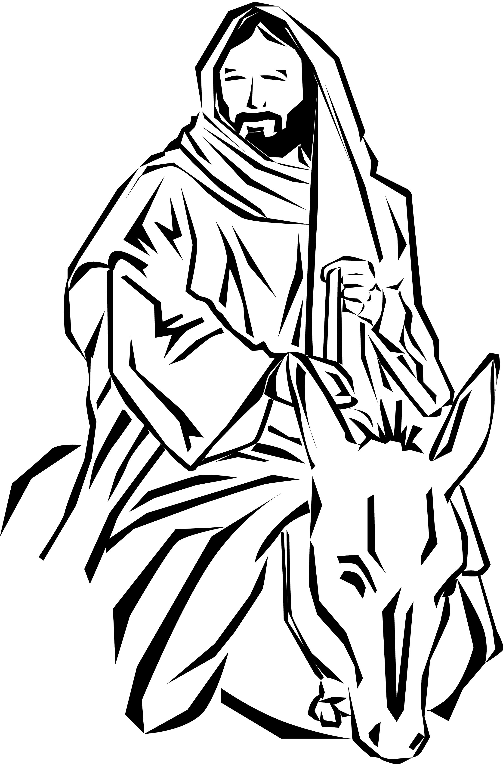
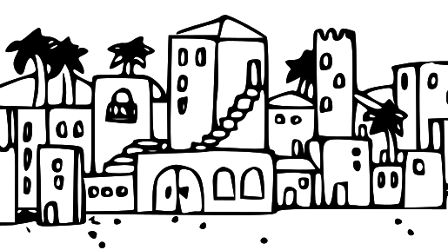
Help the donkey help Jesus get to Jerusalem!

