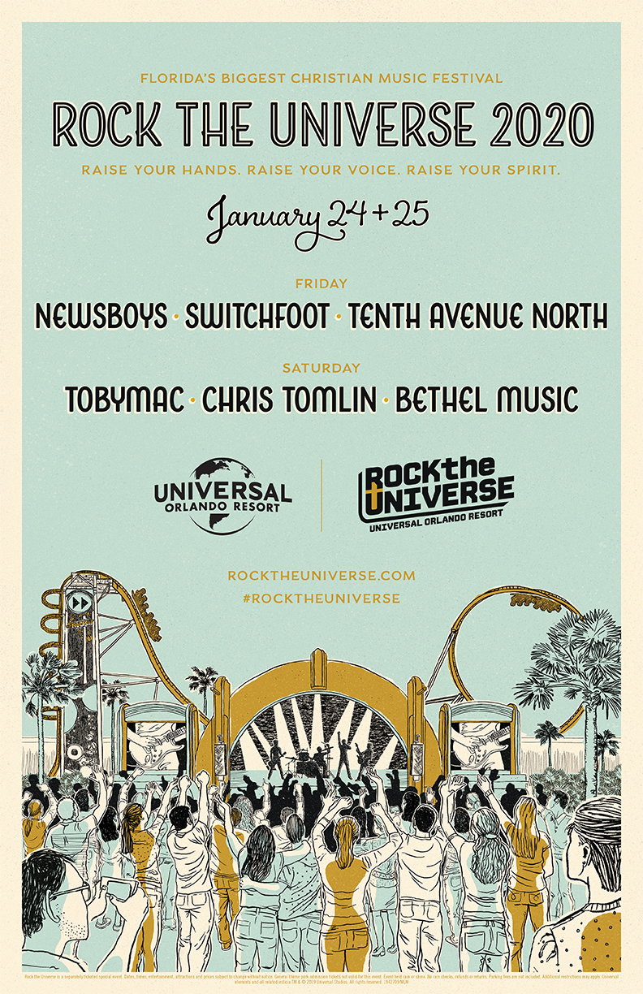

**POSTAGE  
REQUIRED**

*REDEEMER PCA RIVERVIEW  
12404 Boyette Road  
Brandon, FL, 33569*

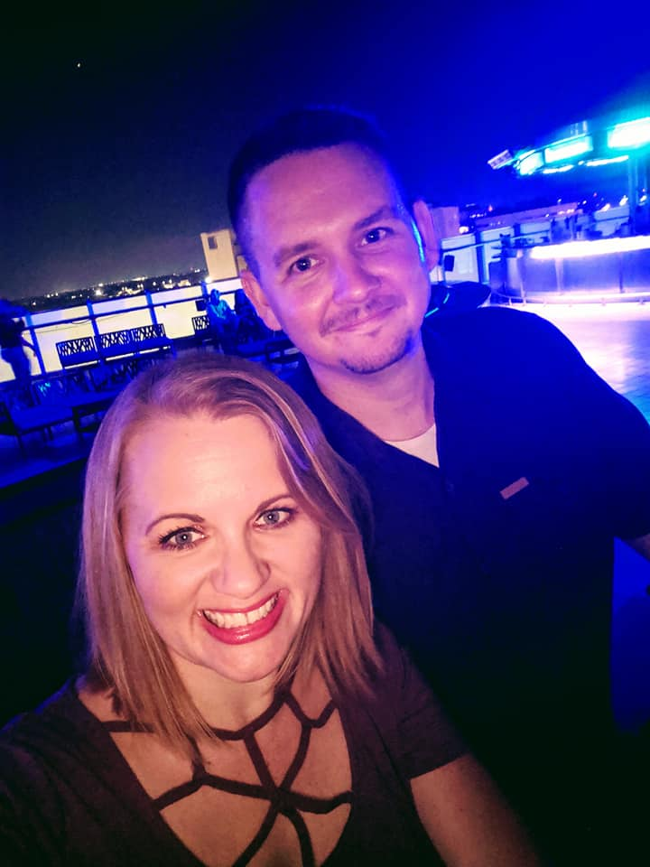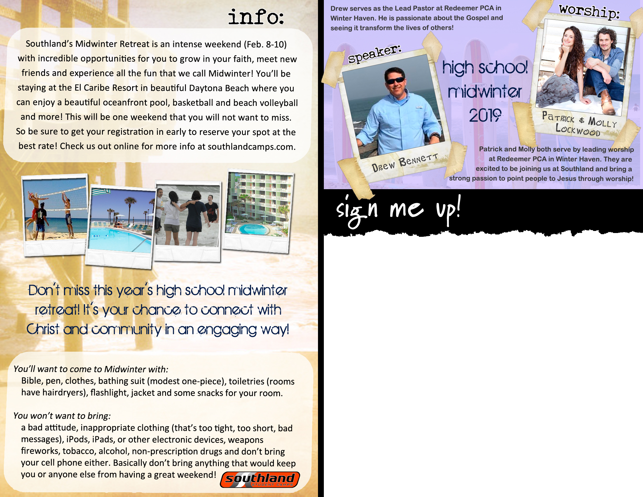

Imago Dei. The image of God. According to Holy Scripture, all human beings are created in it - but what does that really mean? Join us, for a three-session teaching series where we unpack the depth, beauty & profound privilege God has bestowed upon us. Join us as we discover why image matters.

Theme:

JOSH GILMAN

Josh serves as Pastor of Students & Families at Redeemer Church in Riverview, FL. He is passionate about seeing students meet Jesus and growing in their love for Him!

Redeemer UNITED’s Midwinter Retreat is an intense weekend (January 24-26th) with incredible opportunities for you to grow in your faith, meet new friends, and experience all the fun you can handle at Universal Studios Orlando. We will be staying at nearby International Drive at a resort complete with a pool, continental breakfast, and easy access to the nearby parks. This will be one weekend you will not want to miss. So be sure to get your registration in early to reserve your spot at the best rate! Check out the website online for more info at redeemerriverview.org/student_ministry

Name: ________________________________________ [ ] M [ ] F

Address: _____________________________________________

City: ________________________________ Zip: _____________

Email: ________________________________________________

Phone: ____________________ (h) _____________________ (c)

Grade: ______ [ ] counselor T-shirt Size: S | M | L | XL | XXL

*Please complete this registration and turn it in to the Student Ministry Office.*

**MIDWINTER COST**

EARLY (by 12/24/19) $140 [ ]

REGULAR (after 12/24/19) $160 [ ]

*$25 non-refundable deposit will hold your spot and rate at the above dates. Please make checks payable to Redeemer Church. A completed notarized Medical Release Form needs to be on file in order to participate in this event.*

*\*\* THIS TEXT BOX CAN BE EDITED \*\**