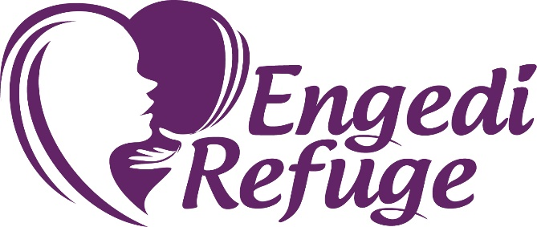 Providing safe housing, education, counseling and vocational training for survivors of sexual exploitation

Donation Suggestions for Engedi Refuge

➢ $10 Walmart, Hobby Lobby or Target gift cards: We have a treasure chest at the Learning Center where I keep incentive gift items for our residents. If a resident goes above and beyond in her chores or other outstanding behavior in the course of the week, the house manager will give her a treasure chest key and on Friday, she can bring the key and exchange it for something in the treasure chest. All items in the treasure chest are $10 or less.

➢ Safeway gift cards: a general grocery gift card would be a great boost to our food budget at the safe house.

Ongoing needs for Engedi House

Toiletries/Cleaning Supplies
Plastic Applicator Tampons Bath sponges Toilet Paper Paper Towels
Swiffer duster refills Swiffer wet mop refills Tylenol PM
Non-chlorine toilet cleaning products Dishwasher detergent laundry detergent
Clorox wipes Ziplock Baggies – lrg & sm Aluminum foil
Saran Wrap Kitchen sponges w/ a scrubbie side

Pantry Items:
Coffee & Creamer canned fruit Canned chicken Salad Dressings Honey Canned Soups Cold Cereal Boxed Dinners Jam/Jelly Peanut Butter
Sandwich crackers Chewy Granola bars Fruit/Chewy Granola Bars Lunch snacks Ramen type noodle soups Chef Boyardee canned food Cold boxed cereal
Potatoes Pizza & spaghetti sauce Pasta Salad mixes Rice Pilafs packages

Ongoing needs for Learning Center
Printer Ink Cartridges: HP 902 HP 950/951 HP 63
Copy Paper Forever Stamps Dry Erase Markers Three pronged pocket folders

Engedi Learning Center 7370 Guide Meridian 360-922-7600
Please call Johanna to arrange for delivery

