Reshape Coaching: Stage 1

|  |  |
| --- | --- |
| Client information | |
| Name |  |
| Gender |  |
| Age |  |
| Height |  |
| Weight |  |
| Days working out per week |  |
| Body Composition from the chart below |  |
| Tell me about yourself (Free format, tell me anything that lets me get to know you a little better.) |  |

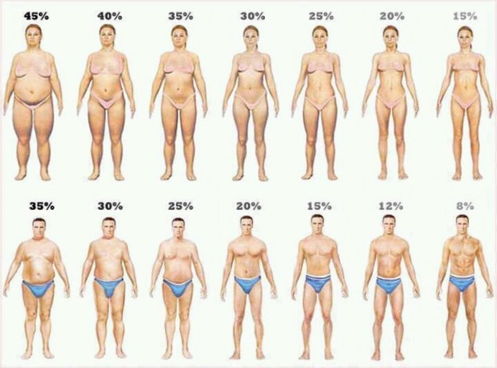

1. My Fitness Pal
   * Download myfitnesspal app (available on android, iphone and desktop)
   * This app is pretty easy to use, download and signup. Their database is very large and has almost every food that I personally have searched.
2. Track
   * Track **4** consecutive days of food and drinks in myfitnesspal. It is important that this is your normal eating habit; so do not begin changing your eating habits for these tracking days.
     1. This gives me consecutive days of what your current macros are to get an idea of where to start your new macros.
3. Screenshots
   * After you have tracked your first 4 days, email me screenshots of each day’s “Nutrition Goals.” So should be 4 total screenshots for this set.
4. The Android directions are as follows, I assume the iphone app is similar: Upon opening myfitnesspal, tap the 3 horizontal bars on the left, tap “Nutrition”, then “Nutrients.”
5. The screenshot will look as follows (photo 1:Mobile version, photo 2:Desktop version):

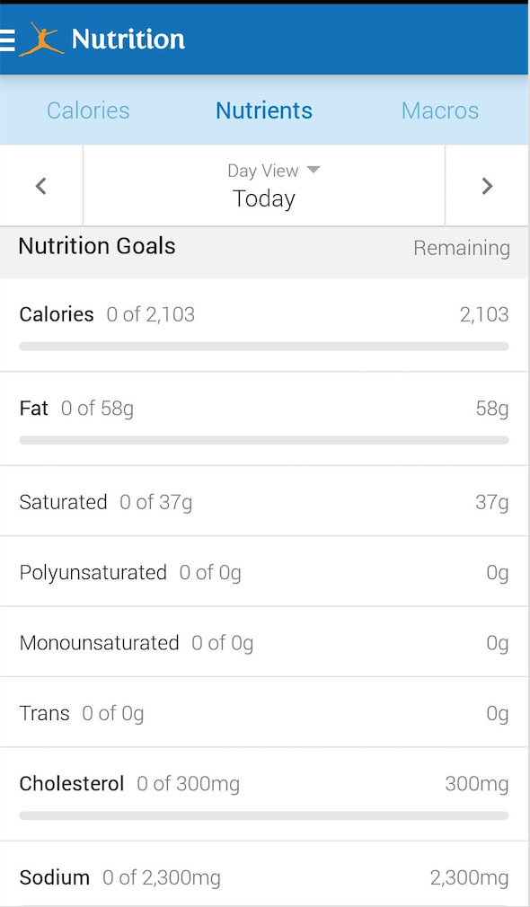 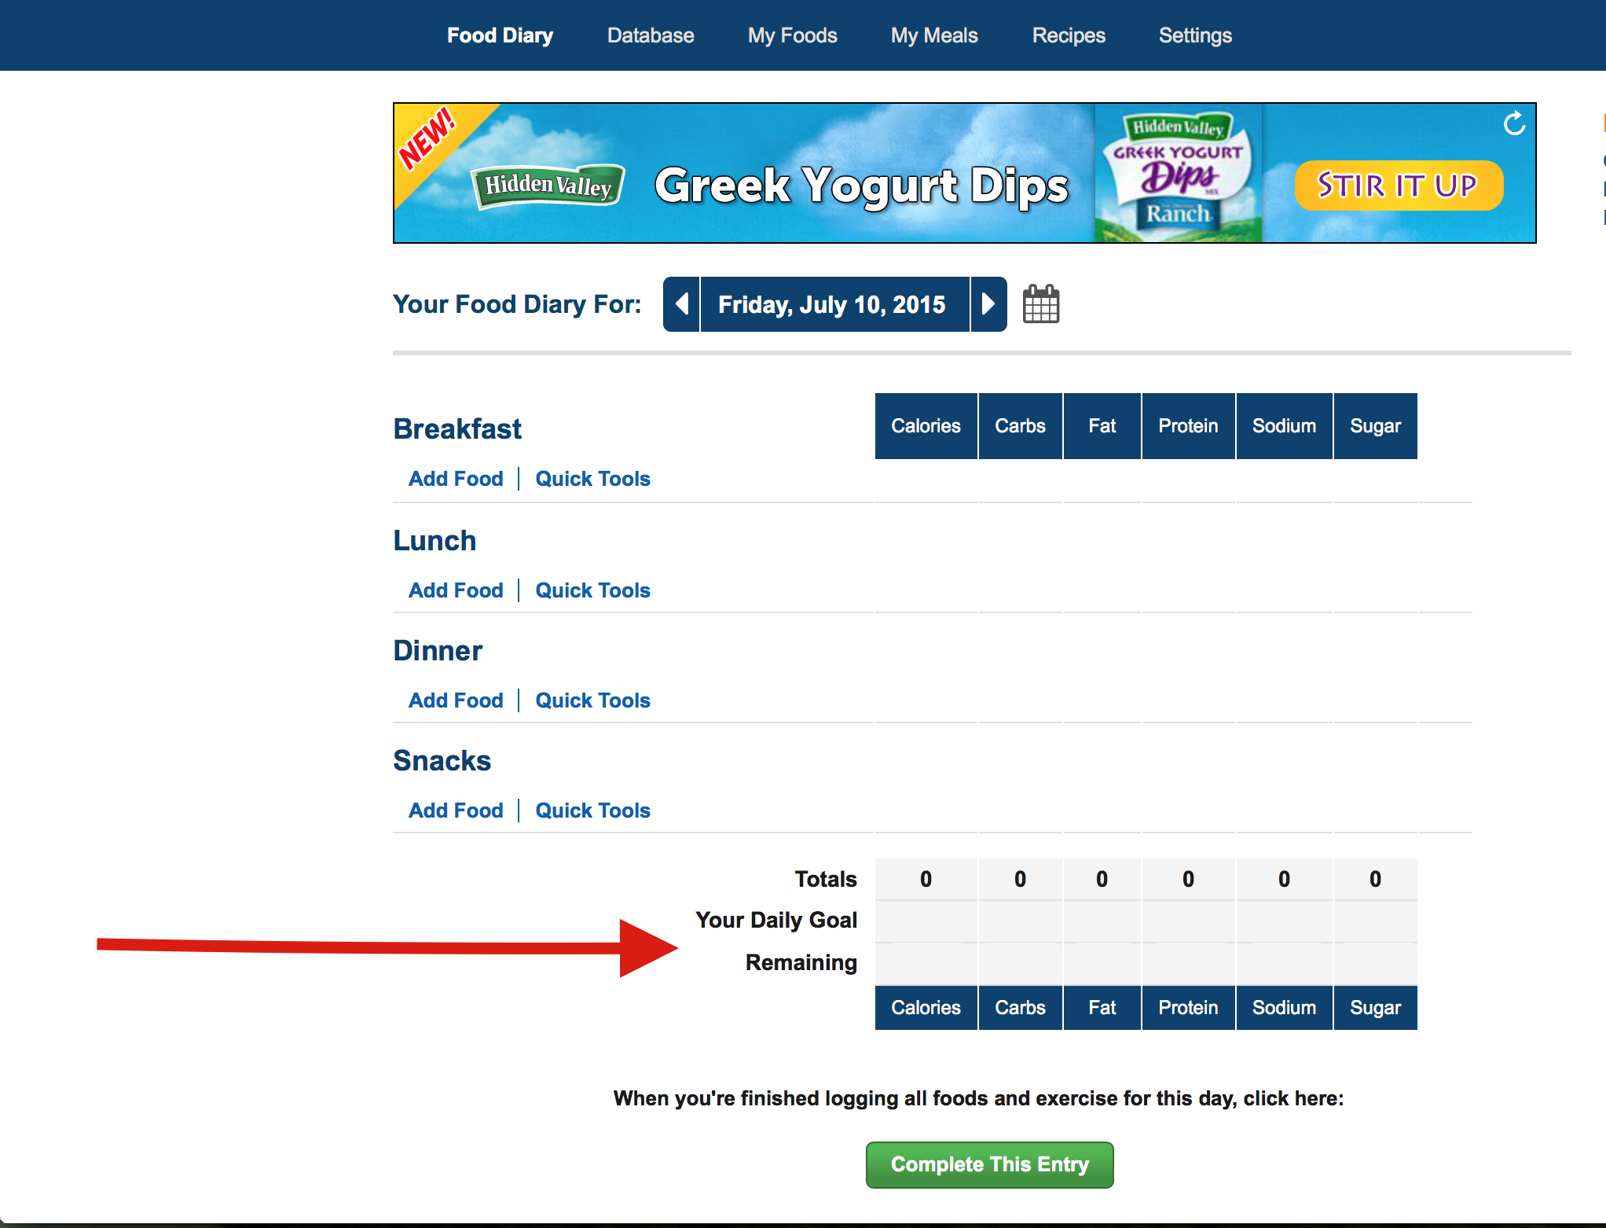

When sending the screenshots above, if you send the screenshots from mobile, you will have to denote the calories that were consumed to the corresponding day. You will not have to worry about that if you send screenshots from the desktop as long as the nutrient table at the bottom is visible.